CACHE Modules on Energy in the Curriculum

Fuel Cells
Module Title: Die Design for Hydroforming Stainless Steel Bipolar Plates
Module Author: Nate Kroodsma and Dennis Desheng Meng
Author Affiliation: Michigan Technological University

Course: Metal Forming Processes

Text Reference: Kalpakjian et al., 2005, Manufacturing, Engineering and Technology, 5th Edition.

Concepts: hydroforming, regression analysis, design

Problem Motivation:
A fuel cell is, in theory, a very simple electrochemical conversion device. Unlike a battery, which is an electrochemical storage device, a fuel cell does not directly store energy but rather converts energy from a fuel supply into usable electricity. Fuel cells have many advantages over batteries such as:
- High energy density
- Continuous operation as long as there is a constant supply of fuel (does not need to be recharged like a battery)
- High conversion efficiencies in excess of 60%
- Zero carbon dioxide emissions makes it environmentally friendly

Just like there are various kinds of automobile engines (gasoline, diesel, natural gas, etc.) and various kinds of batteries (lithium-ion, NiCd, NiMh, lead, etc.), there are various kinds of fuel cells, each one having certain advantages/disadvantages for niche applications. One such kind of fuel cell is called a Proton Exchange Membrane Fuel Cell (PEMFC). Its operation is schematically illustrated in Figure 1.

A PEMFC consists of three main layers: anode, electrolyte, and cathode. Each layer is constructed of a different material and when assembled, the three layers form a single cell that is only several millimeters thick. Typically, the output voltage achieved by a single cell, as pictured, is ~1 volt. To generate a higher voltage system, many single cells are “stacked” together and wired in series to form a fuel cell stack.

Let’s look at each layer in detail:

Anode
A PEMFC is often called a hydrogen fuel cell for the reason that hydrogen gas is the fuel that a PEMFC runs on. Pure hydrogen gas is introduced at the anode where it is oxidized (electrons are “stripped” from the hydrogen) by a platinum catalyst. The half-cell reaction describes this oxidation.

$2H_{2}→4H^{+}+4e^{−}$ (Eq 1)

For each hydrogen molecule, two protons H⁺ and two electrons e⁻ are produced. We will discuss the electrons later, but for now, let’s look at the protons.
e⁻
H₂O
O₂
H₂
e⁻
e⁻
anode
electrolyte
cathode
fuel in
air in
electric current
excess fuel
unused air and water out
H⁺
H⁺
H⁺
Figure 1: Schematic of PEMFC operating principles

Electrolyte
The electrolyte used in PEMFCs is a proton “carrier” and it is a very thin sheet of polymer that is less than 100µm thick. Another acronym for a PEMFC is Polymer Electrolyte Membrane Fuel Cell. This electrolyte is essential to the correct operation of the fuel cell as it must conduct the protons that are generated at the anode. The electrolyte material of choice is called Nafion®. The polymer electrolyte is actually fabricated into a layered assembly called the membrane electrode assembly, or MEA.

Cathode
At the cathode side of the fuel cell, oxygen gas is reduced and combined with electrons and protons (initially from the anode) to form water
$O_{2}+4H^{+}+4e^{−}→2H_{2}O$ (Eq 2)
In summary, the protons transport through the electrolyte, and the electrons move through the external circuit to recombine with oxygen at the cathode. Therefore, the overall reaction is the sum of Eq 1 and Eq 2
$2H_{2}+O_{2}→2H_{2}O$ (Eq 3)

The most common source of oxygen gas is atmospheric air, however, purified oxygen can also be used. Any un-reduced oxygen gas at the cathode is either exhausted back into the air or in the case of purified oxygen, recirculated back into the inlet. The electrons that were separated from the fuel at the anode travel through an external circuit to get to the cathode. Of course, charge (electrons) flowing through a circuit is the definition of electricity. So the principle of converting fuel into electricity inside a PEMFC is quite simple in theory, but can become quite complex when putting it into practice.

Problem Background:

Although not labeled in Figure 1, the component within the fuel cell that works to distribute the fuel over the electrolyte is called the bipolar plate. The bipolar plate has four main functions [1]:
- Evenly distribute gases (hydrogen at the anode or oxygen at the cathode) across the MEA
- Separate the hydrogen from the oxygen
- Collect the current generated
- Structurally support the compressive load within the fuel cell stack

To meet all three requirements, the bipolar plate must be:
- electrically conductive
- non-corrosive under electrochemical reactions
- non-permeable to hydrogen gas
- thermally conductive
- thermally stable to 120 °C
- high flexural and tensile strength
- cost effective manufacturing with high throughput

Bipolar plates contribute to about 60-80% of a fuel cell stack weight, 50% of the stack volume, and about 35-45% of the cost [2]. Multiple designs exist for the flow pattern of fuel/oxygen, as seen in Figure 2. In a fuel cell stack, a single bipolar plate as pictured in Figure 2 will be sandwiched between two MEAs, which means that hydrogen will be flowing through the channels on one side of the bipolar plate and oxygen will be flowing through the channels on the opposite side.
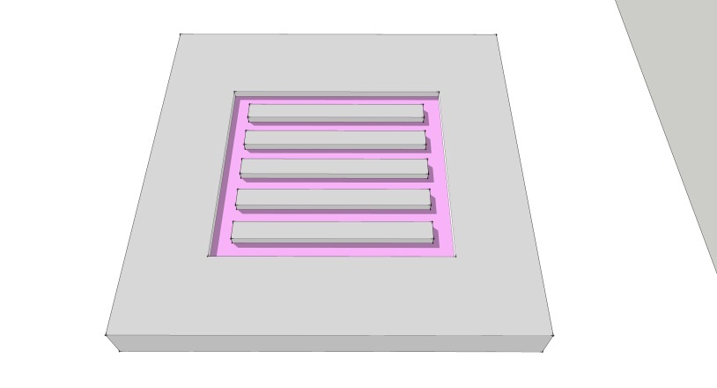
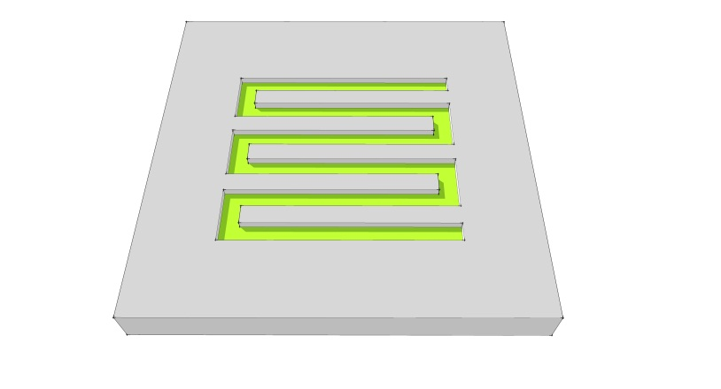
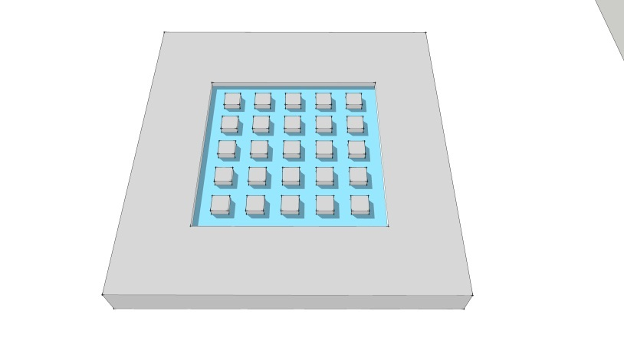
Serpentine
Pin-type
Parallel
Figure 2: three common flow field designs

Example Problem Statement
The company you work for manufactures small fuel cell stacks. Your department is in charge of fabricating the bipolar plates and lately your boss has been thinking about using stainless steel as a material. You suggest using hydroforming as a method to produce the bipolar plates since your company has all the equipment necessary for this process. Hydroforming is a cost effective way to manufacture parts from sheet metal at high production rates. A blank is placed on a die and either pneumatic (gas) or hydraulic (liquid) pressure is used to press the blank into the shape of the die (See Figure 3). Your job is to design the die.
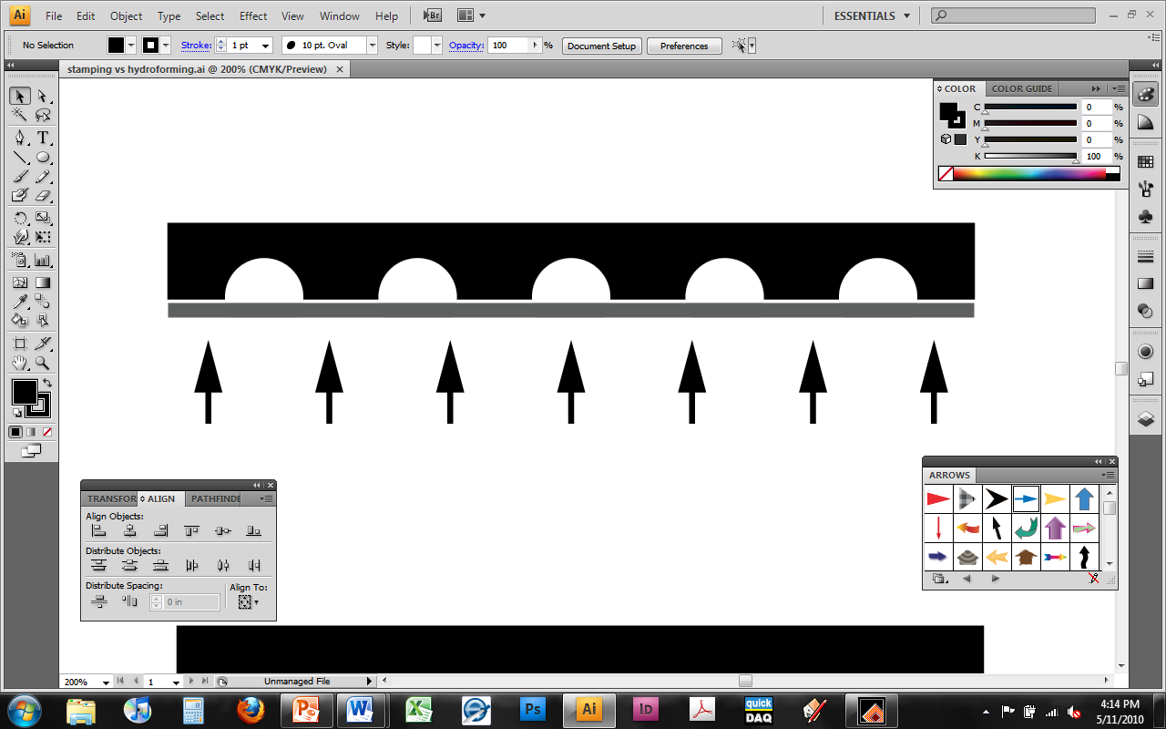
die
sheet blank
Hydraulic/pneumatic pressure
Figure 3: hydroforming

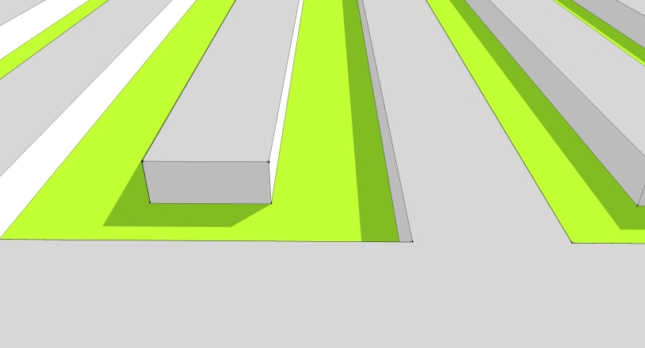
To gain a better understanding for specific design parameters, your colleague runs a few experiments in the lab. He machines a prototype die with 8 simple channels on it, each with a different aspect ratio (the ratio between channel height, h, and channel width, w. See Figure 4 below). Using sheet blanks of stainless steel with thickness t = 0.20 mm, he measures the hydraulic pressure necessary to fully press the blank into each of the channels and tabulates the results in Table 1. The pressure is measured as a function of a dimensionless variable $\frac{h⋅t}{w^{2}}$which is equal to $\left(\text{AR}\right)\frac{t}{w}$ where AR is the aspect ratio, $\frac{h}{w}$.
b
w
h
Figure 4: channel dimensions

h*t/w^2 | Pressure (Mpa)
0.003 | 20
0.01 | 50
0.03 | 125
0.05 | 175
0.075 | 275
0.125 | 400
0.225 | 700
0.4 | 1100
Table 1: pressure vs. dimension,
parallel channels

- Plot the data in Table 1. What kind of trend/s do you observe? Describe them.
- What kind of trendline best fits the data? What is the equation and R² for the line? Is it a good fit?
- The hydroforming setup at your facility is only capable of producing 800 MPa of hydraulic pressure repeatedly and safely. What is the maximum dimensionless value $\left(\frac{h⋅t}{w^{2}}\right)$ that can be obtained at this operating pressure?
- For the particular fuel cell that you are working on, the cell area is 100 cm² (10 cm x 10 cm). There is a 1 cm edge around the perimeter that is used for bolting the stack together, therefore the area that can be utilized for flow channels is 9 cm x 9 cm (see figure below). Design a parallel flow field (Fig.2) by determining the channel dimensions for a die based on the following requirements:
    - Stainless steel thickness, t = 0.20 mm
    - Rib dimension between channels must be at least the same dimension as the channel width, b ≥ w (See figure 4 above).
    - Maximum operating pressure of 800 MPa
    - Total channel volume of at least 2 mL

Example Problem Solution

- Plot the data in Table 1. What kind of trend/s do you observe? Describe them.

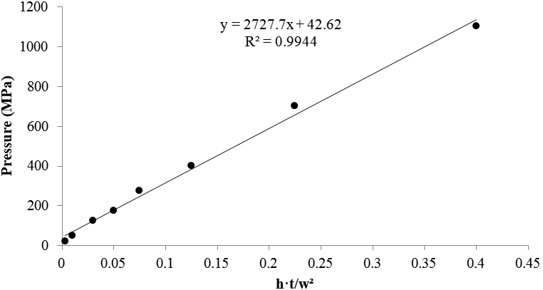

The data increases at a linear rate. Therefore increasing either h or t will increase the needed pressure. Or decreasing w will increase the pressure needed.

- What kind of trendline best fits the data? What is the equation and R² for the line? Is it a good fit?

A linear regression fits the data really well. The equation is $P=\text{2727}\text{.}7∗\left(\frac{h∗t}{w^{2}}\right)+\text{42}\text{.}\text{62}$
and R² = 0.9944 This suggests a good fit.

- The hydroforming setup at your facility is only capable of producing 800 MPa of hydraulic pressure repeatedly and safely. What is the maximum dimensionless value $\left(\frac{h⋅t}{w^{2}}\right)$ that can be obtained at this operating pressure?

Use the equation found in 2) and set it equal to 800 MPa

$$\text{800}=\text{2727}\text{.}7∗\left(\frac{h∗t}{w^{2}}\right)+\text{42}\text{.}\text{62}$$

$$\left(\frac{h∗t}{w^{2}}\right)=0\text{.}\text{2777}$$

- For the particular fuel cell that you are working on, the cell area is 100 cm² (10 cm x 10 cm). There is a 1 cm edge around the perimeter that is used for bolting the stack together, therefore the area that can be utilized for flow channels is 9 cm x 9 cm (see figure below). Design a parallel flow field (Fig.2) by determining the channel dimensions for a die based on the following requirements:
    - Stainless steel thickness, t = 0.20 mm
    - Rib dimension between channels must be at least the same dimension as the channel width, b ≥ w (See figure 4 above).
    - Maximum operating pressure of 800 MPa
    - Total channel volume of at least 2 mL

The die must be designed to meet the dimensionless value calculated in 3)
$$\left(\frac{h∗t}{w^{2}}\right)=0\text{.}\text{2777}$$
since we know the thickness t,
$$\left(\frac{h∗0\text{.}\text{20}}{w^{2}}\right)=0\text{.}\text{2777}$$

$$\left(\frac{h}{w^{2}}\right)=1\text{.}\text{3885}$$

If w=0.75 mm, then h = 0.781mm
From requirement ii, b ≥ 0.75mm

Now calculate the number of channels needed to achieve a total volume of at least 2mL. For this we will use a parallel flow design to simplify the calculations.

$$2\text{mL}=n∗(9\text{cm}∗0\text{.}\text{075}\text{cm}∗0\text{.}\text{0781}\text{cm})$$
n=38 channels

Can 38 channels fit on a 9 cm x 9 cm square?

$$9\text{cm}≥n∗(b+w)$$

$$9\text{cm}≥\text{38}∗(0\text{.}\text{075}+0\text{.}\text{075})$$

$9\text{cm}≥5\text{.}7\text{cm}$ so yes it will fit

It turns out that a total of 60 channels can fit on a 9 cm x 9 cm square for a total volume of 3.16 mL.

References

[1] B. Cunningham and D. G. Baird, "The development of economical bipolar plates for fuel cells," Journal of Materials Chemistry, vol. 16, p. 4385, 2006.
[2] S. Mahabunphachai, Ö. N. Cora, and M. Koç, "Effect of manufacturing processes on formability and surface topography of proton exchange membrane fuel cell metallic bipolar plates," Journal of Power Sources, vol. 195, pp. 5269-5277.

Home Problem Statement

Your colleague stumbles across an unknown material in the lab and decides to run the same experiments as above. He uses the same die with 8 channels on it, each with a different aspect ratio (the ratio between channel height, h, and channel width, w. See Figure 4). Using sheet blanks of this unknown metal with thickness t = 0.10 mm, he measures the hydraulic pressure necessary to fully press the blank into each channel and tabulates the results in Table 2. The pressure is measured as a function of a dimensionless variable $\frac{h⋅t}{w^{2}}$which is equal to $\left(\text{AR}\right)\frac{t}{w}$ where AR is the aspect ratio, $\frac{h}{w}$. Note that the pressure needed for the last two dimensions exceeded the limit of the equipment.
Table 2: Pressure vs. dimensions, Pin-type
h*t/w^2 | Pressure (Mpa)
0.003 | 40
0.01 | 92
0.03 | 166
0.05 | 403
0.075 | 710
0.125 | 1100
0.225 | --
0.4 | --

- Plot the data in Table 1. What kind of trend/s do you observe? Describe them.
- What kind of trendline best fits the data? What is the equation and R² for the line? Is it a good fit?
- Is this unknown material stronger than the stainless steel? Please explain.
- The hydroforming setup at your facility is only capable of producing 800 MPa of hydraulic pressure repeatedly and safely. What is the maximum dimensionless value $\left(\frac{h⋅t}{w^{2}}\right)$ that can be obtained at this operating pressure?
- For the particular fuel cell that you are working on, the cell area is 100 cm² (10 cm x 10 cm). There is a 1 cm edge around the perimeter that is used for bolting the stack together, therefore the area that can be utilized for flow channels is 9 cm x 9 cm (see figure below). Determine the total channel volume that can by hydroformed from the following requirements:
    - Material thickness, t = 0.10 mm
    - b = w = 0.75 mm (See Fig 4)
    - Maximum operating pressure of 800 MPa

