CACHE Modules on Energy in the Curriculum

Fuel Cells
Module Title: Analysis of Hydroforming vs. Stamping of Metallic Bipolar Plates
Module Author: Nate Kroodsma and Dennis Desheng Meng
Author Affiliation: Michigan Technological University

Course: Metal Forming Processes

Text References: Kalpakjian et al., 2005, Manufacturing, Engineering and Technology,
5th Edition.

Hosford and Caddell, 2007, Metal Forming: mechanics and metallurgy

Concepts: hydroforming, stamping, surface roughness

A fuel cell is, in theory, a very simple electrochemical conversion device. Unlike a battery, which is an electrochemical storage device, a fuel cell does not directly store energy but rather converts energy from a fuel supply into usable electricity. Fuel cells have many advantages over batteries such as:
- High energy density
- Continuous operation as long as there is a constant supply of fuel (does not need to be recharged like a battery)
- High conversion efficiencies in excess of 60%
- Zero carbon dioxide emissions makes it environmentally friendly

Just like there are various kinds of automobile engines (gasoline, diesel, natural gas, etc.) and various kinds of batteries (lithium-ion, NiCd, NiMh, lead, etc.), there are various kinds of fuel cells, each one having certain advantages/disadvantages for niche applications. One such kind of fuel cell is called a Proton Exchange Membrane Fuel Cell (PEMFC). Its operation is schematically illustrated in Figure 1.

A PEMFC consists of three main layers: anode, electrolyte, and cathode. Each layer is constructed of a different material and when assembled, the three layers form a single cell that is only several millimeters thick. Typically, the output voltage achieved by a single cell, as pictured, is ~1 volt. To generate a higher voltage system, many single cells are “stacked” together and wired in series to form a fuel cell stack.

Let’s look at each layer in detail:

Anode
A PEMFC is often called a hydrogen fuel cell for the reason that hydrogen gas is the fuel that a PEMFC runs on. Pure hydrogen gas is introduced at the anode where it is oxidized

Figure 1: Schematic of PEMFC operating principles

(electrons are “stripped” from the hydrogen) by a platinum catalyst. The half-cell reaction describes this oxidation.
e⁻
H₂O
O₂
H₂
e⁻
e⁻
anode
electrolyte
cathode
fuel in
air in
electric current
excess fuel
unused air and water out
H⁺
H⁺
H⁺
$2H_{2}→4H^{+}+4e^{−}$ (Eq 1)

For each hydrogen molecule, two protons H⁺ and two electrons e⁻ are produced. We will discuss the electrons later, but for now, let’s look at the protons.

Electrolyte
The electrolyte used in PEMFCs is a proton “carrier” and it is a very thin sheet of polymer that is less than 100µm thick. Another acronym for a PEMFC is Polymer Electrolyte Membrane Fuel Cell. This electrolyte is essential to the correct operation of the fuel cell as it must conduct the protons that are generated at the anode. The electrolyte material of choice is called Nafion®. The polymer electrolyte is actually fabricated into a layered assembly called the membrane electrode assembly, or MEA.

Cathode
At the cathode side of the fuel cell, oxygen gas is reduced and combined with electrons and protons (initially from the anode) to form water
$O_{2}+4H^{+}+4e^{−}→2H_{2}O$ (Eq 2)
In summary, the protons transport through the electrolyte, and the electrons move through the external circuit to recombine with oxygen at the cathode. Therefore, the overall reaction is the sum of Eq 1 and Eq 2
$2H_{2}+O_{2}→2H_{2}O$ (Eq 3)

The most common source of oxygen gas is atmospheric air, however, purified oxygen can also be used. Any un-reduced oxygen gas at the cathode is either exhausted back into the air or in the case of purified oxygen, recirculated back into the inlet. The electrons that were separated from the fuel at the anode travel through an external circuit to get to the cathode. Of course, charge (electrons) flowing through a circuit is the definition of electricity. So the principle of converting fuel into electricity inside a PEMFC is quite simple in theory, but can become quite complex when putting it into practice.

Problem Background:

Although not labeled in Figure 1, the component within the fuel cell that works to distribute the fuel over the electrolyte is called the bipolar plate. The bipolar plate has four main functions [1]:
- Evenly distribute gases (hydrogen at the anode or oxygen at the cathode) across the MEA
- Separate the hydrogen from the oxygen
- Collect the current generated
- Structurally support the compressive load within the fuel cell stack

To meet all three requirements, the bipolar plate must be:
- electrically conductive
- non-corrosive under electrochemical reactions
- non-permeable to hydrogen gas
- thermally conductive
- thermally stable to 120 °C
- high flexural and tensile strength
- cost effective manufacturing with high throughput

Bipolar plates contribute to about 60-80% of a fuel cell stack weight, 50% of the stack volume, and about 35-45% of the cost [2]. Multiple designs exist for the flow pattern of fuel/oxygen, as seen in Figure 2. In a fuel cell stack, a single bipolar plate as pictured in Figure 2 will be sandwiched between two MEAs, which means that hydrogen will be flowing through the channels on one side of the bipolar plate and oxygen will be flowing through the channels on the opposite side.

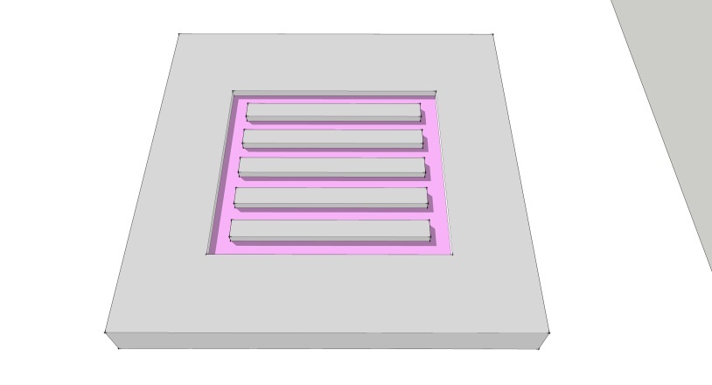
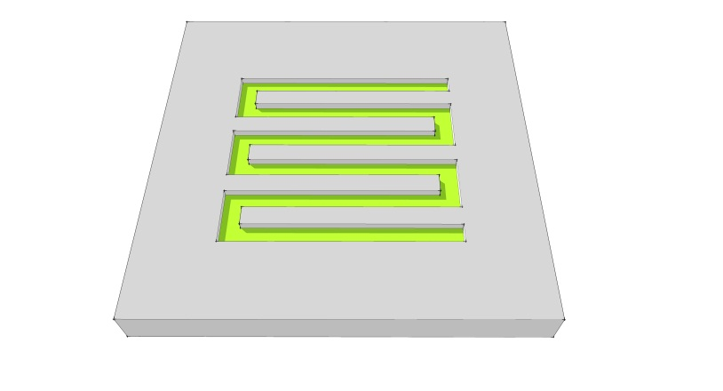
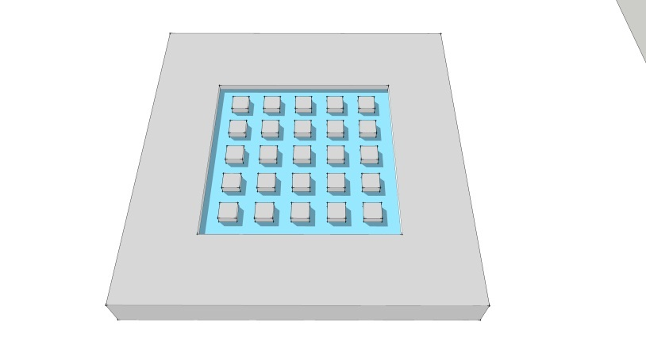
Serpentine
Pin-type
Parallel
Figure 2: Three common flow field designs

Example Problem Statement
The company you work for manufactures small fuel cell stacks. Your department is in charge of fabricating the bipolar plates and lately your boss has been thinking about using stainless steel as a material. You suggest using either hydroforming or stamping as a method to produce the bipolar plates since your company has all the equipment necessary for these processes. Hydroforming and stamping are cost effective ways to manufacture parts from sheet metal at high production rates. In hydroforming, a blank is placed on a die and either pneumatic (gas) or hydraulic (liquid) pressure is used to press the blank into the shape of the die (see Figure 3). Stamping is slightly different as there are two dies involved and a stamping force is applied to form the desired shape (see Figure 4).
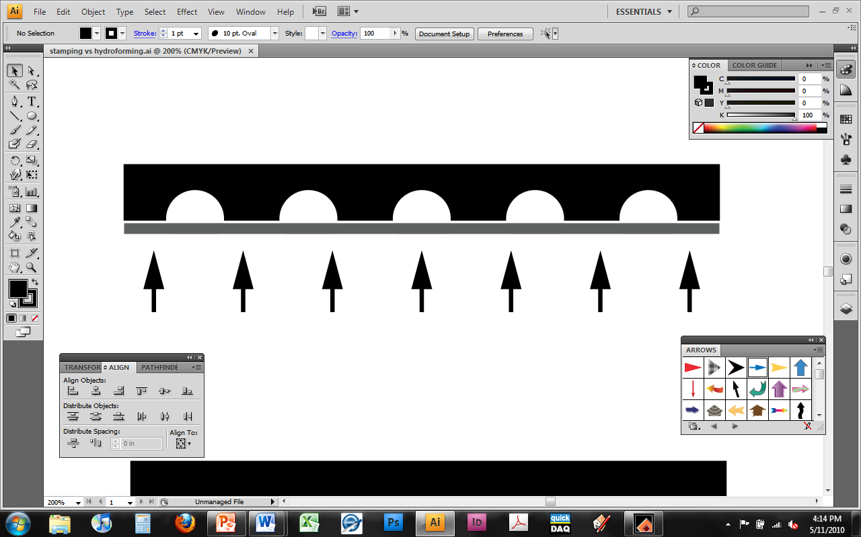
die
sheet blank
Hydraulic/pneumatic pressure
Figure 3: Hydroforming

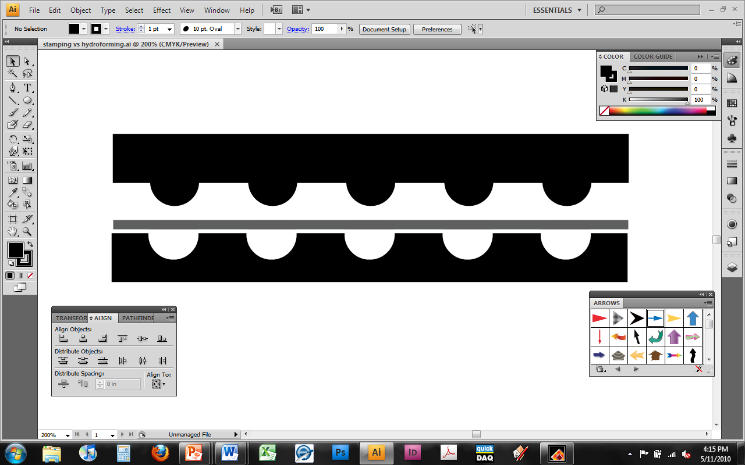
die
sheet blank
stamping force
Figure 4: Stamping
die

Your first goal is to determine a relationship between the hydroforming pressure/stamping force and the height of a channel that can be made. Since stainless steel 316 (SS316) is considered one of the best metals for bipolar plates, you use sheets that are 50 µm (0.05 mm) thick. Using a die that has 50 parallel channels 1mm deep by 0.75mm wide, you measure the average channel height for three pressure/force values and tabulate the data (Table 1).

Table 1: Force/pressure vs. channel height
Stamping force (kN) | Average channel height (mm)
100 | 0.1
200 | 0.14
300 | 0.18
hydroforming pressure (MPa) | avgerage channel height (mm)
20 | 0.11
40 | 0.17
60 | 0.23

- Plot the data in Table 1. What kind of trend/s do you observe? Describe them.
- What stamping force will be required to achieve channels of 150 µm (0.15 mm) height? What hydroforming pressure is needed for the same channel height?
- What stamping force and hydroforming pressure is needed to fully press the stainless steel sheet into the die? (meaning a channel height of 1mm)

References

[1] B. Cunningham and D. G. Baird, "The development of economical bipolar plates for fuel cells," Journal of Materials Chemistry, vol. 16, p. 4385, 2006.
[2] S. Mahabunphachai, Ö. N. Cora, and M. Koç, "Effect of manufacturing processes on formability and surface topography of proton exchange membrane fuel cell metallic bipolar plates," Journal of Power Sources, vol. 195, pp. 5269-5277, 2010.

Example Problem Solution
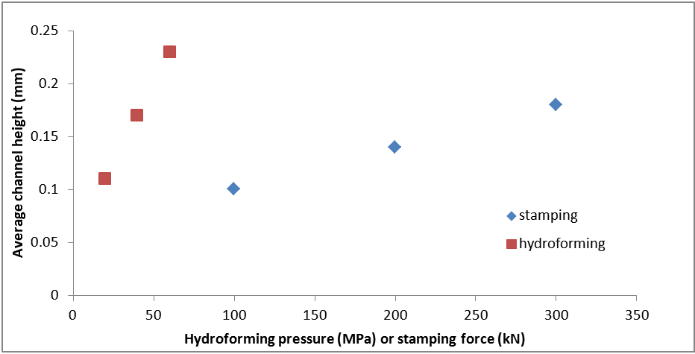
- Plot the data in Table 1. What kind of trend/s do you observe? Describe them.

Similar channel heights were formed with both processes. The biggest difference that is obvious is the slope of each data set. For example, to increase the channel height from 0.2 mm to 0.25 mm, a larger change in stamping force will be required than with the hydroforming pressure.

- What stamping force will be required to achieve channels of 150 µm (0.15 mm) height? What hydroforming pressure is needed for the same channel height?
Stamping force ~225 kN
Hydroforming ~33 MPa

- What stamping force and hydroforming pressure is needed to fully press the stainless steel sheet into the die? (meaning a channel height of 1mm)
First we must extrapolate the data (not always recommended but we can use it here as an example). Fit a trendline to the data to obtain an equation to use.
Stamping Force trendline: height = 0.0004*force + 0.06
Hydroforming trendline: height = 0.003*pressure +0.05

Solving for force/pressure when height=1mm:
Stamping force ~2350 kN
Hydroforming ~317 MPa

Home Problem Statement

Without even conducting the experiment your co-worker has a hunch that pressing the sheet metal 1mm deep into the die will rupture the channels due to thinning (or necking) of the metal.

- Does this seem like a reasonable hunch? Why or why not?
- Plot surface roughness vs. force/pressure (available in table 2 below) for both processes (plot both top and bottom on the same plot). What kind of trends do you observe? Do the roughness values increase at the same rate?
- What location (top or bottom) is generally smoother? Is this location in contact with the die?

Table 2: Surface roughness
 | surface roughness
Stamping force (kN) | Top | Bottom
100 | 0.22 | 0.16
200 | 0.27 | 0.2
300 | 0.29 | 0.23
 | surface roughness
hydroforming pressure (MPa) | Top | Bottom
20 | 0.12 | 0.09
40 | 0.23 | 0.12
60 | 0.33 | 0.14

