CACHE Modules on Energy in the Curriculum
Hydrogen as a Fuel

Module Title: GT Power Model Analysis for Different Fuels
Module Author: Dr. Jeff Naber and Neelima Borate
Author Affiliation: Michigan Technological University

Course: Internal Combustion Engines

Text Reference: J. B. Heywood, Internal Combustion Engine Fundamentals. New York: McGraw-Hill, 1988

Concepts: Stoichiometric air fuel ratio, performance curves, energy content, volumetric efficiency

Introduction:

GT- POWER is a part of GT- SUITE, which is an integrated set of Computer Aided Engineering (CAE) tool for design and analysis of engines, power trains and vehicles. It contains various applications such as engine simulation (GT- POWER), power train and vehicles simulation (GT- DRIVE), valve train components kinematics and dynamics (GT- VRAIN), fuel injection and hydraulics (GT- FUEL), engine heat management and cooling system analysis (GT- COOL) and crankshaft dynamics analysis (GT- CRANK). It can be used in conjunction with other software such as Simulink, STAR- CD, CAD, Fluent, etc. GT‐ POWER includes two powerful software domains called Integrated Simulation Environment (GT‐ ISE) that builds, executes, and manages the simulation process and a post‐processing tool (GT- POST) that provides access to all the plot data generated by the simulation.

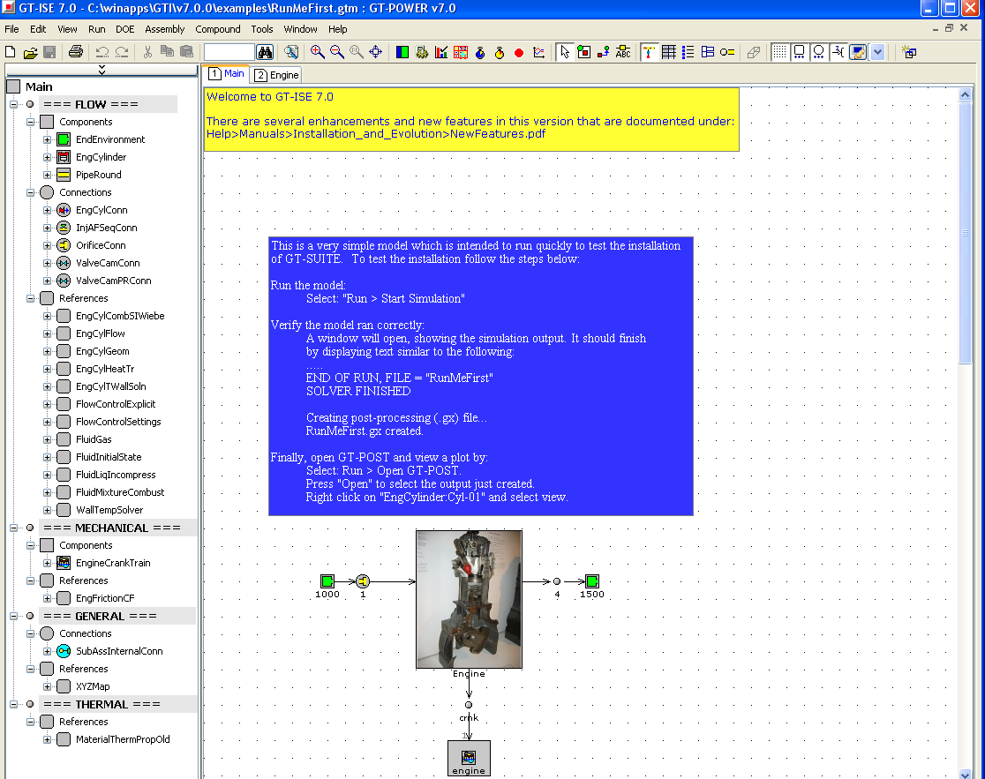
Problem Information

Run the 4-cylinder engine model to obtain WOT performance curves (power and torque) for engine speed ranging from 1500 to 6000 rpm operating on indolene, ethanol and hydrogen. Be sure to run each fuel at its stoichiometric A/F ratio and correct fuel vapor fraction.
(Note: Indolene is a standardized form of gasoline which is generally used for testing.)

Procedure

- The 4-cylinder engine model required for this assignment (“GT_power_model_module_2.gtm”) can be downloaded from link provided here into your personalized folder on the computer. Follow procedure below to setup this folder.
- Create a personalized folder labeled “GTI” (without the quotations in the name) in your H: and then download/save GT-Power module #2 (“GT_power_model_module_2.gtm”) file in this folder. Make sure the file remains a .gtm file.
- Open GT-ISE: Go to Start → All Programs → Other Apps → GTI Applications Group → GTise v7.0.0. Open the 4-cylinder model from your folder mentioned above using File → Open.
- To run the model for indolene, go to “Run” → “Case Setup” and then change the fuel-type to “indolene-combust”, set the AFratio to 14.5 (stoichiometric A/F ratio for indolene) and the vapor_fuel_frac to 0.3.
- To run the simulation preprocessor, go to “Run” → “Start Simulation Preprocessing”, or select the icon (it may take a couple minutes to load so be patient).
- If no errors occur, run the simulation, select “Run” → “Start Simulation”, or select the icon. A command window should appear and GT-Power should begin solving for flow convergence (If error occurs, make sure that the folder path created is correct as described in procedure #b).
- Once the model has run successfully and you have pressed any key to continue, the command window should disappear and the results can now be viewed with GT-POST. Select “Run” → “Open GT-POST”, or select the icon.
- When GT –POST is opened from within GT- ISE, a dialog box will be prompted in order to select a .gx file. The .gx file which automatically appears in the "File name:" field corresponds to the currently active GT-ISE model. Select GT- POST default file (GT_power_model_module_2.gx) generated in the latest simulation.
- To view all the available plots, right click on the “Four Cylinder SI Engine Example” and select “View”. Use the plot navigation arrows towards the end of the toolbar to view all the pages and the various plots. If you want to view only the plots related to engine cylinder, you can right click on “EngCylinder:Cylinder01” in the .gx file pane on the left and select “View”.
- Here we will use “Plot RLT” to obtain the desired plots. Select “Macro” → “RLT Plots” or select the icon. Then “Run RLT Macro” window will appear. Select RLT Type as “Case RLT” and Plot Type as “XY Scatter Plot”, click “Next”. In the RTL Selection menu, lower left hand portion of window, scroll down and expand “Components” then “EngineCrankTrain” then “7005”. Select the “Performance” folder and click on “Engine Speed (cycle average)” from the variable column. In Y1 column, click on the cell corresponding to Plot 1. In the “7005” folder, click on the “Torque-Power” folder and then click on “Brake Torque” from the variable column.
(Note that 7005 represents the part number in model for engine crank train)
- In order to obtain a combined plot, add “Brake Power (HP)” to Y2 column corresponding to Plot 1. Click “Finish” and then confirm assigning the brake power data to the Y2 axis by saying “Yes” when prompted.
- To run the model for ethanol, you again need to go to Case Setup in GT-Suite and change the Fuel type to “ethanol-combust”. The vapor fuel fraction remains 0.3. Set the stoichiometric A/F ratio to 9.
- Here when you go to run the simulation preprocessor by clicking “Start Simulation Preprocessing” for ethanol fuel, there will be a .dat file warning. You will be asked whether you want to overwrite the results obtained in previous simulation run. If you answer it as “Yes”, then both GT-Power (.gtm) and GT-Post file (.gx) for indolene fuel will get overwritten with the results of ethanol fuel. In this case if you want to analyze data for indolene in future, you need to run the simulation again for indolene at that time. To avoid this, you can simply rename the current file with appropriate name (e.g. “GT_power_model_module_2_ethanol.gtm” and “GT_power_model_module_2_ethanol.gx”). You can do this in the H: drive in the GTI folder that you set up earlier. If you rename each .gtm file for different fuels before simulation, each .gtm and .gx (for different fuels) will be there for further analysis until you delete it or over-write it.
- Run the Simulation and obtain the required plots in GT-POST. Repeat the same procedure for Hydrogen. The fuel type is “h2-vap”, vapor fuel fraction is 1.0 and the stoichiometric A/F ratio is 34.51.
- For changing the plot properties or adjusting the axis scales/ labels, right click on the plot and click on “plot properties”

Solution

The performance curves (power and torque) for engine speed ranging from 1500 to 6000 rpm are given below for the engine operating on indolene, methanol and hydrogen.

Indolene combustion
Ethanol combustion

Hydrogen combustion

Home Problem Statement

Obtain a combined plot of brake power vs. engine speed for the fuels indolene, hydrogen, methanol, ethanol, propane and n-butane. Compare brake power for each fuel based upon the heating values of each fuel (MJ/kg_{fuel}), stoichiometric A/F ratio of each fuel, and heat of vaporization. Why does the fuel with the lowest heating value produce the highest power?

 | Stoichiometric Air Fuel Ratio | Q_{LHV} (MJ/kg_{fuel}) | Heat of Vaporization (kJ/kg_{fuel})
Indolene | 14.5 | 44 | 350
Hydrogen | 34.51 | 120 | -
Methanol | 6.47 | 20 | 1103
Ethanol | 9.0 | 26.9 | 840
Propane | 15.69 | 46.4 | 426
n-butane | 15.47 | 45.7 | -

Also, calculate volumetric efficiency for the engine using GT-Power’s calculation of in the equation below for hydrogen fuel at 3000 rpm.

Procedure

- For obtaining a combined plot of brake power vs. engine speed for all these fuels, use the following procedure.
- When the first plot of brake power vs. engine speed for indolene is obtained, go to the ‘.gu file pane’ in lower left corner, expand “Brake Power (HP), Part 7005”, then right click on “7005:bhp” and go to “View Data”. Copy (Ctrl + C) the X and Y values that show up in the table into an Excel file. Repeat this same procedure for hydrogen, methanol, ethanol, propane, and n-butane. (Alternatively you can copy the data by right clicking on the plot, selecting “View Data” → “7005:bhp”)
- Follw the changes in “Run” → “Case Setup” for other fuels as: For methanol, the fuel type is “methanol-combust”, vapor fuel fraction is 0.3 and the stoichiometric A/F ratio is 6.47. For ethanol, the fuel type is “ethanol-combust”, vapor fuel fraction remains as 0.3 and the stoichiometric A/F ratio is 9. For propane, change the fuel-type to “propane-vap”, set the AFratio to 15.69 and the vapor_fuel_frac to 1.0 and for n-butane, change the fuel-type to “n-butane-vap”, set the AFratio to 15.47, keeping vapor_fuel_frac same as 1.0.
- When the plot of brake power vs. engine speed is obtained for n-butane, go the .gu file pane, right click on “Brake Power (HP), Part 7005” and select Add Data. Select “2-D Cartesian Data Set”, click “Next”, enter an appropriate Data name and click “finish”. In the window that shows up, paste (Ctrl + V) the X and Y values for indolene, from the Excel file, and click “OK”. Repeat this procedure to add the data for hydrogen, methanol, ethanol and propane.
- Alternatively when adding data, choose Excel as the data source, click the “Browse” button on the right end, and choose the excel file where you saved the data for indolene. Click next and choose the appropriate X and Y range.
- To view combined plot for brake power vs. engine speed for all the fuels mentioned, go to lower left .gu file pane, right click on “Brake Power (HP), Part 7005” and then click “View”.
- Use the following equation for volumetric efficiency calculation,
Where,
= air mass flow rate,
ρ_{air,inlet} = inlet air density,
V_{d} = displacement volume of an engine
N = engine speed.
- Air flow, density and total displacement of the engine required for volumetric efficiency calculation can be found as:
- Density: In GT-Post, go to “RLT Plots”. In the RLT selection menu, lower left hand portion of the window, scroll down and expand “Components” then “PipeRound” then “5002”. Select the “Pressure” folder and then select the cell for “Average Density”. Plot this against engine speed using instructions given in procedure of problem 1 above. View data at 3000 RPM to get the required value.
- Air flow: In GT-Post, go to “RLT Plots”. In the RLT selection menu, lower left hand portion of the window, scroll down and expand “Components” then “EngineCrankTrain” then “7005”. Select the “Flow” folder and then select the cell for “Air Flow”. Plot and view data for air flow against engine speed using instructions given in procedure of problem 1 above.
- Total displacement of the engine: Click on the “Tables” tab in the .gx file pane on the upper left corner, expand “Engine and Cylinder” and then “Engine Geometry (Cyl # 1)” → “View”.

