CACHE Modules on Energy in the Curriculum

Fuel Cells
Module Title: Phase Change in a Fuel Cell
Module Author: Zachary Edel and Abhijit Mukherjee
Author Affiliation: Michigan Technological University

Course: Heat Transfer

Text Reference: Incropera et al., 2007, Fundamentals of Heat and Mass Transfer, Sixth Edition.
Concepts: Energy Balance, Phase Change, Fourier’s Law

Problem Motivation:
Fuel cells are a promising alternative energy technology. One common type, called a proton exchange membrane (PEM) fuel cell, uses a catalyzed reaction of hydrogen and oxygen to produce electricity and heat. Fundamental to the design of fuel cells is their heat transfer characteristics. Specifically, heat removal is critical to their scale-up for large power applications.

Consider the schematic of a compressed hydrogen tank feeding a PEM fuel cell, as seen in Figure 1. The electricity generated by the fuel cell is used to power a laptop computer. We are interested in analyzing heat transfer within the fuel cell, which involves heat transfer coefficients, thermal conductivities, and temperatures at certain locations within the fuel cell.
H₂ tank
Fuel Cell
H₂ feed line
Computer
(Electric Load)

Anode
Gas
Chamber
Cathode
Gas
Chamber
H₂ out
Air in, Tin
Air / H₂O out, Tout

Figure 1: Schematic of Fuel Cell Operation

Problem Information

Example Problem Statement:
In large PEM fuel cells, air cooling is often times insufficient to maintain the temperature of the cell at acceptable levels and liquid cooling must be used. Consider a PEM fuel cell in an automobile that operates in ambient temperatures as low as -20ºC which is cooled by liquid water: One serpentine channel in the cooling system has a total length of 4m, a square cross-section of 5 mm by 5 mm, a wall thickness of 2 mm, a thermal conductivity of 1 W/m-K, and is exposed to a constant fuel cell bay temperature along one side of the channel. How long would it take for all of the liquid water in the channel to freeze from an initial temperature of 0ºC? You may assume the side of the channel that is exposed to the fuel cell bay is maintained at a constant -5ºC and the other sides are perfectly insulated. The density and latent heat of fusion of the water are 920 kg/m³ and 334 kJ/kg, respectively.

Example Problem Solution:

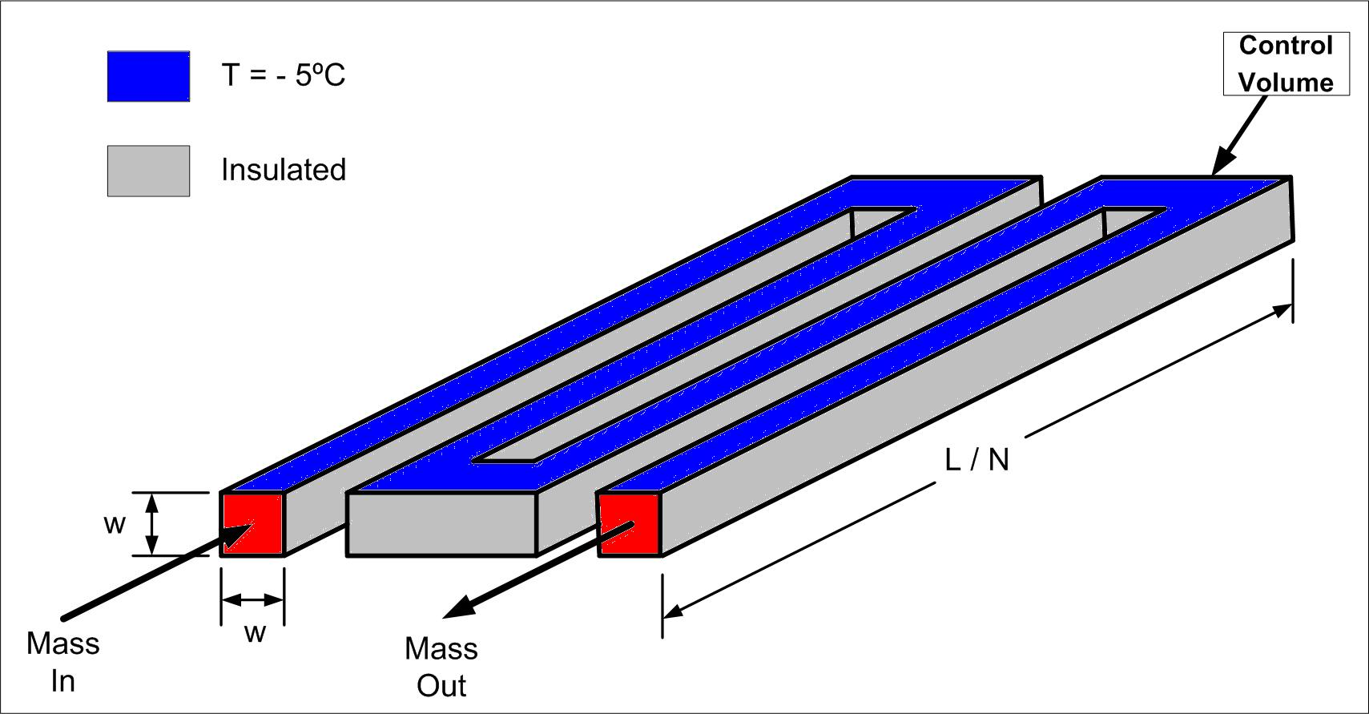

Figure 2: Schematic of Serpentine Channel

Parameters of Water:
T_{w,i} = 0ºC
T_{w,o} = -5ºC
ρ = 920 kg/m³
h_{sl} = 334 kJ/kg
Parameters of Channel:
L = 4 m
w = 5 mm
d = 2 mm
k = 1 W/m-K

Assumptions: 1-D Heat Conduction

Calculate surface area, neglecting ends of channel:

$$A=L⋅w=\left(4m\right)\left(0\text{.}\text{005}m\right)=0\text{.}\text{02}m^{2}$$

Energy Balance:

$E_{\text{in}}−E_{\text{out}}={ΔE}_{\text{sys}}$ (1)

Fourier’s Law:
$$q_{\text{out}}=−k⋅A⋅\frac{∂T}{∂x}=−k⋅A⋅\frac{T_{w,o}−T_{w,i}}{d}$$
$E_{\text{out}}=t⋅q_{\text{out}}=t⋅k⋅A⋅\frac{T_{w,i}−T_{w,o}}{d}$ (2)

Phase Change:

${ΔE}_{\text{sys}}=−m_{\text{sys}}⋅h_{\text{sl}}=−ρ⋅V⋅h_{\text{sl}}$ (3)

$${ΔE}_{\text{sys}}=−\left(\text{920}\text{kg}m^{3}\right)\left(4m\right){\left(0\text{.}\text{005}m\right)}^{2}\left(\text{334}\text{kJ}\text{kg}\right)=−\text{30}\text{.}\text{73}\text{kJ}$$

Substitute (2) and (3) into (1) and set $E_{\text{in}}=0$:
$$0−t⋅k⋅A⋅\frac{T_{w,i}−T_{w,o}}{d}={ΔE}_{\text{sys}}$$

Home Problem Statement:
In large PEM fuel cells, air cooling is often times insufficient to maintain the temperature of the cell at acceptable levels and liquid cooling must be used. Consider a PEM fuel cell in an automobile that operates in ambient temperatures as low as -20ºC which is cooled by liquid water. All of the water is drained from the cooling system when the fuel cell is shut off to avoid rupturing the cooling system when it freezes. The water is moved to a polymer storage tank that is cylindrical in shape, measures 10 cm in diameter, and holds 2 liters of water. How long would it take to melt the ice in the storage tank from an initial temperature of 0ºC if the outer surface of the tank is heated by a resistive heating tape with a resistance of 1.5 Ohms/meter that is wrapped 4 times around the tank and connected to two 12V batteries in series? You may assume that 90% of the heat generated by the heating tape goes into the tank. The density and latent heat of fusion of the water are 920 kg/m³ and 334 kJ/kg, respectively.

