CACHE Modules on Energy in the Curriculum

Fuel Cells
Module Title: Transient Conduction with Convection Cooling in Fuel Cells
Module Author: Zachary Edel and Abhijit Mukherjee
Author Affiliation: Michigan Technological University

Course: Heat Transfer

Text Reference: Incropera et al., 2007, Fundamentals of Heat and Mass Transfer, Sixth Edition.
Concepts: Lump Capacitance Method, Newton’s Law of Cooling

Problem Motivation:
Fuel cells are a promising alternative energy technology. One type of fuel cell, a proton exchange membrane fuel cell reacts hydrogen and oxygen together to produce electricity. Fundamental to the design of fuel cells is an understanding of heat transfer mechanisms within fuel cells. Heat removal from fuel cells is critical to their scaleup for large power applications.

Consider the schematic of a compressed hydrogen tank feeding a proton exchange membrane fuel cell, as seen in the figure below. The electricity generated by the fuel cell is used here to power a laptop computer. We are interested in analyzing heat transfer within the fuel cell, which involves the determination of heat transfer coefficients, thermal conductivities, and temperatures at certain locations within the fuel cell.
H₂ tank
Fuel Cell
H₂ feed line
Computer
(Electric Load)

Anode
Gas
Chamber
Cathode
Gas
Chamber
H₂ out
Air in
Air / H₂O out

Problem Information
Example Problem Statement:
The temperature of a single fuel cell is regulated by heat transfer to surrounding air at 20ºC. The fuel cell consists of a Membrane Electrode Assembly (MEA) and two gas distribution plates. Each square, graphite plate is 2 cm thick, has an active area of 50 cm², and an average thermal conductivity k = 5.7 W/m-K in the direction normal to the surface. The fuel cell operates at a steady-state temperature of 80ºC with a convective heat transfer coefficient of 7.22 W/m²-K over the active area of the plates.
- Is it possible to use the lumped capacitance method to model transient heat transfer from the fuel cell?
- After the fuel cell is shut down, how long will it take for it to reach a temperature of 50ºC? Neglect the mass of the MEA compared to the gas distribution plates and radiation heat transfer.
- Plot the temperature of the fuel cell as a function of time after shut down.

Example Problem Solution:

- Fluid: Air, T∞ = 20ºC, T_{ss} = 80ºC, h = 7.22 W/m²-K
A_{total} = 2(50 cm²) = 100 cm²
L_{c} = 0.02 m

$$∀=2\left(\text{50}{\text{cm}}^{2}\right)\left(2\text{cm}\right)=0\text{.}\text{0002}m^{3}$$

$$\text{Bi}≡\frac{h⋅L_{c}}{k}=\frac{\left(7\text{.}\text{22}Wm^{2}K\right)\left(0\text{.}\text{02}m\right)}{\left(5\text{.}7Wm⋅K\right)}=0\text{.}\text{02533}$$

Bi = 0.025 < 0.1 → Lumped Capacitance Model is Valid

- Properties of Graphite at 300K:
ρ = 2210 kg/m³
c_{p} = 709 J/kg-K

$$\frac{θ}{θ_{i}}=\frac{T−T_{∞}}{T_{i}−T_{∞}}=\text{exp}\left(\left[\frac{−h⋅A_{s}}{ρ⋅∀⋅c_{p}}\right]t\right)$$

$$t=\frac{−ρ⋅∀⋅c_{p}}{h⋅A_{s}}\text{ln}\left(\frac{T−T_{∞}}{T_{i}−T_{∞}}\right)=\frac{−\left(\text{2210}\text{kg}m^{3}\right)\left(0\text{.}\text{0002}m^{3}\right)\left(\text{709}J\text{kg}⋅K\right)}{\left(7\text{.}\text{22}Wm^{2}⋅K\right)\left(\text{100}{\text{cm}}^{2}\frac{m^{2}}{{\text{100}}^{2}{\text{cm}}^{2}}\right)}\text{ln}\left(\frac{\text{50}−\text{20}}{\text{80}−\text{20}}\right)=\text{3009}s$$

$$t≃\text{50}\text{min}$$

- Plotting in MATLAB:
%define parameters:
h = 7.22; %W/m^2-K
As = 0.01; %m^2
rho = 2210; %kg/m^3
V = 0.0002; %m^3
cp = 709; %J/kg-K
Too = 20; %deg C
Ti = 80; %deg C

t = 0:10:14400; %s
for i = 1:numel(t)
T(i) = Too + (Ti-Too)*exp(-h*As/(rho*V*cp)*t(i)); %deg C
End

t = t/3600; %hrs

plot(t,T)
title('Temperature vs Time after Shut-Down')
xlabel('Time (hrs)')
ylabel('Temperature (degC)')

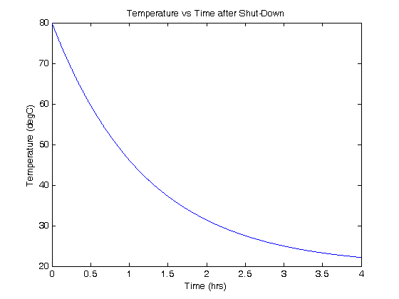

Home Problem Statement:
The temperature of a single fuel cell is regulated by heat transfer to surrounding air. The fuel cell consists of a Membrane Electrode Assembly (MEA) and two gas distribution plates. Each square, graphite plate is 2 cm thick, has an active area of 150 cm², and an average thermal conductivity k = 5.7 W/m-K in the direction normal to the surface. The fuel cell operates at a steady-state temperature of 80ºC with a convective heat transfer coefficient of 12.5 W/m²-K over the active area of the plates.
- Is it possible to use the lumped capacitance method to model transient heat transfer from the fuel cell? Neglect the mass of the MEA compared to the gas distribution plates and radiation heat transfer.
- This fuel cell turns itself on periodically when not in use to keep the water in the cell from freezing; if it shuts down for one hour at a time, what is the coldest environment in which it can be used? You may assume a 5º margin of safety is required for freezing.

