CACHE Modules on Energy in the Curriculum

Fuel Cells
Module Title: Computation of Fuel Cell Voltage Gain due to Increased Air Pressure
Module Author: Abhijit Mukherjee
Author Affiliation: Michigan Technological University

Course: Fuel Cell Technology
Text Reference: Fuel Cells Systems Explained, James Larminie and Andrew Dicks, 2nd Edition.
Concepts: Effect of fuel cell operating pressure on fuel cell performance, compressor power

Problem Motivation:
Fuel cells are a promising alternative energy technology. It is an electrochemical device that converts chemical energy directly into electrical energy. The reactants typically are gaseous hydrogen and oxygen. Raising the pressure of the reactants increases their activity and improves the reversible cell voltage. Increase in system pressure also reduces the losses at the electrodes and at low temperatures, the benefits of raising system pressure are even greater. Compressors are typically used to increase the pressure of the reactants, which consumes power and results in a parasitic load on the fuel cell. It is necessary to understand the net effect of increasing system pressure on fuel cell performance considering the power consumed by the compressor.

The voltage gain in a fuel cell due to pressure increase from P₁ to P₂ is given by:
where C is an empirical constant that depends on the type and operating temperature of the fuel cell.
The voltage loss due to running a compressor assuming air as the working fluid is given by:

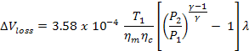
where,
T₁ is the absolute temperature of air at the compressor inlet in Kelvin
η_{m} is the mechanical efficiency of the compressor
η_{c} is the isentropic efficiency of the compressor
λ is the air stoichiometry
γ is the ratio of the specific heat capacity of air (1.4)

The net voltage gain in the fuel cell due to increase in the air pressure is given by:

Problem Information
Example Problem Statement:
Consider that we increase the operating pressure of air incoming to the fuel cell from 1 to 2.5 atmosphere by compressing it. Determine the net voltage rise or drop considering the voltage loss for running the compressor. The air enters the compressor at 25º C. The compressor thermodynamic and mechanical efficiency are given as 0.6 and 0.93 respectively. The air stoichiometry is 2. Assume a voltage constant C=0.06V

Example Problem Solution:
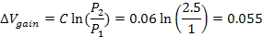
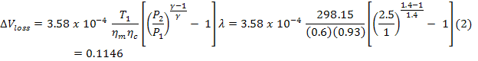

Discussion: We want the net voltage gain in the system to be positive. The compressor losses are too large in this case to be overcome by the voltage gain.

Home Problem Statement:
Consider that we increase the operating pressure of air incoming to the fuel cell from 1 to 3.0 atmosphere by compressing it. Determine the value of the voltage constant at which the net voltage gain is positive. The air enters the compressor at 25º C. The compressor thermodynamic and mechanical efficiency are 0.75 and 0.95 respectively. The air stoichiometry is 3.

