CACHE Modules on Energy in the Curriculum

Fuel Cells
Module Title: Computation of Fuel Cell Irreversibilities
Module Author: Abhijit Mukherjee
Author Affiliation: Michigan Technological University

Course: Fuel Cell Technology
Text Reference: Fuel Cells Systems Explained, James Larminie and Andrew Dicks, 2nd Edition.
Concepts: Fuel cell irreversibilities, effect of fuel cell operating temperature.

Problem Motivation:
Fuel cells are a promising alternative energy technology. It is an electrochemical device that coverts chemical energy directly into electrical energy. There are irreversibilities associated with a fuel cell that causes the operating voltage to be lower than the theoretical ‘no loss’ voltage. It is important to understand the causes of voltage drop and compute them at various load conditions in order to improve the fuel cell efficiency.

There are four major irreversibilities in a fuel cell, the activation losses, fuel crossover and internal current losses, ohmic losses and mass transport or concentration losses. If E is the reversible open circuit voltage (OCV) of a fuel cell, then the operating voltage V at any current density i, can be written as

V = E - ΔV_{ohmic} – ΔV_{activation} – ΔV_{transport}

or
In the above equation,

i_{n} is the internal and fuel crossover equivalent current density (mA/cm²)

A is a constant that depends on the rate of the electrochemical reaction (V)

i₀ is the exchange current density (mA/cm²)

m and n are constants that determines the mass transport overvoltage (V; cm²/mA)

r is the area-specific resistance (kΩ-cm²)

Problem Information
Example Problem Statement:

Consider a Ballard Mark V Proton Exchange Membrane Fuel Cell operating at 70⁰C with the following constants:

E_{oc} (V) | 1.031
r (kΩ cm²) | 2.45x10⁻⁴
A (V) | 0.03
m (V) | 2.11x10⁻⁵
n (cm² mA⁻¹) | 8x10⁻³
i_{o} (mA cm⁻²) | 0.1

  - Calculate the operating fuel cell voltage considering each individual overvoltage separately.
  - Calculate the net operating fuel cell voltage.

For each case, draw a graph of the fuel cell voltage V against the current density i (1 to 1000 mA/cm²).

Take i_{n} = 3 mA/cm²

Example Problem Solution:
Using the constants specified above, the PEM fuel cell voltage considering each loss individually and the net fuel cell voltage is calculated as follows.
i (mA cm⁻²)
V ohmic loss only | V activation loss only | V mass transport loss only | V
1.00E+00 | 1.03E+00 | 9.20E-01 | 1.03E+00 | 9.20E-01
100 | 1.01E+00 | 8.23E-01 | 1.03E+00 | 7.98E-01
200 | 9.82E-01 | 8.03E-01 | 1.03E+00 | 7.53E-01
300 | 9.58E-01 | 7.91E-01 | 1.03E+00 | 7.17E-01
400 | 9.33E-01 | 7.82E-01 | 1.03E+00 | 6.83E-01
500 | 9.09E-01 | 7.75E-01 | 1.03E+00 | 6.52E-01
600 | 8.84E-01 | 7.70E-01 | 1.03E+00 | 6.20E-01
700 | 8.60E-01 | 7.65E-01 | 1.03E+00 | 5.88E-01
800 | 8.35E-01 | 7.61E-01 | 1.02E+00 | 5.53E-01
900 | 8.11E-01 | 7.58E-01 | 1.00E+00 | 5.09E-01
1000 | 7.86E-01 | 7.55E-01 | 9.68E-01 | 4.47E-01

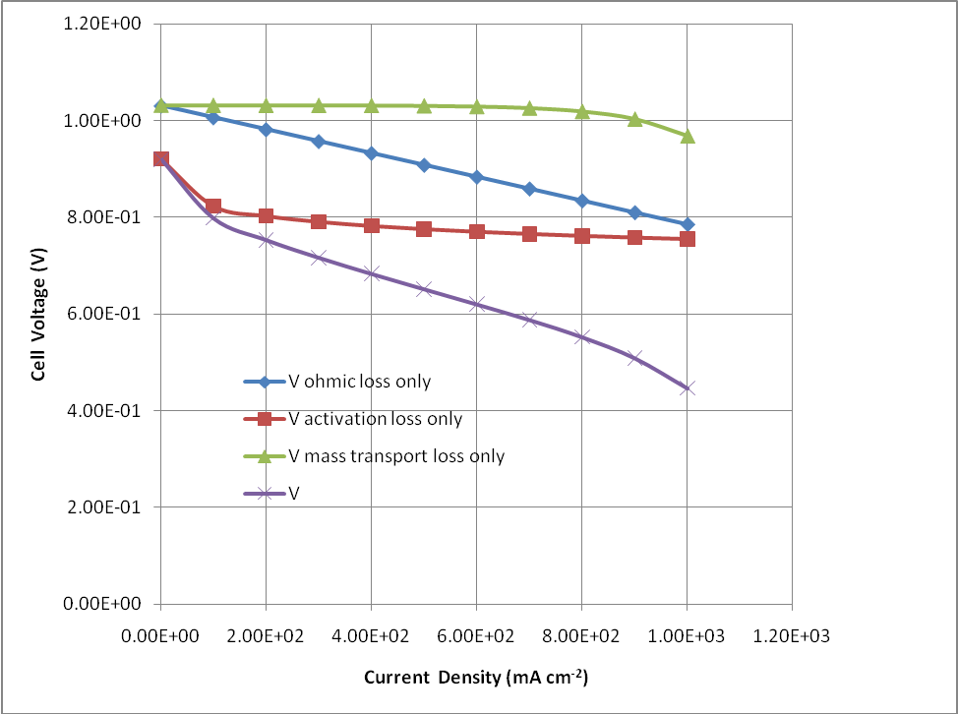

Discussion: The activation losses are the most important losses in a PEMFC. This is caused by the slowness of the electrochemical reactions. There is a steep drop in the cell voltage at the start, and then the graph becomes linear with the ohmic losses becoming relatively important only at higher current densities. The mass transport losses contribute a very little to the net voltage drop below about 800 mA/cm².

Home Problem Statement:

Consider a high temperature Solid Oxide Fuel Cell operating at 800⁰C with the following constants:

E_{oc} (V) | 1.01
r (kΩ cm²) | 2.0x10⁻⁴
A (V) | 0.002
m (V) | 1.0x10⁻⁴
n (cm² mA⁻¹) | 8x10⁻³
i_{o} (mA cm⁻²) | 1.0

- Calculate the operating fuel cell voltage considering each individual overvoltage separately.
- Calculate the net operating fuel cell voltage.

For each case, draw a graph of the fuel cell voltage V against the current density i (1 to 1000 mA/cm²).

Take i_{n} = 3 mA/cm²

