CACHE Modules on Energy in the Curriculum

Fuel Cells
Module Title: Internal Multiphase Flow in a Fuel Cell
Module Author: Zachary Edel and Abhijit Mukherjee
Author Affiliation: Michigan Technological University

Course: Fluid Mechanics

Text Reference: Frank M. White, 2003, Fluid Mechanics, Fifth Edition.
Concepts: Control Volume Analysis, Conservation of Mass, Conservation of Species

Problem Motivation:
Fuel cells are a promising alternative energy technology. One common type, called a proton exchange membrane (PEM) fuel cell, uses a catalyzed reaction of hydrogen and oxygen to produce electricity and heat. Fundamental to the design of fuel cells is their heat transfer characteristics. Specifically, heat removal is critical to their scale-up for large power applications.

Consider the schematic of a compressed hydrogen tank feeding a PEM fuel cell, as seen in Figure 1. The electricity generated by the fuel cell is used to power a laptop computer. We are interested in analyzing multiphase flow in the channels of the bipolar plate.

H₂ tank
Fuel Cell
H₂ feed line
Computer
(Electric Load)

Anode
Gas
Chamber
Cathode
Gas
Chamber
H₂ out
Air in, T_{in}
Air / H₂O out, T_{out}

Figure 1: Schematic of Fuel Cell Operation

Problem Information
Example Problem Statement:
The rate of water production in a particular 1 kW fuel cell is 1.5x10⁻⁴ kg/s at peak operation. The water is removed from the Gas Diffusion Layers (GDL) as it is produced, by air flowing through 30 serpentine channels of 7 mm by 7 mm cross-section and 4 m total length each. The fuel cell operates at a nominal temperature of 50ºC and a fluid outlet pressure of 1 atm.
- What is the required air mass flow rate so that the lengths of the water slugs that are formed are the same lengths as the air slugs that separate them?
- At what velocity are the liquid slugs travelling when they exit the channels?

Example Problem Solution:
Parameters of Water at 50ºC, 1 atm:
ρ_{w} = 988 kg/m³
μ_{w} = 0.548E-3 N-s/m²
Parameters of Air at 50ºC, 1 atm:
ρ_{a} = 1.09 kg/m³
μ_{a} = 1.95E-5 N-s/m²
Parameters of Channels:
L = 4 m
w = 7 mm
N = 30 channels

Control Volume on a Single Channel:
Figure 2: Stretched-Out Schematic of Serpentine Channel

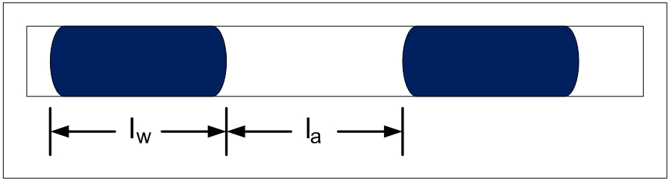

Figure 3: Air and Water Slugs in Channel

Volume of air slug:
Volume of water slug:

Since the air slugs and water slugs travel at the same velocity, their volumetric flow rates are equal:

Since the water is not continuously exiting the channels, the volume fraction of the air slugs will affect the slug velocity. To determine the velocity of the slugs, consider the total volumetric flow rate:

Home Problem Statement:
The rate of water production in a particular 1 kW fuel cell is 1.5x10⁻⁴ kg/s at peak operation. The water is removed from the Gas Diffusion Layers (GDL) as it is produced, by air flowing through 30 serpentine channels of 5 mm by 5 mm cross-section and 4 m total length each. The fuel cell operates at a nominal temperature of 50ºC and a fluid outlet pressure of 1 atm.
- If the air mass flow rate is twice the water mass flow rate, what are the lengths of the water slugs with respect to the lengths of the air slugs that separate them?
- At what velocity are the liquid slugs travelling when they exit the channels?
- Assuming the water production remains constant, at what air mass flow rate will the air slugs transition to turbulence? (Hint: consider total volumetric flow rate)

Parameters of Water at 50ºC, 1 atm:
ρ_{w} = 988 kg/m³
μ_{w} = 0.548E-3 N-s/m²
Parameters of Air at 50ºC, 1 atm:
ρ_{a} = 1.09 kg/m³
μ_{a} = 1.95E-5 N-s/m²
Parameters of Channels:
L = 4 m
w = 5 mm
N = 30 channels

