CACHE Modules on Energy in the Curriculum

Fuel Cells
Module Title: Pressure Losses during Internal Flow in a Fuel Cell
Module Author: Zachary Edel and Abhijit Mukherjee
Author Affiliation: Michigan Technological University

Course: Fluid Mechanics

Text Reference: Frank M. White, 2003, Fluid Mechanics, Fifth Edition.
Concepts: Viscous flow in non-circular ducts, friction loss, minor losses

Problem Motivation:
Fuel cells are a promising alternative energy technology. One common type, called a proton exchange membrane (PEM) fuel cell, uses a catalyzed reaction of hydrogen and oxygen to produce electricity and heat. Fundamental to the design of fuel cells is their heat transfer characteristics. Specifically, heat removal is critical to their scale-up for large power applications.

Consider the schematic of a compressed hydrogen tank feeding a PEM fuel cell, as seen in Figure 1. The electricity generated by the fuel cell is used to power a laptop computer. We are interested in analyzing heat transfer within the fuel cell, which involves heat transfer coefficients, thermal conductivities, and temperatures at certain locations within the fuel cell.
H₂ tank
Fuel Cell
H₂ feed line
Computer
(Electric Load)

Anode
Gas
Chamber
Cathode
Gas
Chamber
H₂ out
Air in, T_{in}
Air / H₂O out, T_{out}

Figure 1: Schematic of Fuel Cell Operation

Problem Information
Example Problem Statement:
The water that is produced in a particular fuel cell is removed from the Gas Diffusion Layer (GDL) by air flowing at 3.5 m/s through a serpentine channel of 5 mm by 5 mm rectangular cross-section and 4 m total length. There are 20 regular 180º elbows in the serpentine pattern. Assuming the flow is fully developed over the entire channel and that the Resistance Coefficient for each 180º elbow is 3.0, what is the minimum pressure drop across the serpentine channel? (Hint: the minimum pressure drop would occur when there was no water production). The fuel cell operates at a nominal temperature of 50ºC and a fluid outlet pressure of 1 atm. Comment on your findings.

Example Problem Solution:
Parameters of Air at 50ºC, 1 atm:
Density of air: ρ_{a} = 1.09 kg/m³
Viscosity of air: μ_{a} = 1.95E-5 N-s/m²
Parameters of Channel:
Channel Length: L = 4 m
Width of channel: a = 5 mm
Height of channel: b = 5 mm
Number of elbows: N = 20
Resistance Coefficient: K = 3.0

Control Volume on Serpentine Channel:

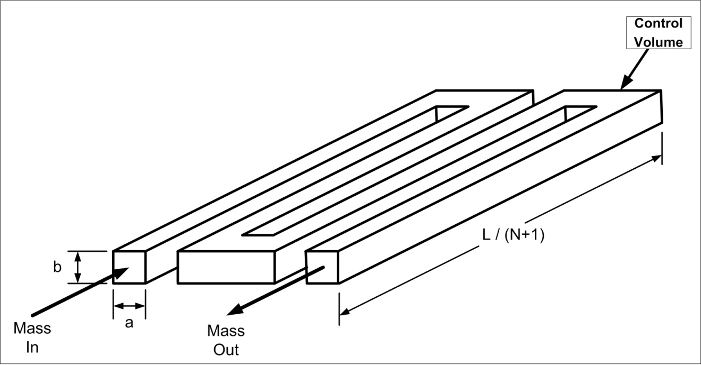

Figure 2: Schematic of Serpentine Channel

Calculate the Reynolds number to determine if the flow is turbulent or laminar:
The hydraulic diameter is defined as :

Reynolds number is defined as :

= 978 < Re_{crit} = 2300 → flow is Laminar

The total head loss due to wall friction and minor losses can be expressed as:

Where: f = Darcy friction factor = fcn(, ε/d, duct shape)
∑K = Sum of Resistance Coefficients for bends

The Darcy friction factor for non-circular cross sections is tabulated on page 383 of the text book for rectangular and isosceles triangle shapes:

b/a
0.0 | 96.00
0.05 | 89.91
0.1 | 84.68
0.125 | 82.34
0.167 | 78.81
0.25 | 72.93
0.4 | 65.47
0.5 | 62.19
0.75 | 57.89
1.0 | 56.91

The effective diameter of the channel is then

All parameters have now been determined to calculate the overall pressure head:

Pressure drop can be calculated using the definition of pressure head:

This is less than 1% of one atmosphere and would not require excessive power consumption in the fan, even for a fuel cell stack with many of these channels.

Home Problem Statement:
The water that is produced in a particular fuel cell is removed from the Gas Diffusion Layer (GDL) by air flowing at 0.2 m/s through a serpentine channel of 3 mm by 6 mm rectangular cross-section and 4 m total length. There are 14 regular 180º elbows in the serpentine pattern. You may assume the flow is fully developed over the entire channel length and the Resistance Coefficient for each 180º elbow is 3.0. The fuel cell operates at a nominal temperature of 50ºC and a fluid outlet pressure of 1 atm.
- If the entire channel became flooded and the same air flow rate was used to clear it, what would be the maximum pressure drop within the channel? Comment on your findings.
- If the channel configuration was changed to 15 parallel channels occupying the same area of the plate [i.e. l_{ch}=L/(N+1)] and connected using common inlet and outlet plenums, how many times would the required flow rate have to increase to maintain the same average velocity and what would be the corresponding maximum pressure drop for a flooded channel? Compare your answer to the result of (A). You may assume that the channel inlets are sudden contractions and the channel outlets are sudden expansions (i.e. sharp corners, not rounded) and that the spacing between channels is the same dimension as the channel widths. The Resistance Coefficients for Sudden Contractions and Sudden Expansions are given by:

,

