CACHE Modules on Energy in the Curriculum

Fuel Cells
Module Title: Fatigue and Failure of Thin Membrane Electrode Assembly in PEMFC
Module Author: Nate Kroodsma and Dennis Desheng Meng
Author Affiliation: Michigan Technological University

Course: Failure of Materials in Mechanics

Text Reference: Brooks et al., 2001, Failure Analysis of Engineering Materials
Concepts: fatigue from thermal swelling and contracting leading to micro-cracks

Problem Motivation:
A fuel cell is, in theory, a very simple electrochemical conversion device. Unlike a battery, which is an electrochemical storage device, a fuel cell does not directly store energy but rather converts energy from a fuel supply into usable electricity. Fuel cells have many advantages over batteries such as:
- High energy density
- Continuous operation as long as there is a constant supply of fuel (does not need to be recharged like a battery)
- High conversion efficiencies in excess of 60%
- Zero carbon dioxide emissions makes it environmentally friendly

Just like there are various kinds of automobile engines (gasoline, diesel, natural gas, etc.) and various kinds of batteries (lithium-ion, NiCd, NiMh, lead, etc.), there are various kinds of fuel cells, each one having certain advantages/disadvantages for niche applications. One such kind of fuel cell is called a Proton Exchange Membrane Fuel Cell (PEMFC). Its operation is schematically illustrated in Figure 1.

A PEMFC consists of three main layers: anode, electrolyte, and cathode. Each layer is constructed of a different material and when assembled, the three layers form a single cell that is only several millimeters thick. Typically, the output voltage achieved by a single cell, as pictured, is ~1 volt. To generate a higher voltage system, many single cells are “stacked” together and wired in series to form a fuel cell stack.

Let’s look at each layer in detail:

Anode
A PEMFC is often called a hydrogen fuel cell for the reason that hydrogen gas is the fuel that a PEMFC runs on. Pure hydrogen gas is introduced at the anode where it is oxidized (electrons are “stripped” from the hydrogen) by a platinum catalyst. The half-cell reaction describes this oxidation.

$2H_{2}→4H^{+}+4e^{−}$ (Eq 1)

For each hydrogen molecule, two protons H⁺ and two electrons e⁻ are produced. We will discuss the electrons later, but for now, let’s look at the protons.
e⁻
H₂O
O₂
H₂
e⁻
e⁻
anode
electrolyte
cathode
fuel in
air in
electric current
excess fuel
unused air and water out
H⁺
H⁺
H⁺
Figure 1: Schematic of PEMFC operating principles

Electrolyte
The electrolyte used in PEMFCs is a proton “carrier” and it is a very thin sheet of polymer that is less than 100µm thick. Another acronym for a PEMFC is Polymer Electrolyte Membrane Fuel Cell. This electrolyte is essential to the correct operation of the fuel cell as it must conduct the protons that are generated at the anode. The electrolyte material of choice is called Nafion®. The polymer electrolyte is actually fabricated into a layered assembly called the membrane electrode assembly, or MEA.

Cathode
At the cathode side of the fuel cell, oxygen gas is reduced and combined with electrons and protons (initially from the anode) to form water
$O_{2}+4H^{+}+4e^{−}→2H_{2}O$ (Eq 2)
In summary, the protons transport through the electrolyte, and the electrons move through the external circuit to recombine with oxygen at the cathode. Therefore, the overall reaction is the sum of Eq 1 and Eq 2
$2H_{2}+O_{2}→2H_{2}O$ (Eq 3)

The most common source of oxygen gas is atmospheric air, however, purified oxygen can also be used. Any un-reduced oxygen gas at the cathode is either exhausted back into the air or in the case of purified oxygen, recirculated back into the inlet. The electrons that were separated from the fuel at the anode travel through an external circuit to get to the cathode. Of course, charge (electrons) flowing through a circuit is the definition of electricity. So the principle of converting fuel into electricity inside a PEMFC is quite simple in theory, but can become quite complex when putting it into practice.

Problem Background:
Proton exchange membrane fuel cells are best suited for mid-sized applications such as transportation. PEMFCs are under consideration to be the future replacement of internal combustion engines in automobiles. Automobiles undergo some of the harshest environments and demanding loads of any mechanical system, and therefore fuel cells placed in these applications must live up to a high standard of robustness and durability. For example, automobiles should have a minimum lifetime of 10 years and 5500 hours of operation to be successful [1, 2]. On top of that, vehicles need to be operable in sub-freezing weather, hot and humid weather, in stop-and-go traffic, extended road trips, under heavy loads, under heavy acceleration, etc.
In this study we will look at the durability of the electrolyte. As we have already mentioned, the MEA is essential for the transport of protons. It is also responsible for keeping the gas at the anode (hydrogen) separated from the gases at the cathode (air, oxygen). If the thin electrolyte fails to do either of those things, the performance of the fuel cell will be significantly impaired and may render the fuel cell inoperable.
An electrolyte is able to conduct protons only when it is hydrated—a fuel cell will not work if the electrolyte is dry. This presents a challenging problem because of the high variability of air conditions at the cathode. Dry air, humid air, cold air, or hot air all present new challenges to keep the membrane in the right condition. Additionally, most PEMFCs are designed to operate at a stable 80°C. It is noted that electrolytes experience a volumetric expansion, or swelling, during an increase in temperature and absorption of water. To make things even worse, the electrolyte does not shrink back to its initial size or shape when drying, but can shrink to 10% smaller than the original area (area at time of fabrication). This creates compressive stresses when swelling, and tensile stresses when drying out.
For simplicity, we can assume that the average vehicle is driven three times a day—driving to work in the morning, going to lunch at noon, and driving back home in the evening. Each one of these trips will cause the membrane to heat up and swell during operation, and then cool down, dry out, and shrink after the vehicle is parked. A common mode of failure for electrolytes is micro-crack propagation, which we will study in this module.

Problem Statement
Let’s pretend several membranes were acquired from a popular MEA manufacturer. These membrane electrode assemblies were tested in an ex situ laboratory setting (meaning the MEAs were tested out of the fuel cell) at room temperature (25°C) and 25% relative humidity (RH). Each membrane was subjected to a controlled cyclic loading in a universal testing machine. For each load (from 1 MPa to 8 MPa) the measured strain was plotted as a function of cycles, Figure 2. It can be seen that for this membrane significant shape deformation occurs above a cyclic load of 1 MPa. In other words, cyclic stress above 1 MPa will lead to a stretching of the membrane, which will eventually lead to micro crack propagation.

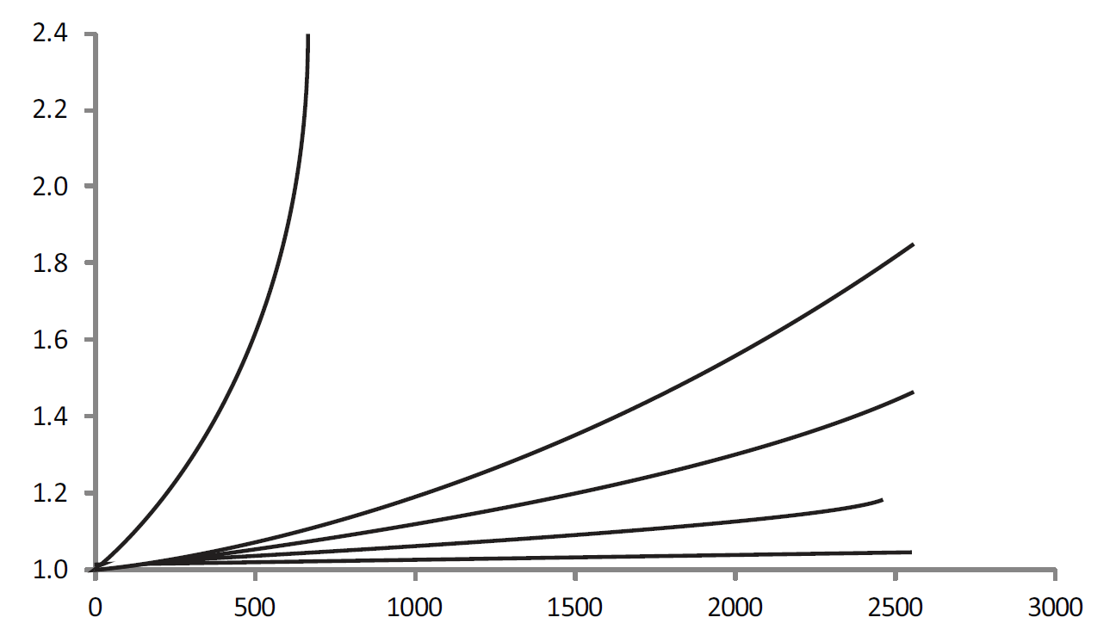
Cycles
Strain (mm/mm)
8 MPa
6 MPa
4 MPa
2 MPa
1 MPa
Figure 2: Strain as a function of cycles for 5 load settings

As already mentioned, stresses induced in the membrane can come from temperature changes, swelling and contracting from hydration, or a combination of the two. Compared to hydration induced stresses, temperature induced stresses can be considered negligible. The data in Figure 3 shows a hypothetical relationship between the shrinkage stress and change in RH (adapted from [2]). The shrinkage stress is a result of the membrane shrinking after it has dried out. In Figure 3, three different membranes were initially put in an environmental chamber at 25°C at a specific RH. Three values of RH were tested: 40%, 60%, and 100%. Then the hydrated membrane was allowed to dry naturally to an RH of 25%.

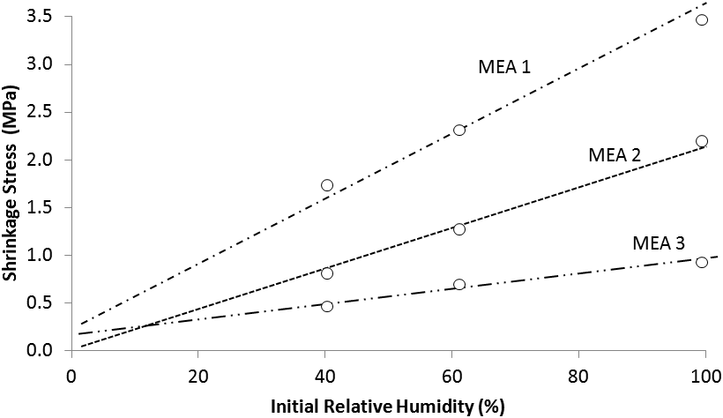
Figure 3: Shrinkage stress as a function of RH for 3 MEAs at 40%RH, 60%RH, and 100%RH

Example Problem Statement

- What kind of failure mechanism is likely to explain the expansion in Figure 2?
- Which of the three MEAs (MEA1, MEA2, MEA3 from Fig 3) is robust enough to withstand at least 2500 cycles in Fig 2? Why?
- Estimate the number of RH cycles a typical fuel cell automobile would experience per year. How about for a 10 year period?
- From this data, do you think commercial MEAs are mechanically stable enough for automotive applications? Why or why not?
- Why are pinhole cracks destructive for proper fuel cell operation?
- Come up with at least two creative solutions for preventing mechanical degradation.

Example Problem Solution

- What kind of failure mechanism is likely to explain the expansion in Figure 2?

The membranes stretch from cyclic loading. This is called creep.

- Which of the three MEAs (MEA1, MEA2, MEA3 from Fig 3) is robust enough to withstand at least 2500 cycles in Fig 2? Why?
MEA 3 because even at 100% RH the shrinkage stress is below 1MPa. From Figure 2 it can be seen that cyclic stress below 1MPa is safe for the MEA. Anything above that will start to introduce creep.

- Estimate the number of RH cycles a typical fuel cell automobile would experience per year. How about for a 10 year period?

At 3 cycles a day for 5 days a week and 52 weeks/year yields 780 cycles/year. Over a 10 year period that is 7800 cycles.

- From this data, do you think commercial MEAs are mechanically stable enough for automotive applications? Why or why not?

The data above was only tested for ~2500 cycles which is less than half of the 7800 cycles that a car might experience in a 10 year period. Commercial MEAs may be robust enough, but it looks as if more testing is needed both in the lab and on the road in real vehicles.

- Why are pinhole cracks destructive for proper fuel cell operation?

Pinhole cracks will open up the possibility for hydrogen gas to migrate from the anode to the cathode. If the cracks are large enough, oxygen gas may also transport to the anode. In either case, the gases are no longer separated and the fuel cell may become inoperable.

- Come up with at least two creative solutions for preventing mechanical degradation.

Sample answers:
- Keep the membranes hydrated after the fuel cell has shut down. This will prevent the shrinkage stress induced after the membrane has dried out.
- Have a flexible architecture that flexes and shrinks with the membrane. When the membrane dries out and shrinks, the structure (bipolar plates in this case) shrinks with the membrane. Therefore the shrinkage stress is reduced or eliminated.

References

[1] X. Huang, R. Solasi, Y. Zou, M. Feshler, K. Reifsnider, D. Condit, S. Burlatsky, and T. Madden, "Mechanical endurance of polymer electrolyte membrane and PEM fuel cell durability," Journal of Polymer Science Part B: Polymer Physics, vol. 44, pp. 2346-2357, 2006.
[2] H. Tang, S. Peikang, S. P. Jiang, F. Wang, and M. Pan, "A degradation study of Nafion proton exchange membrane of PEM fuel cells," Journal of Power Sources, vol. 170, pp. 85-92, 2007.

Home Problem Statement

After reviewing the data above and realizing that the MEAs provided by that particular manufacturer are not suitable for automotive applications, you consult another popular MEA manufacturer. They provide you with three different MEAs, along with a similar set of data as the first manufacturer (see Table 1 and Figure 4)

Table 1: RH vs Stress for 3 MEAs
RH % | Stress (MPa)
 | MEA 1 | MEA 2 | MEA 3
40 | 1.1 | 0.5 | 0.33
60 | 1.7 | 1.1 | 0.5
80 | 2.2 | 1.5 | 0.7
100 | 2.9 | 1.9 | 0.95

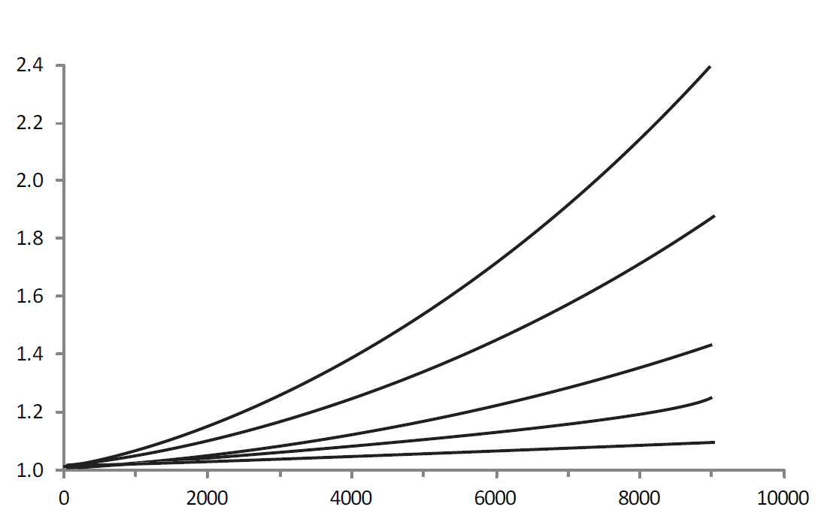
Cycles
Strain (mm/mm)
10 MPa
8 MPa
6 MPa
4 MPa
2 MPa
Figure 4: Strain vs. cycles from second manufacturer

- Plot the data in Table 1. How do these MEAs compare to those provided by the first manufacturer?
- From Figure 4, what is the maximum load the MEAs can be cycled through before significant creep occurs? At that load, how many cycles can the MEA withstand?
- Using the maximum load found in 2) and the plot in 1), determine which MEA (or MEAs) is stable enough to be used in an automotive application. Remember, micro crack propagation is likely if significant cyclic stresses are present.

