CACHE Modules on Energy in the Curriculum

Fuel Cells
Module Title: Structural Analysis of Thin Film Oxide Electrolyte in SOFCs
Module Author: Nate Kroodsma and Dennis Desheng Meng
Author Affiliation: Michigan Technological University

Course: Failure of Materials in Mechanics

Text Reference: A. C. Ugural, Stresses in Beams, Plates, and Shells, 3rd ed. Boca Raton: CRC Press, 2009.

Concepts: Failure (in tension or buckling) of thin film membrane, thermal expansion, engineer membrane to meet design specs

Problem Motivation:
A fuel cell is, in theory, a very simple electrochemical conversion device. Unlike a battery, which is an electrochemical storage device, a fuel cell does not directly store energy but rather converts energy from a fuel supply into usable electricity. Fuel cells have many advantages over batteries such as:
- High energy density
- Continuous operation as long as there is a constant supply of fuel (does not need to be recharged like a battery)
- High conversion efficiencies in excess of 60%
- Zero carbon dioxide emissions makes it environmentally friendly

Just like there are various kinds of automobile engines (gasoline, diesel, natural gas, etc.) and various kinds of batteries (lithium-ion, NiCd, NiMh, lead, etc.), there are various kinds of fuel cells, each one having certain advantages/disadvantages for niche applications. One such kind of fuel cell is called a Solid Oxide Fuel Cell (SOFC). Its operation is schematically illustrated in Figure 1.

An SOFC consists of three main layers: anode, electrolyte, and cathode. Each layer is constructed of a ceramic material and when assembled, the three layers form a single cell that is only several millimeters thick. Typically, the output voltage achieved by a single cell, as pictured, is ~1 V. To generate a higher voltage system, many single cells are “stacked” together and wired in series to form a fuel cell stack.

Cathode
At the cathode side of the fuel cell, oxygen gas is reduced into an oxygen ion by the addition of electrons according to the reaction equation:
$O_{2}+4e^{−}→2O^{−2}$ (Eq 1)
The most common source of oxygen gas is atmospheric air, however, purified oxygen can also be used. Any un-reduced oxygen gas at the cathode is either exhausted back into the air or in the case of purified oxygen, recirculated back into the inlet.

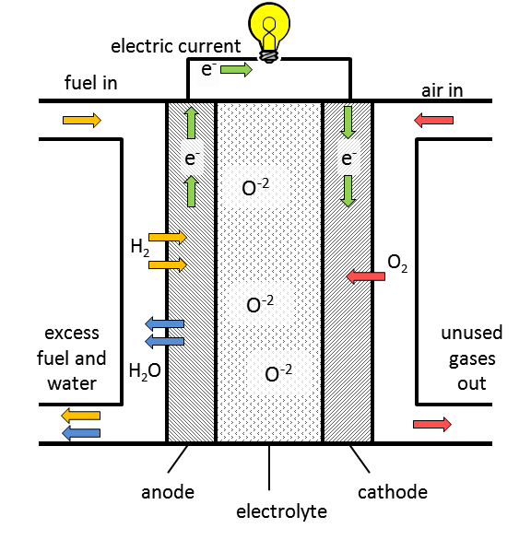
Figure 1: Schematic of SOFC operating principles

Electrolyte
After the oxygen ions are produced at the cathode, they transport through the ceramic electrolyte towards the positively charged anode. It is important that the electrolyte be conductive to oxygen ions, but not electrically conductive. The material of choice for the oxide electrolyte is yttria-stabilized zirconia (YSZ), a dense ceramic which contains cubic zirconia (artificial diamond).

Anode
Once the oxygen ions reach the anode they oxidize the fuel (hydrogen gas) to produce electrons, heat, and water,
$2H_{2}+2O^{−2}→2H_{2}O+4e^{−}+\text{heat}$ (Eq 2)

These electrons that are separated from the fuel then travel through an external circuit back to the cathode, where they are used to reduce oxygen and begin the process again. Of course, charge (electrons) flowing through a circuit is the definition of electricity. So the principle of converting fuel into electricity inside an SOFC is quite simple in theory, but can become quite complex when putting it into practice.

The combination of the cathode and anode equations gives the overall reaction:

(Eq 3)

Problem Background:
Solid oxide fuel cell stacks are best suited for large scale power generation and they can be manufactured to generate electricity in the range of 2kW-10MW. For this study, however, we will consider SOFC’s manufactured by conventional micro-manufacturing processes. In today’s generation, Micro-ElectroMechanical Systems (MEMS) devices are inescapable (FYI, one millimeter = 1000 micrometers). Whether you know it or not, most people use MEMS devices many times a day, from small accelerometers in automobile airbag deployment systems, to integrated circuits in electronic devices such as laptops, cell phones, and radios. As we see the sizes of these devices (laptops, cell phones, etc.) continue to shrink, the energy density of the power supply used to run these devices must increase. Smaller package size means higher energy per unit volume. The preferred power supply for electronic devices is currently the battery. As mentioned above, fuel cells exhibit a higher energy density than batteries and therefore fuel cells are seen as a promising replacement for the battery in the near future, especially for portable electronics and MEMS devices.
When we consider the design considerations for manufacturing SOFC’s on the micro scale, several things must be evaluated, two of which we will look at in this study:
- Typical MEMS fabrication processes involve deposition, or layering, of thin films of oxides, metals, or polymers. This is often done at elevated temperatures or in a vacuum, or a combination of the two. As the layering is completed and the thin films are cooled down to room temperature, a mismatch in thermal expansion coefficients between the layers will produce an intrinsic residual stress (σ_{res}).
- SOFC’s operate in a temperate range of 500-1000°C. Often SOFC’s run continuously because of the demanding start-up procedures to reach the high operating temperatures. This high operating temperature puts another burden on the structural integrity of the thin films. Because of the mismatch between thermal expansion coefficients, a large thermal stress (σ_{th}) may develop at elevated temperatures.
One of the beauties of micro-manufacturing methods is the flexibility and fine-tuning of processing conditions. The intrinsic stress (σ_{res}) mentioned above can be considered a design parameter if the process conditions during the layering process are carefully controlled to produce the desired results [1].

Let us consider a MEMS fabricated solid oxide fuel cell that is circular in shape and built on a plate of silicon (in the MEMS industry they call these plates “wafers” or “substrates”). On the surface of the silicon wafer are three layers of oxide: the anode, electrolyte, and cathode (see Fig 2). The electrolyte is typically much thicker and denser than the anode or cathode thickness, so we shall only examine the failure mechanisms of the electrolyte.

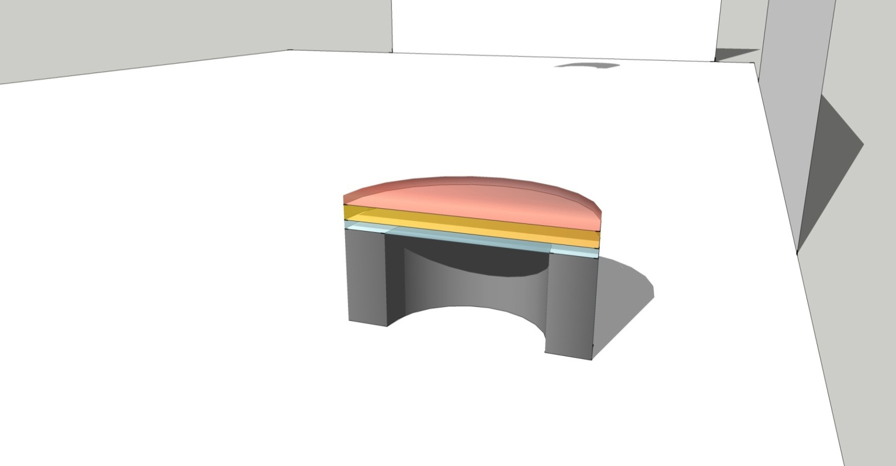
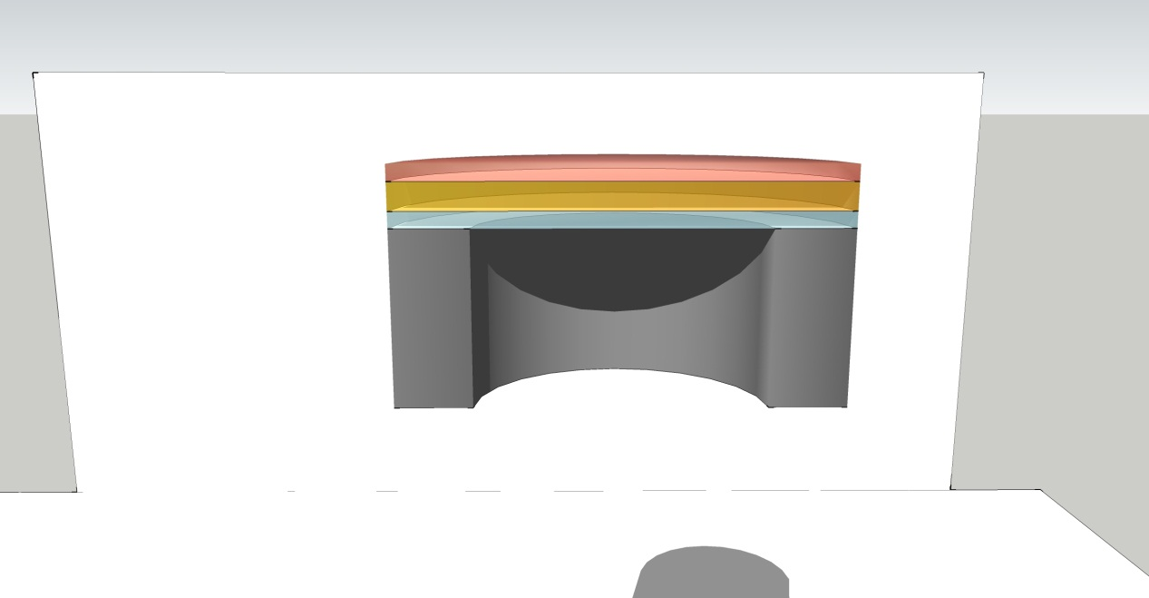
cathode
electrolyte
anode
t
r
silicon
Figure 2: cutaway of MEMS fabricated solid oxide fuel cell

The total stress in the YSZ electrolyte is given by,
$σ=σ_{\text{res}}+σ_{\text{th}}$ (Eq 4)
Where the thermal stress can be calculated from,
$σ_{\text{th}}=\frac{−E}{1−ν}\left(α_{\text{YSZ}}−α_{s}\right)\left(T−T_{∞}\right)=\frac{−E}{1−ν}\left(Δα\right)\left(ΔT\right)$ (Eq 5)

For material properties and definitions of variables, see Table 1.
We have now concluded that the total stress in the electrolyte membrane is a function of the intrinsic stress (σ_{res}) that is introduced during fabrication, and the thermal stress (σ_{th}) that is introduced during the high operating temperatures. If we assume that the operating temperature of the fuel cell does not change (a good assumption), then the thermal stress will be a fixed constant. As mentioned above, the intrinsic stress can be fine-tuned during fabrication to produce a desirable result (in either compression or tension). Therefore the total stress can be estimated quite easily.

Table 1: Material Properties [1]
 |  | YSZ | Silicon
E | Young’s Modulus | 200 GPa | 160 GPa
$$ν$$ | Poisson ratio | 0.2 | 0.2
$$α_{\text{YSZ}}$$ | Coefficient of thermal expansion for YSZ | 10 x 10⁻⁶ K⁻¹ | --
$$α_{s}$$ | Coefficient of thermal expansion for silicon substrate | -- | 3 x 10⁻⁶ K⁻¹
$$T$$ | Operating temperature | 900°C
$$T_{∞}$$ | Room temperature | 23°C

Example Problem Statement:
The electrolyte can be modeled as a circular plate with clamped boundary conditions. If the total stress, σ, in the membrane is compressive, the failure mode will be due to buckling. The critical buckling stress can be calculated from [2],
$σ_{\text{cr}}=\frac{−π^{2}}{\text{12}}\frac{E}{1−ν^{2}}{\left(\frac{t}{r}\right)}^{2}$ (Eq 6)

- For a membrane thickness, t = 20µm and radius, r = 100 µm, find the critical buckling stress for the electrolyte.
- Calculate the thermal stress in the membrane at 900°C
- Calculate the intrinsic stress under these conditions.
- If σ_{res}= 0, make a plot of ΔT as a function of membrane radius, r, and thickness, t for thicknesses of 0.1, 1, 2, 3, 4, 5, 10, and 20 μm over a radius range from 0 to 400 μm.
- Use the plot to find the maximum allowable ΔT for r = 100µm and t = 20µm.
- What if we desired to know the maximum radius for a ΔT = 900°C at this thickness?
- What is the minimum thickness for ΔT = 900°C and r = 100µm?

Example Problem Solution:

- For a membrane thickness, t = 20µm and radius, r = 100 µm, find the critical buckling stress for the electrolyte.

$$σ_{\text{cr}}=\frac{−π^{2}}{\text{12}}\frac{\text{200}\text{GPa}}{1−0\text{.}2^{2}}{\left(\frac{\text{20}μm}{\text{100}μm}\right)}^{2}$$

$σ_{\text{cr}}=$ -6.85 GPa

- Calculate the thermal stress in the membrane at 900°C

$$σ_{\text{th}}=\frac{−E}{1−ν}\left(α−α_{s}\right)\left(T−T_{∞}\right)=\frac{−E}{1−ν}\left(Δα\right)\left(ΔT\right)$$
$$σ_{\text{th}}=\frac{−\text{200}\text{GPa}}{1−0\text{.}2}\left(\text{10}×{\text{10}}^{−6}−3×{\text{10}}^{−6}\right)\left(\text{900}°C−\text{23}°C\right)$$
$σ_{\text{th}}=$-1.53 GPa
- Calculate the intrinsic stress under these conditions.

$$σ=σ_{\text{res}}+σ_{\text{th}}$$

-6.85 GPa = σ_{res} + -1.53 GPa

σ_{res} ≤ -5.32 GPa

- Now just for fun, let’s assume σ_{res}= 0. Then the critical buckling stress is only dependent upon the stress from thermal expansion,
$σ_{\text{cr}}=σ_{\text{th}}$ (Eq 7)
and then,
$\frac{−π^{2}}{\text{12}}\frac{E}{1−ν^{2}}{\left(\frac{t}{r}\right)}^{2}=\frac{−E}{1−ν}\left(Δα\right)\left(ΔT\right)$ (Eq 8)

rearranging,

$ΔT=\frac{π^{2}}{\text{12}⋅Δα}\frac{1−ν}{1−ν^{2}}{\left(\frac{t}{r}\right)}^{2}$ (Eq 9)

We can now plot ΔT as a function of membrane radius, r, and thickness, t as shown in Figure 3. Here we have plotted ΔT vs. r for eight different thicknesses ranging from 0.1µm to 20µm.
- If we look at the values used in the example above, we see that the maximum allowable ΔT for r = 100µm and t = 20µm is well above 900°C.
- What if we desired to know the maximum radius for a ΔT = 900°C at this thickness? This would be ~210µm.
- What is the minimum thickness for ΔT = 900°C and r = 100µm? This would be ~10µm. Even though it is not an exact calculation, the plot offers a quick way to estimate values.

Figure 3: maximum temperature change as a function of electrolyte radius for various thicknesses

References
[1] V. T. Srikar, K. T. Turner, T. Y. Andrew Ie, and S. M. Spearing, "Structural design considerations for micromachined solid-oxide fuel cells," Journal of Power Sources, vol. 125, pp. 62-69, 2004.
[2] A. C. Ugural, Stresses in Beams, Plates, and Shells, 3rd ed. Boca Raton: CRC Press, 2009.

Home Problem Statement

- Find the critical buckling stress for a membrane with t = 3µm and r = 100µm
- If the intrinsic stress, σ_{res} = -3 GPa, will the membrane fail due to buckling if ΔT=900°C?
- Using the plot from the example problem, estimate the maximum radius that can be fabricated when: t = 3µm and ΔT=900°C. Assume σ_{res}= 0.
- If you needed the dimensions t = 3µm and r = 100µm for the membrane, what is the maximum allowable ΔT that the cell can withstand? Can the SOFC operate at this temperature? Assume σ_{res}= 0 and use the plot from the example problem.

