CACHE Modules on Energy in the Curriculum
Hydrogen as a Fuel

Module Title: Effect of Temperature on Laminar Flame Speed
Module Authors: Neelima Borate and Jeff Naber
Author Affiliation: Michigan Technological University

Course: Combustion and Air Pollution
Text Reference: S. R. Turns, An Introduction to Combustion: Concepts and Application

Concepts: Laminar flame speed (LFS), equivalence ratio

Problem Motivation:

Hydrogen combustion is unstable. In large volume vessels (pipelines, tanks, containers) the H2-air mixture can burn unstable starting from deflagration with an accelerating flame until detonation occurs. Then, the flame speed rapidly increases to several thousand m/s (supersonic velocity). Laminar flame speed can affect the combustion duration. Thus several conclusions can be found if laminar flame speed vs temperature or equivalence ratio is computed at NTP.

Introduction:

Laminar flame speed is an important parameter of a combustible mixture and it can be defined as the rate at which the flame front moves in a combustion reaction. Simulation of various complex chemical reactions is possible with two softwares, Cantera and CHEMKIN. Cantera is an object –orientated tool and can be run via the MATLAB interface. CHEMKIN is a combustion computational tool which supports various chemical kinetic mechanisms with a large number of species and reactions. Out of many other mechanisms, GRI mechanism is a relevant mechanism for methane and natural gas combustion (CHEMKIN compatible files for this mechanism can be obtained from here: http://www.me.berkeley.edu/gri_mech/)

CHEMKIN accurately predicts the reacting systems behavior. For solving any specific problem in CHEMKIN, the major steps involved are the choice of reactor model, reactor definition, and specification of the operating conditions.

Problem Information

Example Problem Statement:
Compute the laminar flame speed (LFS) of a stoichiometric H2-air at various temperatures and a pressure of 1 atm: 300 K, 400 K, 500 K, 600 K and 690 K.

Procedure

- Go to Start → All Programs → Other Apps → Reaction Design → CHEMKIN 4.1.1 → CHEMKIN Interface. Then using Project → Open or clicking the icon open the Chemkin model saved in step 1.
- Select projects, the open the Chemkin model required for this assignment (“flame_speed__freely_propagating.ckprj”), which can be copied from H:\chemkin\samples41 to another folder in order to keep original Chemkin sample file intact (If you don’t get chemkin folder in your H:, then search for it in other drives/folders on your computer).
- Then double click on Pre-Processing on left side pane. Under “Chemistry Set” tab, you will find Gas- Phase Kinetics File, Thermodynamics Data File and Gas Transport Data File already present there (default files). If you want to use different combustion mechanisms (e.g. GRI mechanism) for the analysis, this chemistry can be edited. To edit chemistry click on “Edit Chemistry Set”, replace the existing files clicking “Browse” i.e. the icon and then click “Save”
- Click “Run Pre- Processor”. If there is no error in the chemistry set, the commands which are there after Pre- Processing at left pane become active.
- Then double click on Cluster (C1) and then on C1_Flame Speed on left side pane. Set pressure as 1 atm. Here we want to see the effect of temperature on laminar flame speed. So, we need to modify temperature profile for each temperature value.
- Temperature profiles needed in this problem (.csv files) can be downloaded from the links provided (Folder: Temperature Profiles_CHEMKIN).

- Go to “Edit” or to the icon at the right side of “Temperature Profile” under “Reactor Physical Properties” tab. There is temperature profile set by default for a 500 K temperature. To replace the existing profile with the temperature profile for 300 K, select all the values of distance and temperature (by left clicking mouse and dragging it down), click “Delete Row”, “import” the saved file “temp_profile_300” and then click “Done”. Then “Save the profile” window pops up asking whether you want save the changes made in the profile. Click “Yes”. Then change “Fixed Temperature to Constrain Flame Position” to 770 K. You will change this temperature for different initial temperatures.
- Under “Initial Grid Properties” and “Species-specific Properties” tabs, all the parameters are set already.
- Then double click on “C1_Inlet1” on left side pane. Click on “Species-specific Properties” tab. According to the fuel we are using, enter the species. Here we are using stoichiometric H2- air mixture. Firstly in Species- Reactant Fraction table, select all the existing Species and Reactant Fraction values (by left clicking mouse and dragging it down) and click “Delete Row”.
- Then for hydrogen fuel, according to the stoichiometric combustion equation, we need to enter the number of moles of the reactants i.e. the number of moles of the fuel and the air. Here enter “Species” as “H2” (or you can select H2 from drop down menu at Species) and “Data” as 1, then click “Add”. Enter “Species” as “O2” and “Data” as 0.5 and then click “Add”. For N₂, enter “Species” as “N2” and “Data” as 1.88 and then click “Add”.
Once all the reactant species are entered, click “Normalize”.
- Then double click on “Run Model” on left side pane. Click “Create Input File”, then “Create Chemkin Input File” window appears. The name of the file comes as default input file. Click “OK”. Then click “Run Model” (it may take a couple minutes to run depending upon the complexity of the model so be patient). Once running all the jobs is done successfully, click “Close”.
- Click on “Run Post Processor” at “Run Model” window. Then “Select Post-Processing Variables” window appears. Click on “Process Solution Data” at the bottom. Then at “Post- Processor Control Panel” window, go to “Data Manager” tab. Select “Data Action” as “Export/ View”, “Data Type” as “Plot Set”, “Plot Set” as “File_1: solution no 3 and “Arrays” as “Distance Soln#3” and “Axial velocity Soln#3”(Multiple variables can be selected pressing “Ctrl” key). Then click either “Export” or “View”. Choosing “Export” option, we can save that data file in .csv format and can check the values required by opening that saved file while choosing “View” option, we can view the values in a temporary window and close it once we check the required values without getting it saved. After clicking Export/ View, look for the value of laminar flame speed (V) corresponding to distance (X) 0.0 cm.
- Alternatively results can be viewed by clicking “View Results” → “Output File” at “Run Model” window. In output file, you will find final results after some iteration. Go to the last “Final Solution” values. As shown in the following diagram, we are looking for the value of laminar flame speed (V) corresponding to distance (X) 0.0 cm. 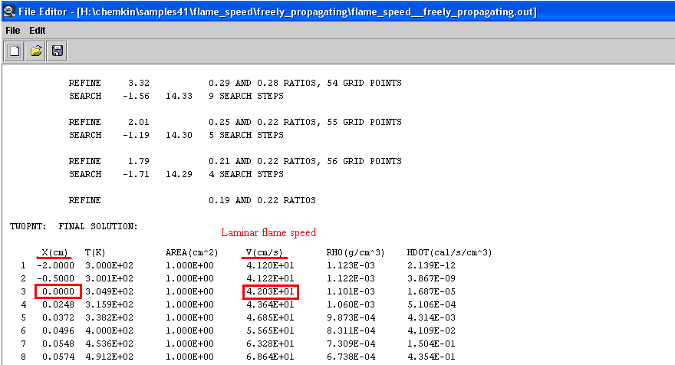
Note down this value in an excel file to obtain a plot later.
- Now we will run this model for laminar flame speed values at different temperatures for the same fuel (hydrogen).
- To find out the laminar flame speed for different temperatures, follow the same procedure with two changes for each temperature
- Import different temperature profile file and
- Choose “Fixed Temperature to Constrain Flame Position” value.
- For each temperature, there is separate temperature profile file (temp_profile_400, temp_profile_500, temp_profile_600, and temp_profile_690) given. Replace the existing temperature profile file with the temperature profile file specific to that temperature as explained in step 7 above. Then choose “Fixed Temperature to Constrain Flame Position” value for 400 K, 500 K, 600 K and 690 K as 850 K, 975 K, 1075 K and 1160 K respectively.
- Now plot a graph of laminar flame speed vs temperature for hydrogen in excel with the values saved in excel after each run.
- Similarly follow the same procedure (except step 10) to find out laminar flame speed of stoichiometric methane- air mixture at various temperatures.

Example Problem Solution

Temperature (K) | LFS (cm/s)
Temperature (K) | Hydrogen
300 | 260.58
400 | 411.91
500 | 605.97
600 | 848.00
690 | 1143.37

Home Problem Statement
Repeat the example problem but for a methane fuel. For initial temperatures of 300 K, 400 K, 500 K, 600 K, and 690 K, enter the “Fixed Temperature to Constrain Flame Position” use 500 K, 600 K, 700 K, 800 K, and 950 K, respectively.

