CACHE Modules on Energy in the Curriculum
Hydrogen as a Fuel

Module Title: Manual Calculations of Adiabatic Flame Temperature:
Hydrogen vs. Alternative Fuels
Module Authors: Neelima Borate and Jeff Naber
Author Affiliation: Michigan Technological University

Course: Combustion and Air Pollution

Text Reference: Thermodynamics: An Engineering Approach by Yunus A. Cengel and Michael A. Boles
Concepts: Adiabatic flame temperature, stoichiometric amount of air, enthalpy of formation

Problem Motivation

This module may be used as a continuation of the first Combustion and Air Pollution Module. In that module, we calculated adiabatic flame temperature using EES with built-in fluid property values (e.g. enthalpy of a species). In this module, we will calculate adiabatic flame temperature manually with the enthalpy values from the tables provided at the end of the module.

Problem Information

Example Problem Statement:

Hydrogen is burned with a stoichiometric amount of air during an adiabatic steady-flow combustion process. Both the fuel and the air enter the combustion chamber at 25° C and 1 atm. Calculate the exit temperature of the product gases, assuming complete combustion.

Solution:
As seen before, for combustion chamber under adiabatic conditions and with no work interactions we can write,

Where HR is the enthalpy of the reactant stream and HP is the enthalpy of the product stream. Also, is the heat of formation at 25 ºC and 1 atm pressure and is the enthalpy at a certain state (R = reactants, 25 ºC; (R = reactants, unknown temperature)

Here the fuel and the air enter at 25° C (i.e. 298 K) to the combustion chamber.
The combustion equation for H₂ with stoichiometric air is
Now from the tables 2.1 to 2.6,

Species | kJ/kmol | kJ/kmol
H₂ | 0 | -
O₂ | 0 | -
N₂ | 0 | 8669
H₂O(g) | -241820 | 9904

Now,
But HP = HR
So,
From this equation the adiabatic temperature is obtained with trial and error method. Initial guess value can be find out by dividing right hand side of the above equation by the total number of moles i.e. i.e. 93063.1 kJ. This value corresponds to about 2750 K for N₂. But because of higher specific heat of H₂O, adiabatic temperature should be less than 2750 K in this case. So, by trial and error find out two temperatures at which the enthalpies () are just above and below the required enthalpy value (here it is 268021.72 kJ).
At 2500 K,
At 2550 K,
By interpolation,
Temp (K) | Enthalpy (kJ)
2500 | 264872.28
T | 268021.72
2550 | 271015.32

Solving this,
This is the adiabatic flame temperature for hydrogen when both the fuel and the air enter the combustion chamber at 25° C.

Home Problem Statement:

Liquid ethyl alcohol (C₂H₅OH) at 25 °C is burned steadily with the stoichiometric amount of air at 25 °C and 1 atm. Both the fuel and the air enter the combustion chamber at 25 °C and 1 atm. Calculate the exit temperature of the product gases, assuming combustion is complete and adiabatic.

Table 2.1
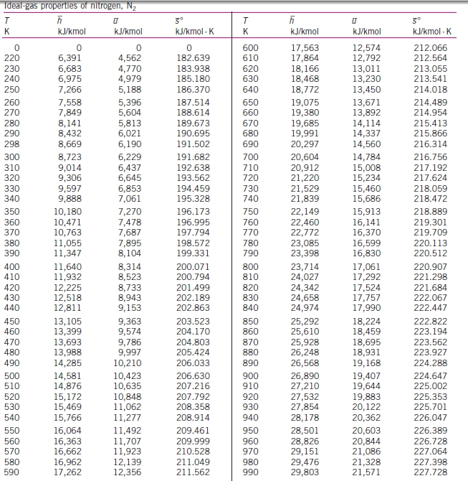
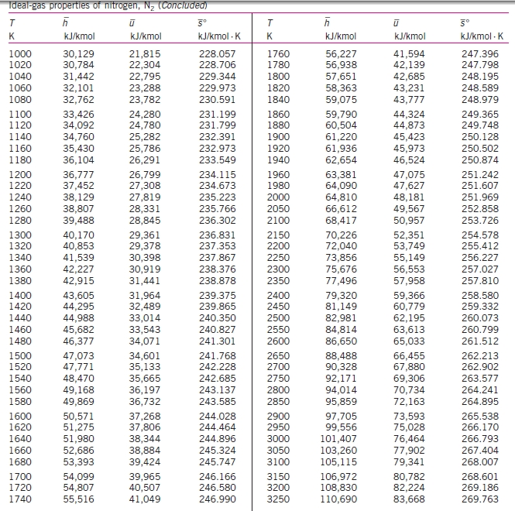

Table 2.2
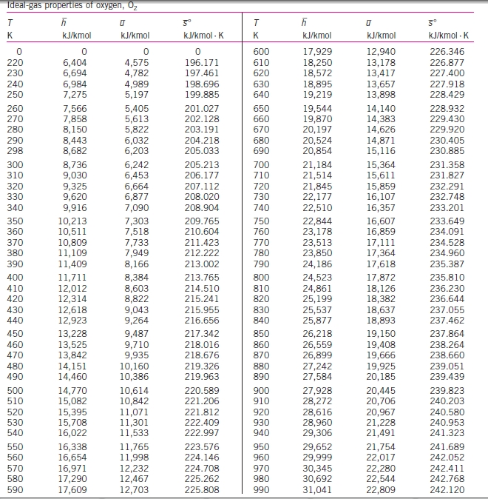

Table 2.3
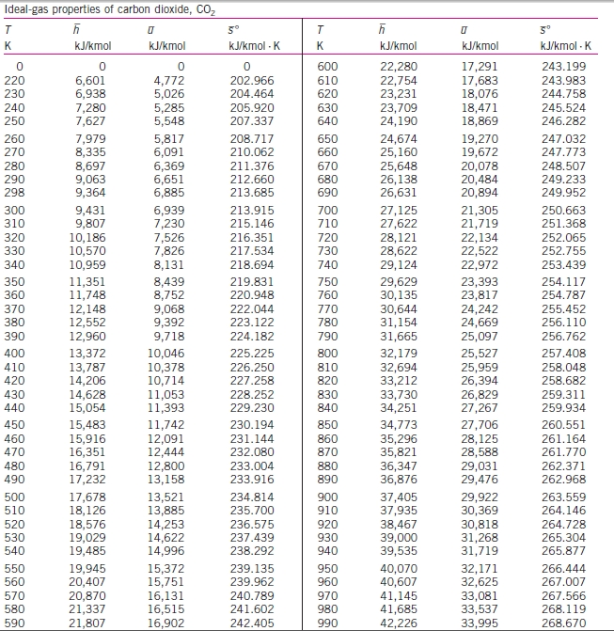

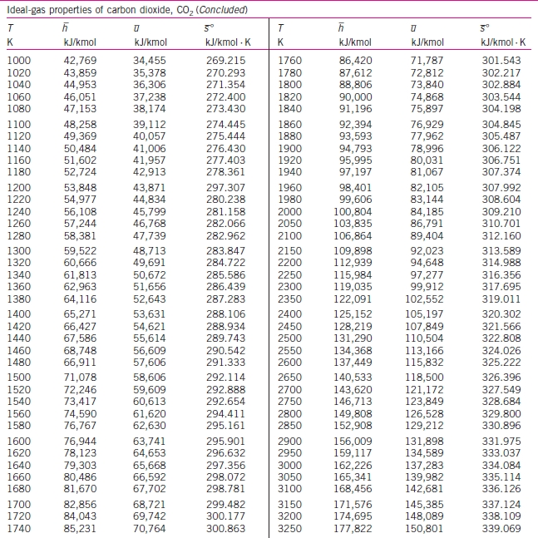

Table 2.4
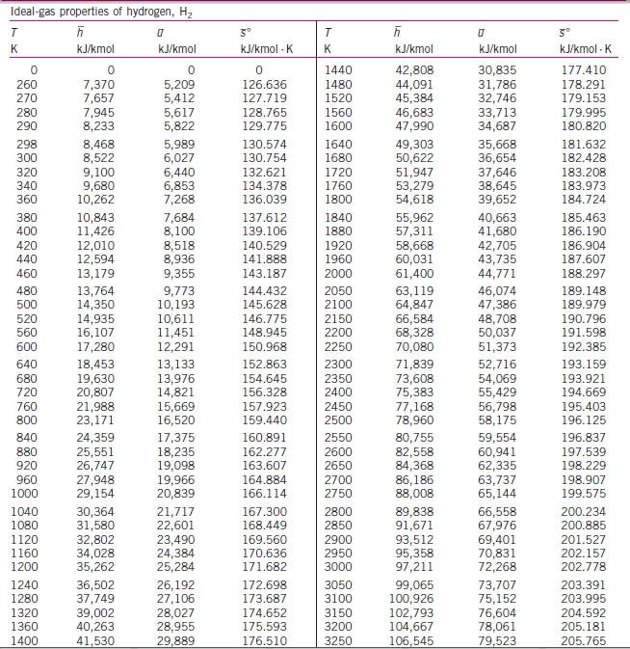

Table 2.5
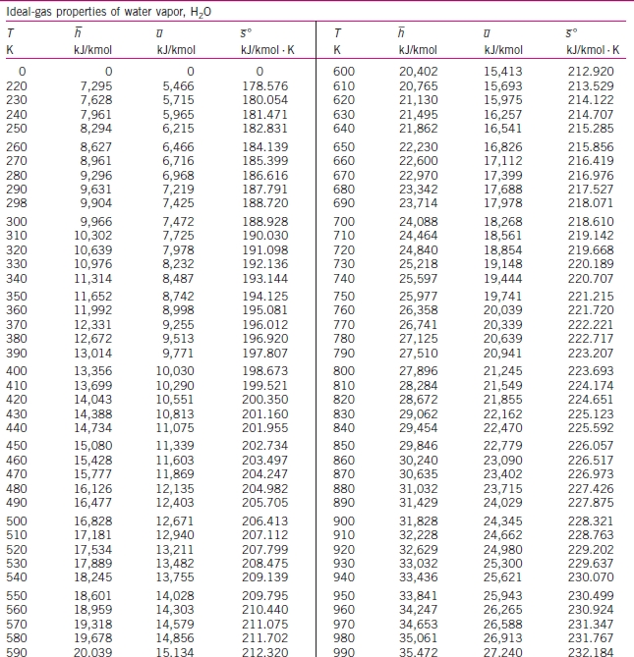

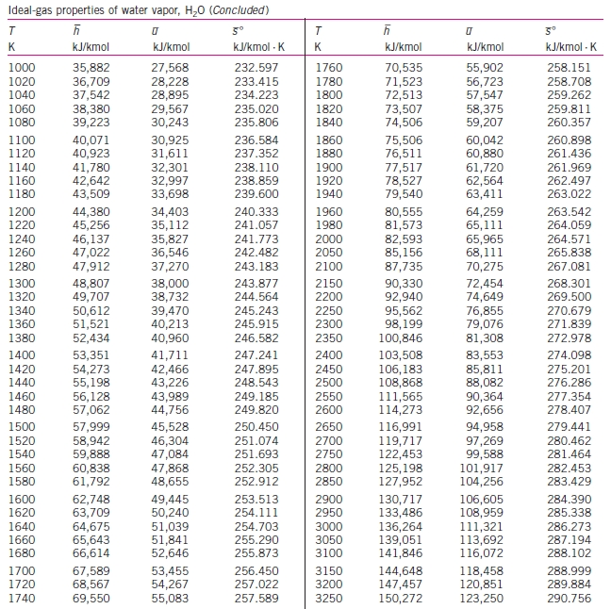

Table 2.6
