CACHE Modules on Energy in the Curriculum

Fuel Cells
Module Title: Analysis of DC/DC Converter in a PEM Fuel Cell Application
Module Author: Jason Keith
Author Affiliation: Michigan Technological University

Course: Electrical circuits

Text Reference: G. Rizzoni, 1993, Principles and Applications of Electrical Engineering
Concepts: Fundamentals of electric circuits

Problem Motivation:
Fuel cells are a promising alternative energy technology. One common type, called a proton exchange membrane (PEM) fuel cell, uses a catalyzed reaction of hydrogen and oxygen to produce electricity and heat. Fundamental to the design of fuel cells is their use in transportation applications, where they need to provide reliable electrical energy to variable loads.

Consider the schematic of a compressed hydrogen tank feeding a PEM fuel cell, as seen in Figure 1. The electricity generated by the fuel cell is used to power a laptop computer. We are interested in analyzing the flow of DC electricity from the fuel cell.
H₂ tank
Fuel Cell
H₂ feed line
Computer
(Electric Load)

Anode
Gas
Chamber
Cathode
Gas
Chamber
H₂ out
Air in, Tin
Air / H₂O out, Tout

Figure 1: Schematic of Fuel Cell Operation

The performance of fuel cells are characterized by a polarization plot, which shows the single cell voltage as a function of the current density (total current divided by cross-sectional area). Such a plot is illustrated below for a PEM fuel cell.
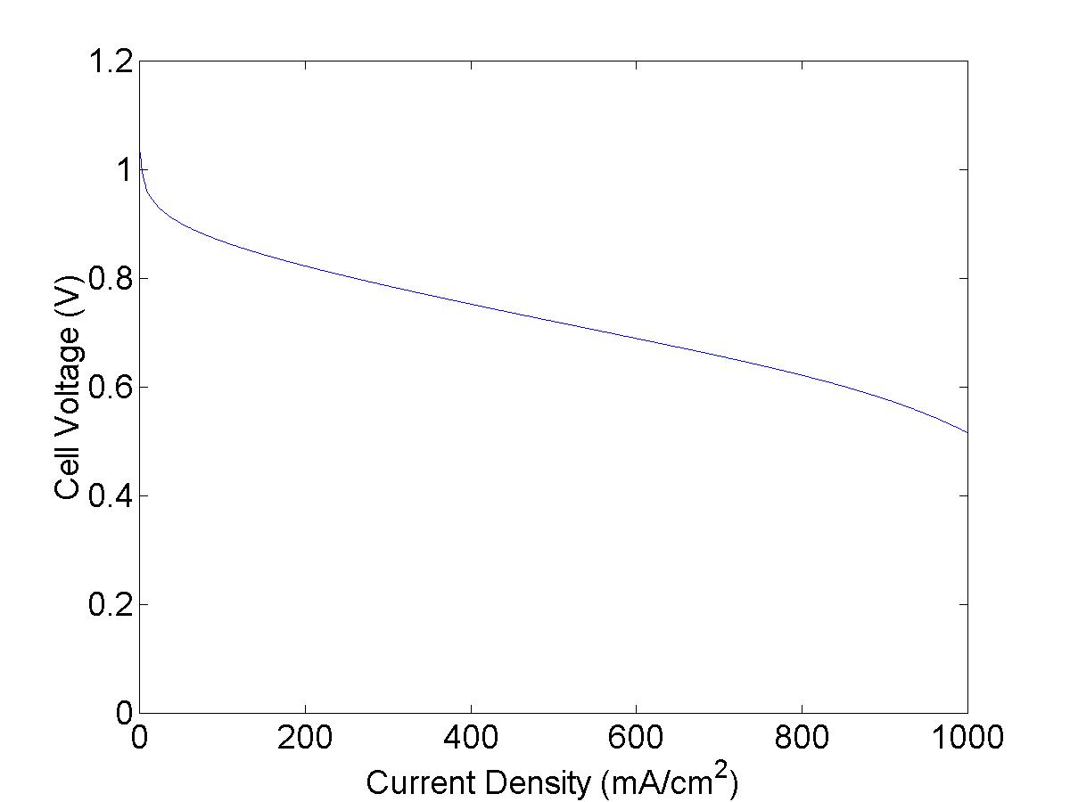

Figure 2. Polarization Plot

For fuel cell stacks a stack curve is often used which plots the stack voltage V as a function of the total current I.

Problem Information
Example Problem Statement:
A DC/DC converter takes fuel cell output at 100 A load and converts at 90% efficiency to 300 V for an electric motor.

Consider the operation of a proton exchange membrane fuel cell which acts as a battery at an unknown voltage and current in a DC circuit. This fuel cell provides power to a vehicle. The stack curve follows the equation:

In this equation, V_{oc} represents the open circuit voltage, A represents activation losses, R represents resistive losses, and m and n represent mass transfer losses. It is desired to have the open circuit (no load) voltage be as high as possible and the voltage loss terms be as low as possible.

The fuel cell parameters are V_{oc} = 436 V, A = 12.9 V, R = 0.181 Ω, m = 0.0091 V, and n = 0.013 A⁻¹.

Example Problem Solution:
At 100 A, the voltage of the fuel cell is:

The total power is thus P = IV = 100 A x 358 V = 35,800 W.

At 90% conversion efficiency, the delivered power is 32,200 W.

At 300 V, the current to the electric motor is 107.4 A.

Homework Problem Statement:
A DC/DC converter takes fuel cell output at 200 A load and converts at 88% efficiency to 300 V for an electric motor.

Consider the operation of a proton exchange membrane fuel cell which acts as a battery at an unknown voltage and current in a DC circuit. This fuel cell provides power to a vehicle. The stack curve follows the equation:

In this equation, Voc represents the open circuit voltage, A represents activation losses, R represents resistive losses, and m and n represent mass transfer losses. It is desired to have the open circuit (no load) voltage be as high as possible and the voltage loss terms be as low as possible.

The fuel cell parameters are V_{oc} = 436 V, A = 12.9 V, R = 0.181 Ω, m = 0.0091 V, and n = 0.013 A⁻¹.

