CACHE Modules on Energy in the Curriculum

Fuel Cells
Module Title: Solid Oxide Fuel Cell Stack Performance: Single Load
Module Author: Jason Keith
Author Affiliation: Michigan Technological University

Course: Electrical circuits

Text Reference: G. Rizzoni, 1993, Principles and Applications of Electrical Engineering
Concepts: Fundamentals of electric circuits

Problem Motivation:
Fuel cells are a promising alternative energy technology. One common type, called a proton exchange membrane (PEM) fuel cell, uses a catalyzed reaction of hydrogen and oxygen to produce electricity and heat. Fundamental to the design of fuel cells is their use in transportation applications, where they need to provide reliable electrical energy to variable loads.

Consider the schematic of a compressed hydrogen tank feeding a PEM fuel cell, as seen in Figure 1. The electricity generated by the fuel cell is used to power a laptop computer. We are interested in analyzing the flow of DC electricity from the fuel cell.
H₂ tank
Fuel Cell
H₂ feed line
Computer
(Electric Load)

Anode
Gas
Chamber
Cathode
Gas
Chamber
H₂ out
Air in, Tin
Air / H₂O out, Tout

Figure 1: Schematic of Fuel Cell Operation

The performance of fuel cells are characterized by a polarization plot, which shows the single cell voltage as a function of the current density (total current divided by cross-sectional area). Such a plot is illustrated below for a PEM fuel cell.
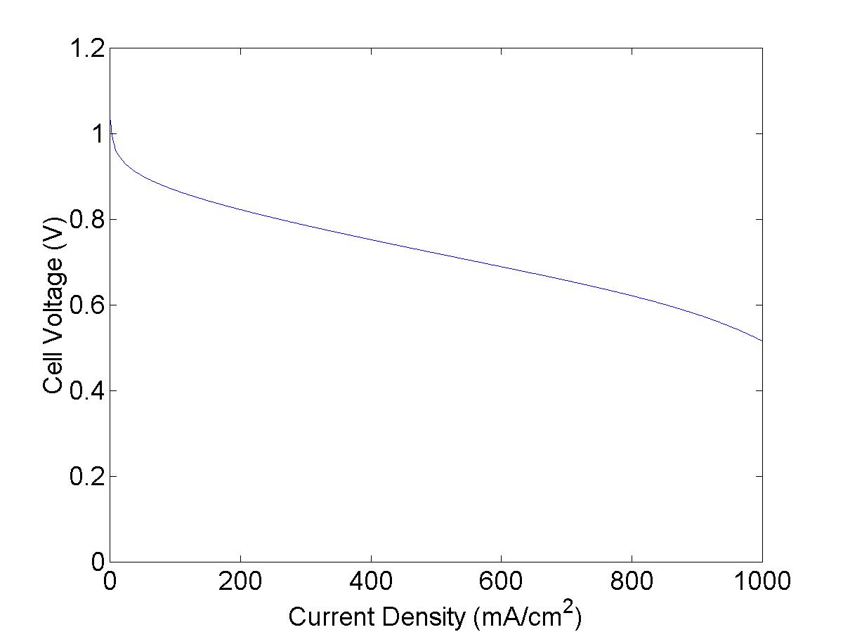

For fuel cell stacks a stack curve is often used which plots the stack voltage V as a function of the total current I.

Problem Information
Example Problem Statement:
Consider the operation of a solid oxide fuel cell which acts as a battery at an unknown voltage and current in a DC circuit. This fuel cell provides power to a small city. The stack curve follows the equation:

Note that at zero current, the fuel cell operates at its maximum voltage (959.2 V), and the voltage drops by 0.23 V for each 1 A increase in current. It is desired to have the open circuit (no load) voltage be as high as possible and the voltage loss term be as low as possible.

- Under low load conditions, 100 kW of power is drawn from the system. Determine the current and voltage of the fuel cell.
- Under high load conditions, 1 MW of power is drawn from the system. Determine the current and voltage of the fuel cell.

Example Problem Solution:
A circuit diagram of this process is shown below:

Fuel Cell
V = f(I)
R₁

Part a) We know that the total power delivered by the fuel cell is equal to the product of the current and voltage, P = IV. Substituting the current-voltage relationship in the problem statement, we have:

This is a quadratic equation of the form aI² + bI + c = 0 and can be solved to give two roots for the stack current.

With a = –0.23, b = 959.2, and c = –100000, we obtain I = 107 A and I = 4063 A. Thus, there are two separate currents that give the same power. It is better to operate at the lower current.

Then, using the expression for the stack curve we obtain:

We can double check that P = IV = 107 A x 935 V = 100,000 W.

Part b) We can repeat part a with c = –1,000,000 W. As such, we obtain I = 2102.7 A and I = 2067.7 A. Thus, there are two separate currents that give the same power. It is better to operate at the lower current.

Then, using the expression for the stack curve we obtain:

We can double check that P = IV = 2068 A x 483.6 V = 1,000,000 W.
Homework Problem Statement:
Consider the operation of a different solid oxide fuel cell which acts as a battery at an unknown voltage and current in a DC circuit. This fuel cell provides power to a small city. The stack curve follows the equation:

- Under low load conditions, 100 kW of power is drawn from the system. Determine the current and voltage of the fuel cell.
- Under high load conditions, 1 MW of power is drawn from the system. Determine the current and voltage of the fuel cell.
- You are told the hydrogen usage rate is proportional to the stack current. Thus, do you think this fuel cell is better than the one in the example problem?

