CACHE Modules on Energy in the Curriculum

Fuel Cells
Module Title: Proton Exchange Membrane Fuel Cell Stack Performance: Single Load
Module Author: Jason Keith
Author Affiliation: Michigan Technological University

Course: Electrical circuits

Text Reference: G. Rizzoni, 1993, Principles and Applications of Electrical Engineering
Concepts: Fundamentals of electric circuits

Problem Motivation:
Fuel cells are a promising alternative energy technology. One common type, called a proton exchange membrane (PEM) fuel cell, uses a catalyzed reaction of hydrogen and oxygen to produce electricity and heat. Fundamental to the design of fuel cells is their use in transportation applications, where they need to provide reliable electrical energy to variable loads.

Consider the schematic of a compressed hydrogen tank feeding a PEM fuel cell, as seen in Figure 1. The electricity generated by the fuel cell is used to power a laptop computer. We are interested in analyzing the flow of DC electricity from the fuel cell.
H₂ tank
Fuel Cell
H₂ feed line
Computer
(Electric Load)

Anode
Gas
Chamber
Cathode
Gas
Chamber
H₂ out
Air in, Tin
Air / H₂O out, Tout

Figure 1: Schematic of Fuel Cell Operation

The performance of fuel cells are characterized by a polarization plot, which shows the single cell voltage as a function of the current density (total current divided by cross-sectional area). Such a plot is illustrated below for a PEM fuel cell.
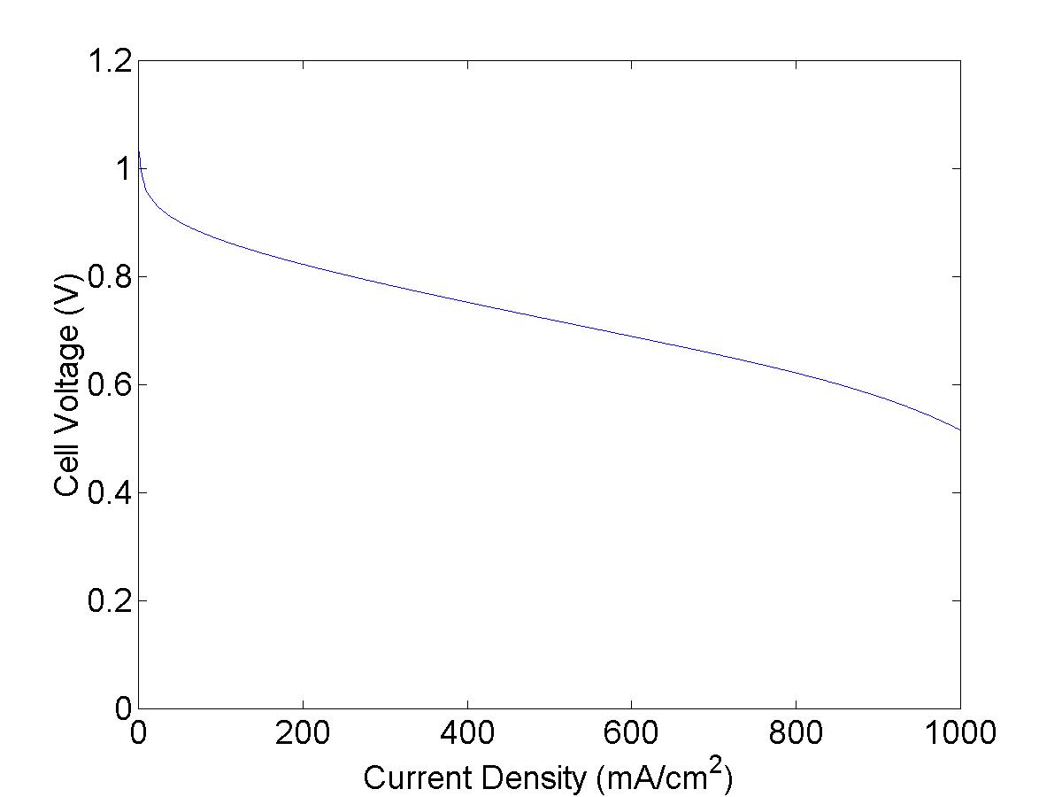

Figure 2. Polarization Plot

For fuel cell stacks a stack curve is often used which plots the stack voltage V as a function of the total current I.

Problem Information
Example Problem Statement:
Consider the operation of a proton exchange membrane fuel cell which acts as a battery at an unknown voltage and current in a DC circuit. This fuel cell provides power to a vehicle. The stack curve follows the equation:

In this equation, V_{oc} represents the open circuit voltage, A represents activation losses, R represents resistive losses, and m and n represent mass transfer losses. It is desired to have the open circuit (no load) voltage be as high as possible and the voltage loss terms be as low as possible.

The fuel cell parameters are V_{oc} = 436 V, A = 12.9 V, R = 0.181 Ω, m = 0.0091 V, and n = 0.013 A⁻¹.

- If the load on the fuel cell is 10 kW of power, determine the current and voltage of the fuel cell.
- Determine the maximum power of the fuel cell, and the corresponding voltage and current.

Example Problem Solution:
A circuit diagram of this process is shown below:

Fuel Cell
V = f(I)
R₁

Part a) We know that the total power delivered by the fuel cell is equal to the product of the current and voltage, P = IV. We can use this relationship and the parameters for the stack voltage given in the problem statement (as shown in figure 3) to construct a graph of the power as a function of the current (as shown in figure 4). This is shown below.

For a load of 10000 W, Figure 4 can be used to show the current is 25.7 A. Figure 3 can then be used to show this corresponds to 389.5 V.

Part b) Figure 4 shows a maximum power of 134 kW at a current of 574 A. Figure 3 can then be used to show this corresponds to 234 V.
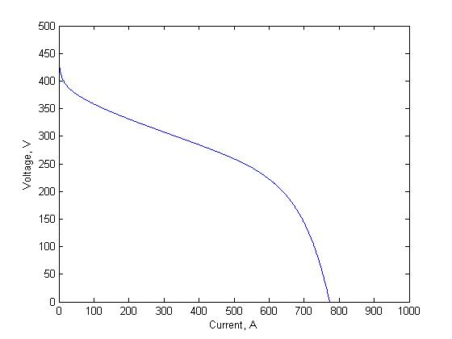
Figure 3. Fuel Cell Stack Voltage as a Function of Stack Current.
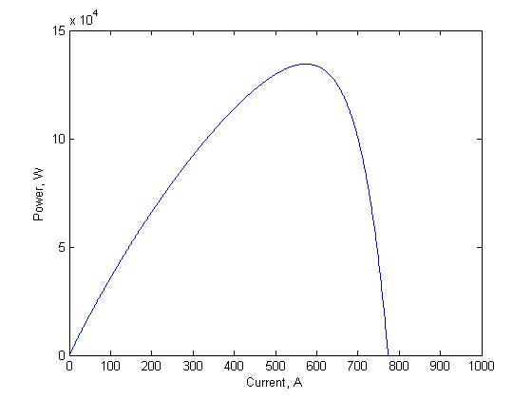
Figure 4. Fuel Cell Stack Power as a Function of Stack Current.

Homework Problem Statement:
Consider the operation of a proton exchange membrane fuel cell which acts as a battery at an unknown voltage and current in a DC circuit. This fuel cell provides power to a vehicle. The stack curve follows the equation:

In this equation, Voc represents the open circuit voltage, A represents activation losses, R represents resistive losses, and m and n represent mass transfer losses. It is desired to have the open circuit (no load) voltage be as high as possible and the voltage loss terms be as low as possible.

The fuel cell parameters are V_{oc} = 436 V, A = 12.9 V, R = 0.181 Ω, m = 0.0091 V, and n = 0.013 A⁻¹.

Determine the effect of decreasing parameter A, R, or m by 20% on the maximum power output.

