Unisim Model of a Solid Oxide Fuel Cell
INSTRUCTIONS
- Click on Start→All programs→Other Apps→Honeywell→Unisim Design Suite →Unisim Design
- After the program starts click on File→New→Case
- Add the components
  - Under the components tab click on the Add button
  - Find the components Hydrogen, Oxygen, Nitrogen, Water, Carbon Monoxide, and Carbon Dioxide and click Add Pure for each one then exit the component list window
- Add the fluid package and reactions and reaction set
  - Click on the fluid pkgs tab, click add and choose the Antoine package then close the window
  - Click on the reactions tab→Add Rxn→Conversion Reaction
  - In the conversion rxn window in the components column click the dropdown menu and add the components Carbon Monoxide, Oxygen, and Carbon Dioxide to the reaction
  - In the Stoich Coeff column you must enter the stoichiometric coefficients. If they are reactants then they are negative, products are positive. 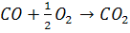 and inerts are entered as 0. Thus, use the following:
    - CO - 1.0
    - O₂ - 0.5
    - CO₂ 1.0
  - Click on the basis tab→change the rxn phase to overall phase and the C0 to 100 for a 100% conversion. You can come back and change this value at any time. Also make Carbon monoxide the base component. Exit the window.
  - Click Add Rxn→Conversion Reaction once again to add the second reaction
  - In the conversion reaction window in the components column click the dropdown menu and add the components Hydrogen, Oxygen, Nitrogen, and Water to a second reaction
  - Once again, the coefficients will be positive, negative, and zero depending on the reaction 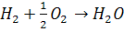
    - H₂ - 1.0
    - O₂ - 0.5
    - H₂O 1.0
    - N₂ 0
  - Click on the basis tab→change the rxn phase to overall phase and the C0 to 100 for a 100% conversion. Exit the window
  - In the simulation basis manager on the far right click add set. Under the active column click the dropdown list and choose both of your reactions. Close the window
  - With Set-1 highlighted click Add to FP in the bottom right corner then click add set to fluid package.
  - Click enter simulation environment
- Enter the Simulation Environment
  - Drag the corner of the green screen to enlarge the work area
- Add material streams
  - If the operations palette is not in view then click F4. Select the blue material stream and add it to the workspace. Double click on the stream to view its properties.
  - Add the following properties
    - Stream Name→ Anode (H₂+CO) Feed
    - Molar flow rate → empty
    - Pressure→ 1131 (kPa)
    - Temperature→ 600 (Cº)
  - Click on composition→then change the CO composition to 0.25 and the H₂ to 0.75. Close the window
  - Add a 2nd material stream and open its properties.
    - Stream Name Cathode (Air) Feed
    - Molar flow rate→ empty
    - Pressure→ 1131 (kPa)
    - Temperature→ 600 (Cº)
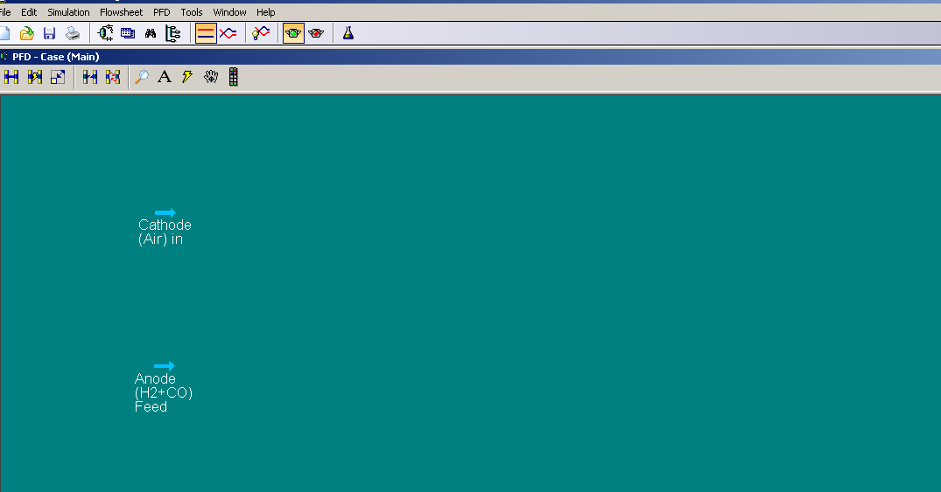
  - Click on composition →then change the nitrogen composition to 0.79 and the oxygen to 0.21. Close the window

- Add the Splitters
  - Under the operations palette click on the component splitter. Under inlets add the stream Anode (H₂+CO) Feed. In the overhead outlet put in 1 and push enter. Then 2 in the bottom outlet and push enter to define and name the streams.
  - Click on splits. Under column one enter zero for all of the entries except for hydrogen. Make hydrogen 1.
  - UNISIM should ask for an overhead pressure. Click on the worksheet tab and enter 1131 kPa for a pressure in stream 1. Enter a pressure into the bottom outlet named 2 and enter the same pressure. The splitter will not be solved but close the window.
  - Insert another component splitter into the workspace. Open its properties. Make the inlet come from stream Cathode (Air) Feed. Define the outlet streams and name them 3 (overhead) and 4 (bottoms).
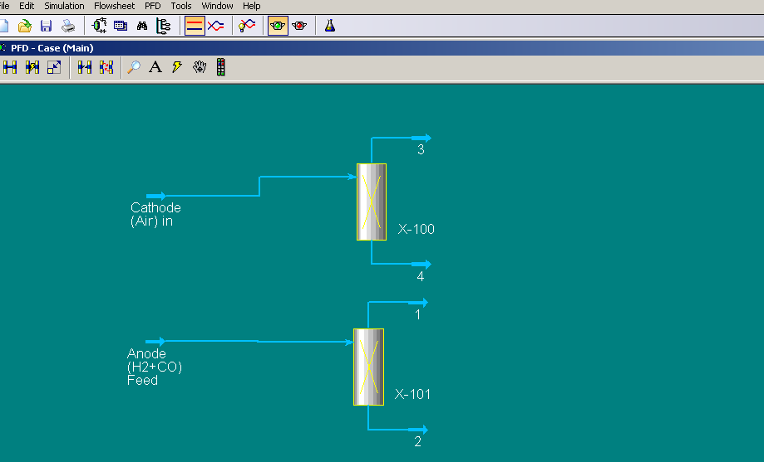
  - Click on splits, change the Nitrogen and Oxygen in column 3 to 0.75 and the rest 0; this will cause 75% of the air to go into the top outlet stream. Click on the worksheet tab and enter 1131 for a pressure in stream 3 and 4. Close the window.

Add the Reactors
  - Click on general reactors in the operation palette and choose the conversion reactor. Double click on the reactor to open its properties.
  - Under Inlets add streams 3 and 1. Under Outlets you must enter a name for the vapor outlet and the liquid outlet by clicking on their boxes and typing in 5 for the top and 6 for the bottoms outlet. We do not need to provide the outlets specific names because they do not exist in a fuel cell. Name the energy stream E1 by typing it in its tab and pushing enter.
  - Click on the Reactions tab, click the dropdown menu under Reaction set and choose your reaction set. Then under the reactions tab choose Rxn-2.
  - The reactor should tell you that there is an Unknown Duty in yellow.
  - Under the Worksheet tab change the temperature of stream 5 to 600ºC and the pressure to 1131 kPa. Close the window.
  - In the reaction palette select another conversion reactor and add it to the workspace. Then double click on it.
  - Under inlet add the streams 2 and 4. Define the overhead outlet as stream 7 and the bottoms as stream 8. Define the energy stream as E2.
  - Click the reactions tab and add your set with the drop down arrow. Then select Rxn-1 under the reaction drop down menu to the right.
  - The reactor should tell you that there is an Unknown Duty in yellow.
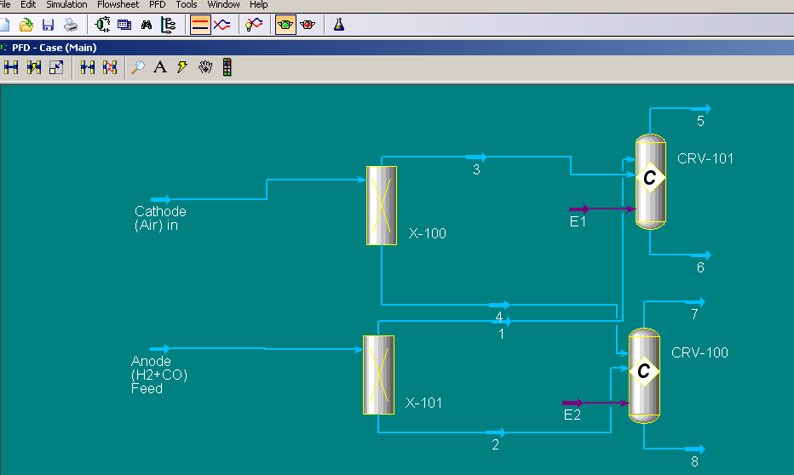
  - Click on the worksheet tab and change the pressure and temp. of stream 7 to 1131 kPa and 600ºC. Close the window.

- Add a Mixer
  - In the operation palette choose the Mixer and add it to the workspace and open its properties
  - Make the Inlets streams 5,6,7, and 8. Name the Outlet stream 9 by clicking the Outlet box and typing 9 then push enter. It is named stream 9 because it also does not exist in a fuel cell.
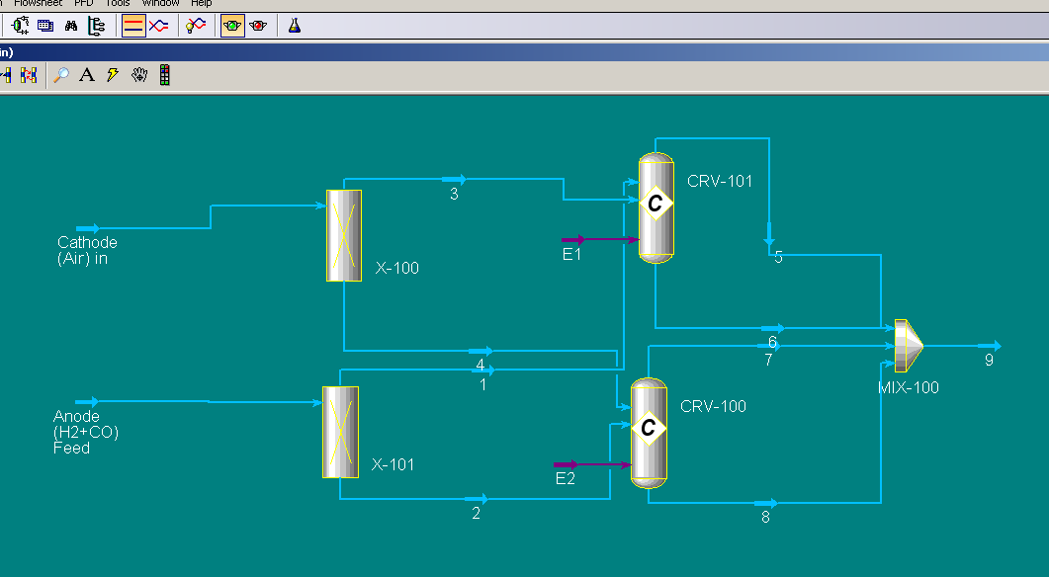
  - Close the mixer window

- Add a Component Splitter
  - In the operation palette choose the Component Splitter and add it to the workspace and open its properties
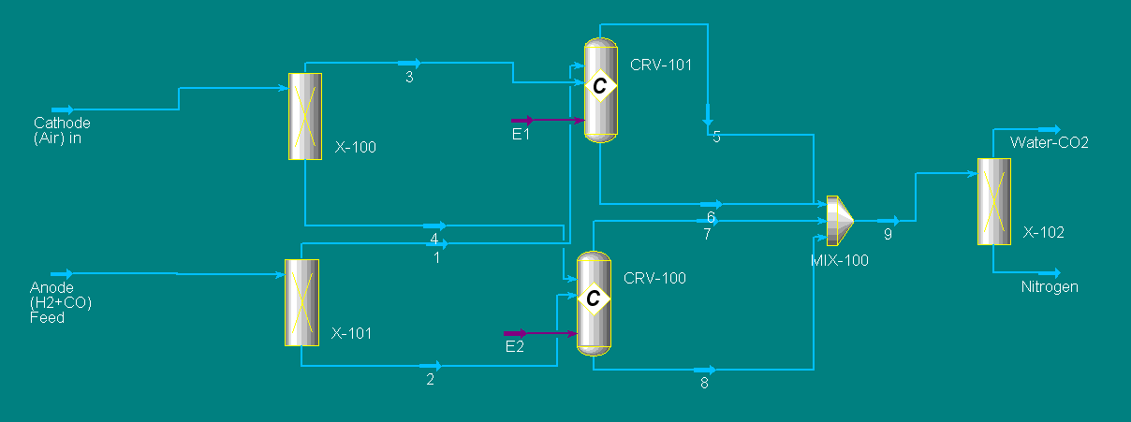
  - Make the Inlet stream 9 and name the outlet stream Water-CO2 in the Overhead Outlet box and Nitrogen in the Bottoms Outlet box. Name the energy stream E3 by clicking on the energy stream box, entering the name, and pushing enter.
  - Click on Splits and under the Water-CO2 column change the water and CO₂ to 1 for we want 100% of the water and CO₂ in that stream and make the others 0 for that stream.
  - The window should now say Unknown Overhead Pressure. Click on the Worksheet tab and change the pressure of the Water-CO2 stream to 1131 kPa and the temp. to 600ºC. Then Unisim asks for a Bottoms Pressure, enter the same pressure.
  - The window will now say Not Solved. Close the window.

- Add a Spreadsheet
  - In the operation palette choose the Spreadsheet, add it to the workspace and open its properties
  - You will also need to click on the parameters tab to increase the number of rows to 20.
  - When entering data in Unisim’s spreadsheet, you must enter the cell values individually; you cannot add cells to formulas by clicking on them. Follow the equations below exactly and the system will work properly. For reference to the equations below, refer to the equation sheet provided.
  - Right click in cell B5 and select export formula result. Then in the same screen select stream Anode (H₂+CO) Feed →scroll down under Variable and choose Molar Flow and select Add.
  - Right click in cell B6 and select export formula result. Then in the same screen select stream Cathode (Air) Feed → Molar Flow→ and select OK. Close the window.
  - Close the spreadsheet window. If there is a problem in setting up the spreadsheet you can enter the molar flowrates directly into Unisim or in the spreadsheet in cells B5 and B6.
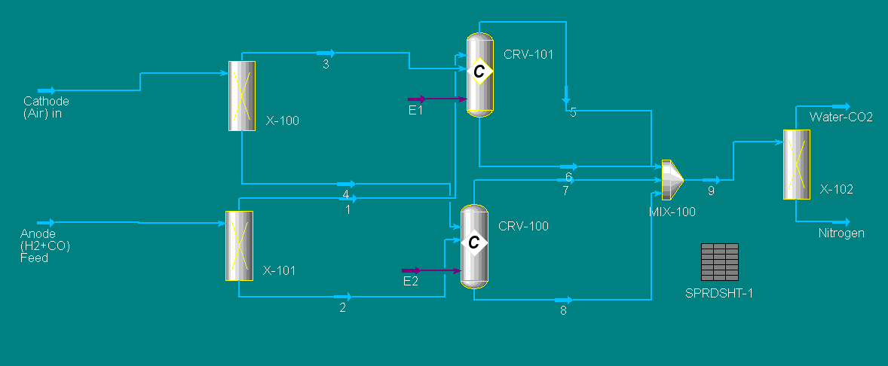
  - Close the spreadsheet window.

- Add the Last Details
  - You are now looking at the entire system, and it should read not ready because the pressures in the splitters in step 7-j must be reentered. Double click on each splitter and click on the worksheet tab and change the overhead outlet of each splitter to 1131 kPa. If the system is still not ready, it is because a temperature must be defined in the splitters again. Put in the appropriate information at 600ºC.
  - You may also go back and change the names of the reactors to H₂ rxn and CO rxn.

Below is a description of the spreadsheet in UNISIM of which equations were used in each cell, and on the following page is a pictorial view of the spreadsheet with and without its formulas shown. Follow the formulas exactly for the system to work properly.
For the cell D19 be sure to use this format: =@SQRT(D18)
Here is the spreadsheet with the formulas
 | A | B | C | D
1 | Number of cells | 815 | Total Current (A) | =B2/B3
2 | Power | 1400000 | Total feed in (mol/s) | =B1*D1/2/96485
3 | Voltage | 480 | feed H₂ (mol/s) | =D2*3/4
4 | Efficiency | 0.47 | feed CO (mol/s) | =D2*1/4
5 | Anode Feed (kgmole/hr) | =D5+D6 | Feed H₂ (kgmol/hr) | =D3*3600/1000
6 | Cathode Feed (kgmole/hr) | =D9/0.21 | Feed CO (kgmol/hr) | =D4*3600/1000
7 |  |  | O₂ in H₂ reactor (kgmol/hr) | =D5/2
8 |  |  | O₂ in CO reactor (kgmol/hr) | =D6/2
9 |  |  | Total O₂ needed (kgmol/hr) | =D7+D8
10
11 | Water produced (mol/s) | =D3 | Delta G for H₂ | -237000
12 | CO₂ produced (mol/s) | =D4 | Delta G for CO | -257000
13 | Mol H₂O produced * ΔH | =B11*248000 | voltage from Gibbs H₂ | =D11/-2/96485
14 | Mol CO₂ produced * ΔH | =B12*283000 | voltage from Gibbs CO | =D12/-2/96485
15 | Combustion power (W) | =B13+B14 | Voltage avg | =(D13*0.75)+(D14*0.25)
16 |  |  | Cell voltage | =D15*B4
17 |  |  | Current density (mA/cm²) | =((D16-1.1)/-0.0011)
18 |  |  | Cell area cm² | =D1*1000/D17
19 |  |  | cm per side | =@SQRT(D18)
20 |  |  | heat production rate (W) | =B15-B2

Here is how your spreadsheet should look in UNISIM.
 | A | B | C | D
1 | Number of cells | 815 | Total Current (A) | 2916.67
2 | Power | 1400000 | Total feed in (mol/s) | 12.32
3 | Voltage | 480 | feed H₂ (mol/s) | 9.24
4 | Efficiency | 0.47 | feed CO (mol/s) | 3.08
5 | Anode Feed (kgmole/hr) | 44.35 | Feed H₂ (kgmol/hr) | 33.26
6 | Cathode Feed (kgmole/hr) | 105.59 | Feed CO (kgmol/hr) | 11.09
7 |  |  | O₂ in H₂ reactor (kgmol/hr) | 16.63
8 |  |  | O₂ in CO reactor (kgmol/hr) | 5.54
9 |  |  | Total O₂ needed (kgmol/hr) | 22.17
10
11 | Water produced (mol/s) | 9.24 | Delta G for H₂ | -237000.00
12 | CO₂ produced (mol/s) | 3.08 | Delta G for CO | -257000.00
13 | Mol H₂O produced * ΔH | 2291224.02 | voltage from Gibbs H₂ | 1.23
14 | Mol CO₂ produced * ΔH | 871527.42 | voltage from Gibbs CO | 1.33
15 | Combustion power (W) | 3162751.44 | Voltage avg | 1.25
16 |  |  | Cell voltage | 0.59
17 |  |  | Current density | 464.17
18 |  |  | Cell area cm² | 6283.68
19 |  |  | cm per side | 79.27
20 |  |  | heat production rate (W) | 1762751.44

Here is a view of the Final System

