Formulas for fuel cell production
Moles of H₂ in feed (mol/s)
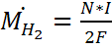 eq.1
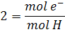
N= # of cells
F= 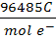
I = A =
To solve for current - 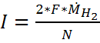 eq.2

- Use the current to find the current density by dividing by the cross sectional area.
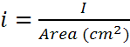 eq.3
- Change the current density to Milliamperes per square centimeter and put it into equation 3.14 in Fuel Cells Systems Explained to obtain a cell voltage.
eq.4
E_{oc} = 1.031 (V)
r = 2.45*10⁻⁴ (kΩcm²)
A = 0.03 (V)
m = 2.11*10⁻⁵ (V)
n = 8*10⁻³ (cm²mA⁻¹)

- Multiply the cell voltage by the total number of cells for a total voltage.
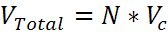 eq.5
- Multiply the total voltage by the current to find the total power produced.
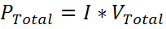 eq.6
- To find the energy due to heat, subtract the power from the energy stream.
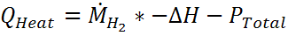 eq.7
We use the molar flow of since for each mole of H₂ reacted we form one mole of H₂O.
Where ΔH is the heat of reaction for and is equal to -241000 J/mol
The value for Q heat in eq.7 should be almost exactly the same as the value in the energy stream of the conversion reactor.
For equation 4 the constants are given pg.60 in Fuel Cell Systems Explained for a Ballard Mark V PEMFC at 70ºC fuel cell. Other constants are available when using a high temperature SOFC fuel cell. The constants are listed below.
E_{oc} = 1.01 (V)
r = 2.0*10⁻³ (kΩcm²)
A = 0.002 (V)
m = 1.0*10⁻⁴ (V)
n = 8*10⁻³ (cm²mA⁻¹)

