CACHE / AIChE Modules on Energy in the Curriculum

Module Title: Wind Energy Analysis
Module Author: Jason Keith
Author Affiliation: Michigan Technological University

Concepts: Numerical Integration; Electrolysis

Problem Motivation: The availability of energy has become an important part of our society. In this and related problems, we will discuss issues of energy consumption, energy reserves, and energy related emissions. Furthermore, we will analyze conventional and alternative energy systems. A particular emphasis will be placed on the generation of hydrogen for use in fuel cells for transportation and/or stationary applications.

Problem Information
Example Problem Statement: During a typical day, an anemometer near a wind turbine records the following data for a 1 hour period.

minute | mph | minute | mph | minute | mph | minute | mph
1 | 14.6 | 16 | 11.8 | 31 | 13 | 46 | 11.3
2 | 13.9 | 17 | 10.6 | 32 | 11.9 | 47 | 12
3 | 13.9 | 18 | 12.5 | 33 | 13.3 | 48 | 11.2
4 | 13.5 | 19 | 10.9 | 34 | 12.9 | 49 | 10.9
5 | 13.4 | 20 | 11.7 | 35 | 13.6 | 50 | 10.3
6 | 14.2 | 21 | 11.7 | 36 | 13.3 | 51 | 9.7
7 | 13.1 | 22 | 12.3 | 37 | 12 | 52 | 9.8
8 | 12.5 | 23 | 11 | 38 | 11.6 | 53 | 8.9
9 | 11.9 | 24 | 13.2 | 39 | 12.1 | 54 | 8.5
10 | 11.5 | 25 | 12.5 | 40 | 12.2 | 55 | 9.1
11 | 11.7 | 26 | 11.7 | 41 | 11.8 | 56 | 9.9
12 | 10.7 | 27 | 11.2 | 42 | 12.5 | 57 | 11.1
13 | 11.9 | 28 | 12.6 | 43 | 11.6 | 58 | 11
14 | 11.9 | 29 | 12.6 | 44 | 12.5 | 59 | 10.7
15 | 11.8 | 30 | 12.5 | 45 | 11.6 | 60 | 9.6

The following data is available:
- The air density is 1.18 kg/m³
- The wind turbine has a diameter of 3.2 m
- The turbine parameters are that the turbine collects a fraction C_{p} = 0.335 of the wind, the generator efficiency is N_{g} = 0.80, and the bearing efficiency is N_{b} = 0.95.
- The instantaneous electrical power that is generated by the wind is given by the expression P = ½ ρAC_{p}N_{g}N_{b}V³, where A is the swept area of the wind turbine.

- Determine the instantaneous power for the wind turbine as a function of time.
- Use the power data to estimate the cumulative electrical energy produced in kW-hr
- Assuming similar wind over the course of an entire day, estimate kW-hr for the day and then compare with the average energy consumption for a household in the United States of 27 kW-hr / day.
- An electrolysis unit operates at 60% efficiency. If the theoretical amount of energy needed to convert 1 mol of liquid water into 1 mol of hydrogen and ½ mol of oxygen is 285 kJ, determine the mass of hydrogen produced in g for one day. Use your answer in kW-hr from part c.

Example Problem Solution:

- The instantaneous power can be estimated by the formula: P = ½ ρAC_{p}N_{g}N_{b}V³

We have a swept area of A = πD²/4 = π(3.2 m)²/4 = 8.04 m²

For the first minute the wind velocity is 14.6 miles per hour. We can use unit conversions to determine the velocity in m/s. We have:

This can be done for all of the data provided, and is best done with a spreadsheet. At 10 min, when V = 11.5 mph, V = 5.1 m/s.

Finally, we can use the wind velocity in m/s to determine the power according to the formula:

For a time of 10 minutes, the power is 172 W.

- We can use numerical integration using the Trapezoidal rule to determine the total amount of electrical energy produced by the panel.

(1)

For a constant step size Δt we can calculate the energy production as:

(2)

In our data, the step size is uniform at 1 min = 1/60 hr so we can use equation 2 to estimate the energy production. We obtain:

E = (½ * 351 + ½ * 99.8 + 303 + 303 + 277 + …) W (1/60) hr = 189 W-hr = 0.18 kW-hr

- Extrapolating over the course of the day, we have 0.18 kW-hr x 24 = 4.5 kW-hr. This represents a fraction of 4.5 / 27 = 17% of the typical household energy consumption.

- Taking into account efficiency, we can estimate hydrogen production as:

Home Problem Statement: The following data was obtained for wind speed over the course of a 12 hour period.

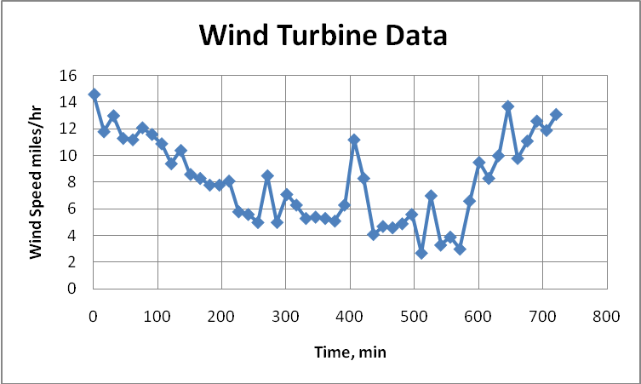

The following data is available:
- The air density is 1.18 kg/m³
- The turbine parameters are that the turbine collects a fraction C_{p} = 0.31 of the wind, the generator efficiency is N_{g} = 0.79, and the bearing efficiency is N_{b} = 0.96.
- The instantaneous electrical power that is generated by the wind is given by the expression P = ½ ρAC_{p}N_{g}N_{b}V³, where A is the swept area of the wind turbine.

- Determine the average electrical power production in kW per square meter of wind turbine area.
- Scale up the wind turbine (what is the blade diameter required) to produce 1 kW under these wind conditions.

