CACHE Modules on Energy in the Curriculum
Hydrogen as a Fuel

Module Title: Flame Temperature Analysis and NOx Emissions for Different Fuels

Author Affiliation: Michigan Technological University

Course: Combustion and Air Pollution

Text Reference: S. R. Turns, An Introduction to Combustion: Concepts and Application

Concepts: Adiabatic flame temperature, theoretical air, EGR percent

Problem Motivation

For a combustion process that takes place with no heat loss to the surrounding, the temperature of the products is referred to as the adiabatic flame temperature. It is found that with an increase in the adiabatic flame temperature, there is increase in NOx emissions from internal combustion engines. As we know, vehicles are a major source of air pollutants such as nitric oxides, hydrocarbons, carbon dioxide, etc., there is a growing shift in the fuels from the petroleum-based fuels such as gasoline and diesel fuel to the alternative fuels such as natural gas, ethanol, methanol, liquefied petroleum gas and hydrogen. So, in order to study NOx emissions, the change in adiabatic flame temperature values for conventional fuels in comparison to the alternative fuels with various equivalence ratios and various EGR rates is studied in this module. Depending on how the process is completed, adiabatic flame temperature can be of constant volume or constant pressure type.

Theory

Theoretical Air:

The minimum amount of air needed for the complete combustion of a fuel is called the stoichiometric or theoretical or 100 % theoretical air. If the air is less than theoretical air, a combustion process cannot be complete.

Adiabatic Flame Temperature:

According to first law of thermodynamics, for any thermodynamic system the change in internal energy of a system is equal to the difference between the heat transfer to the system and the work done by the system.

Let Q represent the heat added to the system with W as the amount of work done by the system. Also U, H, P, T, V are internal energy, enthalpy, pressure, temperature and volume of the system.

At state 1, Q= 0, W= 0, U= U₁, H=H₁, P=P₁, T=T₁, V=V₁.

Heat is added to the system (Q) from which there is work done by the system (W).

Thus, at state 2, Q, W, U= U₂, H=H₂, P=P₂, T=T₂, V=V₂

According to first law of thermodynamics,
∆U = U₂- U₁ = Q - W

Furthermore, according to the definition of internal energy, U= H- PV
i.e. U₁= H₁- P₁V₁ and U₂= H₂- P₂V₂

For constant pressure adiabatic process:

As we know,
U₂- U₁ = Q - W
As the process is adiabatic, Q= 0 and work done by the system,
Substituting these values in the above equation,
U₂- U₁ = 0 – (P₂V₂- P₁V₁)

But U= H – PV

Giving,
(H₂- P₂V₂) – (H₁- P₁V₁) = – P₂V₂ + P₁V₁
i.e. H₂ – H₁ = 0
i.e. H₂ = H₁

For a combustion process, reactants and products represent state 1 and state 2 respectively.

So, for a constant pressure adiabatic combustion process,

For constant volume adiabatic process:

As we know,
U₂- U₁ = Q - W
As the process is adiabatic, Q= 0 and work done by the system, because there is no change in volume of the system ().

Substituting these values in the above equation,
U₂- U₁ = 0

But U= H – PV

Giving,
(H₂- P₂V₂) – (H₁- P₁V₁) = 0

According ideal gas law,
PV = N R_{u} T

Where,
R_{u} – Universal Gas Constant
n – Number of moles of a gas

For state 1, P₁V₁ = N₁ R_{u} T₁ and for state 2 P₂V₂ = N₂ R_{u} T₂

Substituting these values in the above equation (H₂- P₂V₂) – (H₁- P₁V₁) = 0,
(H₂- N₂ R_{u} T₂) – (H₁- N₁ R_{u} T₁) = 0

So, for a constant pressure adiabatic combustion process,

Where, T_{i} is the temperature at which products enter into the combustion chamber and T_{a} is the adiabatic flame temperature of products as shown in figure 1.
Now, enthalpy of a component on a unit mole basis is given as enthalpy, where is the enthalpy of formation at the standard reference state (25°C temperature and 1 atm pressure), is the sensible enthalpy at standard reference state and is the sensible enthalpy at the specified state. The enthalpy of a component is the product of the specific enthalpy i.e. the enthalpy per unit mole of a component and the number of moles of a component. So, total enthalpy of products (or reactants) is the summation of enthalpies of all the product (or reactant) components i.e.
and
.
Air
Fuel
Products
T_{i}
T_{a}
Combustion
Chamber
Q= 0

Figure 1

Exhaust Gas Recirculation (EGR):

A Exhaust gas re-circulation i.e. EGR is EGR decreases the adiabatic flame temperature and so the NOx emissions. It is the most effective technique used to reduce NOx emissions in internal combustion engines. As shown in figure 2, a fraction (x₁) of the exhaust gases is re-circulated with the intake air into the engine.

x₁(Exhaust gases)
Engine
Air
Exhaust Gases
Fuel
Air +
x₁(Exhaust
Gases)

Figure 2: Exhaust Gas Re- circulation

Problem Information

Example Problem Statement:

- Compute the adiabatic flame temperature of H2- air at constant pressure and at constant volume using EES for 40, 60, 80, 100, 120, 140, 160, 180, 200 and 250 percent theoretical air. Consider that both the fuel and the air enter the combustion chamber at 25 °C. Discuss the difference between the adiabatic flame temperature values at constant pressure and constant volume case.

- Compute the adiabatic flame temperature of gasoline- air and ethyl alcohol- air mixtures at constant pressure using EES for 100, 120, 140, 160, 180, 200 percent theoretical air. Obtain and compare a combined plot of adiabatic flame temperature vs % theoretical air (100 – 200 %) for H2- air, gasoline- air and ethyl alcohol- air mixture.

Procedure

- Go to Start → All Programs → Other Apps → EES → ees.
- Copy the program given below in solution and paste it in the EES equation window.
- Go to “Options” → “Unit System”. Here we are calculating adiabatic temperature in this example. Select Unit System: “SI”, Specific Properties: “Molar basis”, Temperature Units: “K” and Energy Units: “kJ”.
- To avoid potential unit problems in the solution, go to “Options” → “Variable Info” and enter units of the enthalpies as kJ/kmol and temperatures as K. Also Lower Guess value for adiabatic temperature (Ta) can be set as “500 K” instead of “–infinity” in variable information window.
- In EES equation window, comments can be included wherever necessary with the use of braces { } or quote marks “ ”. To comment entire line, // can be used at the start of the line.
- To provide % theoretical air values, go to “Tables” → “New Parametric Table” and then enter number of runs. Select “Variables in equations” as “Theo_air” and “Ta” and then “Add” and click “OK”.
- Then in parametric table window, enter the % theoretical air values for which the adiabatic flame temperature is to be found. For first case i.e. for % theoretical air less than 100 %, enter values less than 100 % in the parametric table. Also make sure that for these values of theoretical air you run correct enthalpy of products equation (other equation for enthalpy of products can be enclosed in { } or “ ” for a while). For second case i.e. for % theoretical air greater than or equal to 100 %, enter % theoretical air values 100 % and greater in the parametric table and quote the previously used equation for enthalpy of products.
- Alternatively “if-else” statement can be used to automatically select the case according to % theoretical air input.
- Once the parametric table is prepared, go to “Calculate” → “Solve Table”.
- If any error occurs, check for the definition of parameters, constant values, total number of variables, total number of equations, etc.
- Copy the values obtained for adiabatic flame temperature with respect to % theoretical air and paste them into an excel file in order to obtain a combined plot later.
- As explained in the theory part, there are some changes in the equations for constant volume and constant pressure adiabatic flame temperature.

Hints:
- The combustion of hydrogen for two cases (i.e. for Lambda>=1 or for Theo_air/100 >= 100% and for Lambda< 1 or for Theo_air/100< 100%) can be explained with the following combustion equations.

- Lambda>=1 or for Theo_air/100 >= 100%

- Lambda< 1 or for Theo_air/100 < 100%

- To get specific enthalpy of each component, go to “Options” → “Function Info” and then select “Fluid properties”. There are number of fluids and fluid property values provided in EES. Select “Enthalpy” from “Function Info” column and fuel type from “Fluid Info” column.

Solution (part a):

EES program for calculation of adiabatic flame temperature of H2- air vs theoretical air at constant pressure and constant volume:

Constant Pressure:

// Initial temperature at which fuel and air enter into the combustion chamber
Ti=298 [K]

// Molar enthalpies of reactants at initial temperature (Ti)
H_H2_Ti=enthalpy ('H2', T=Ti)
H_N2_Ti=enthalpy ('N2', T=Ti)
H_O2_Ti=enthalpy ('O2', T=Ti)

// Molar enthalpies of products at adiabatic temperature (Ta)
H_H2O_Ta=enthalpy ('H2O', T=Ta)
H_N2_Ta=enthalpy ('N2', T=Ta)
H_O2_Ta=enthalpy ('O2', T=Ta)
H_H2_Ta=enthalpy ('H2', T=Ta)

// For constant pressure adiabatic combustion process as derived above
HR=HP

// Enthalpy of reactants
HR=2*H_H2_Ti+ (Theo_air/100)*H_O2_Ti+ (Theo_air/100)*3.76*H_N2_Ti

// Enthalpy of products

"Case 1: (Theo_air/100)>=1 i.e. Lambda >= 1"

{HP=2*H_H2O_Ta+ (Theo_air/100)*3.76*H_N2_Ta+ ((Theo_air/100)-1)*H_O2_Ta}

"Case 2: (Theo_air/100) <1 i.e. Lambda < 1”

HP=(Theo_air/100)*2*H_H2O_Ta+(Theo_air/100)*3.76*H_N2_Ta+(2-(Theo_air/100)*2)*H_H2_Ta

Constant Volume:

// Initial temperature at which fuel and air enter into the combustion chamber
Ti=298 [K]

// Universal gas constant
R_u = 8.314 [kJ/kmol-K]

// Molar enthalpies of reactants at initial temperature (Ti)
H_H2_Ti=enthalpy ('H2', T=Ti)
H_N2_Ti=enthalpy ('N2', T=Ti)
H_O2_Ti=enthalpy ('O2', T=Ti)

// Molar enthalpies of products at adiabatic temperature (Ta)
H_H2O_Ta=enthalpy ('H2O', T=Ta)
H_N2_Ta=enthalpy ('N2', T=Ta)
H_O2_Ta=enthalpy ('O2', T=Ta)
H_H2_Ta=enthalpy ('H2', T=Ta)

// For constant volume adiabatic combustion process as derived above
UP = UR

// Enthalpy of reactants
UR=2*(H_H2_Ti-R_u* Ti) +(Theo_air/100)*(H_O2_Ti- R_u* Ti) +(Theo_air/100)*3.76*(H_N2_Ti-R_u* Ti)

// Enthalpy of products

"Case 1: (Theo_air/100)>=1 i.e. Lambda >= 1”

UP=2*(H_H2O_Ta-R_u* Ta) + (Theo_air/100)*3.76*(H_N2_Ta-R_u* Ta) + ((Theo_air/100)-1)*(H_O2_Ta-R_u* Ta)

"Case 2: (Theo_air/100) <1 i.e. Lambda < 1”

"UP= (Theo_air/100)*2*(H_H2O_Ta-R_u*Ta) + (Theo_air/100)*3.76*(H_N2_Ta-R_u* Ta) + (2-(Theo_air/100)*2)*(H_H2_Ta-R_u* Ta)"

Results:

Theo_air (%) | T_{adiabatic, CP} (K) | T_{adiabatic, CV}  (K)
40 | 1907 | 2331
60 | 2199 | 2670
80 | 2391 | 2890
100 | 2527 | 3045
120 | 2267 | 2744
140 | 2063 | 2505
160 | 1897 | 2310
180 | 1761 | 2148
200 | 1646 | 2011
250 | 1427 | 1745

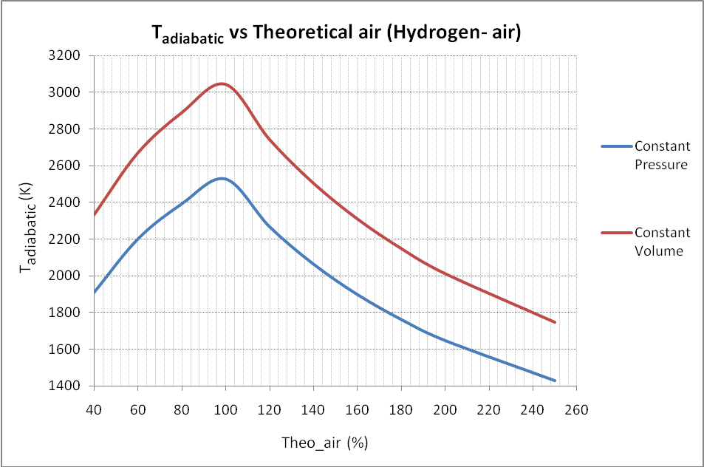

The adiabatic flame temperature at constant volume is greater than that at constant pressure because there is no work done (due to no volume change).

b) Compute the adiabatic flame temperature of gasoline- air and ethyl alcohol- air mixtures at constant pressure using EES for 100, 120, 140, 160, 180, 200 percent theoretical air. Obtain and compare a combined plot of adiabatic flame temperature vs % theoretical air (100 – 200 %) for H2- air, gasoline- air and ethyl alcohol- air mixture.

Procedure

- As explained in procedure of example problem part (a), follow steps from 1 to 6.
- Then in parametric table window, enter the % theoretical air values for which the adiabatic flame temperature is to be found. Here we are considering only one case in which % theoretical air is greater than or equal to 100 %. So, here in program there is only one equation for enthalpy of products.
- Once the parametric table is prepared, go to “Calculate” → “Solve Table”.
- If any error occurs, check for the definition of parameters, constant values, total number of variables, total number of equations, etc.
- Copy the values obtained for adiabatic flame temperature with respect to % theoretical air and paste them into an excel file in order to obtain a combined plot later.

Hints:
The combustion of gasoline and ethyl alcohol for Lambda>=1 or for Theo_air/100 >= 100% can be explained with the following combustion equations.

Gasoline

Ethyl Alcohol

Solution (part b):

EES program for calculation of adiabatic flame temperature of gasoline- air and ethyl alcohol- air vs theoretical air at constant pressure:

Gasoline:

// Initial temperature at which fuel and air enter into the combustion chamber
Ti=298 [K]

// Molar enthalpies of reactants at initial temperature (Ti)
H_C8H18_Ti=enthalpy ('C8H18', T=Ti)
H_N2_Ti=enthalpy ('N2', T=Ti)
H_O2_Ti=enthalpy ('O2', T=Ti)

// Molar enthalpies of products at adiabatic temperature (Ta)
H_CO2_Ta=enthalpy ('CO2', T=Ta)
H_CO_Ta=enthalpy ('CO', T=Ta)
H_H2O_Ta=enthalpy ('H2O', T=Ta)
H_N2_Ta=enthalpy ('N2', T=Ta)
H_O2_Ta=enthalpy ('O2', T=Ta)

// At adiabatic flame temperature constant pressure, the enthalpy of the reactants is equal to the enthalpy of the products
HR=HP

// Enthalpy of products
"Case: (Theo_air/100)>=1"

HP=8*H_CO2_Ta+9*H_H2O_Ta+12.5*(Theo_air/100)*3.76*H_N2_Ta+12.5*((Theo_air/100)-1)*H_O2_Ta

// Enthalpy of reactants
HR=1*H_C8H18_Ti+12.5*(Theo_air/100)*H_O2_Ti+12.5*(Theo_air/100)*3.76*H_N2_Ti

Ethyl alcohol:

// Initial temperature at which fuel and air enter into the combustion chamber
Ti=298 [K]

// Enthalpies of reactants at initial temperature (Ti)
H_C2H5OH_Ti=enthalpy ('C2H5OH', T=Ti)
H_N2_Ti=enthalpy ('N2', T=Ti)
H_O2_Ti=enthalpy ('O2', T=Ti)

// Enthalpies of products at adiabatic temperature (Ta)
H_CO2_Ta=enthalpy ('CO2', T=Ta)
H_CO_Ta=enthalpy ('CO', T=Ta)
H_H2O_Ta=enthalpy ('H2O', T=Ta)
H_N2_Ta=enthalpy ('N2', T=Ta)
H_O2_Ta=enthalpy ('O2', T=Ta)

// At adiabatic flame temperature, the enthalpy of the reactants is equal to the enthalpy of the products
HR=HP

// Enthalpy of products
"Case: (Theo_air/100)>=1"

HP=2*H_CO2_Ta+3*H_H2O_Ta+3*(Theo_air/100)*3.76*H_N2_Ta+3*((Theo_air/100)-1)*H_O2_Ta

// Enthalpy of reactants
HR=1*H_C2H5OH_Ti+3*(Theo_air/100)*H_O2_Ti+3*(Theo_air/100)*3.76*H_N2_Ti

Results

Theo_air (%) | T_{a, hydrogen} (K) | T_{a, gasoline} (K) | T_{a, ethyl alcohol} (K)
100 | 2527 | 2411 | 2355
120 | 2267 | 2136 | 2104
140 | 2063 | 1926 | 1909
160 | 1897 | 1760 | 1753
180 | 1761 | 1626 | 1625
200 | 1646 | 1515 | 1518

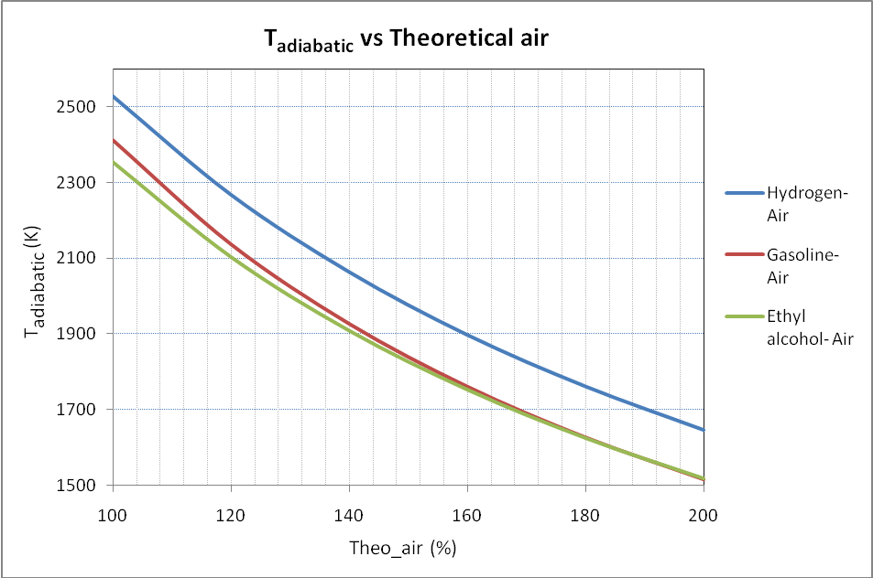

From the nature of the graph of the adiabatic temperature vs the theoretical air percent for different fuels, it is clear that hydrogen has higher adiabatic flame tempearture values compared to other fuels. Also since NOx emissions increase with increasing flame temperature values, NOx emissions are expected to be higher for hydrogen fuel. For the fuels gasoline and ethyl alcohol, the trends for the adiabatic flame tempeature are similar. For these fuels, the adiabatic flame temperature reaches a maximum approximately at 100 % theoretical air and then starts decreasing with increasing excess air.

Home Problem Statement:

Compute the adiabatic flame temperature of the stoichiometric mixture of H2- air, gasoline- air, and ethyl alcohol- air at constant pressure using EES for 0, 5, 10, 15, 20, 25, 30% EGR percent. Assume that each fuel is burned with the stoichiometric amount of air in the combustion chamber. Obtain and compare a combined plot of adiabatic flame temperature vs EGR percent for H2- air, gasoline- air and ethyl alcohol- air mixture. Assume that the recirculation does not change the air feed temperature to the exhaust.

Procedure:

- As explained in procedure of example problem part (a), follow steps from 1 to 4.
- To provide EGR percent values, go to “Tables” → “New Parametric Table” and then enter number of runs. Select “Variables in equations” as “EGR_percent” and “Ta”, click “Add” and then click “OK”.
- Then in parametric table window, enter the EGR percent values for which the adiabatic flame temperature is to be found. Here we are considering stoichiometric mixtures of fuel and air.
- Once the parametric table is prepared, go to “Calculate” → “Solve Table”.
- If any error occurs, check for the definition of parameters, constant values, total number of variables, total number of equations, etc.
- Copy the values obtained for adiabatic flame temperature with respect to EGR percent and paste them into an excel file in order to obtain a combined plot for all the fuels later.

Hints:
- Generalized equation for combustion of fuel including EGR is given by
- EGR (fraction) and the number of moles of the exhaust gas mixture to be re- circulated per mole of fuel C_{x}H_{y}O_{z} (x1) are related to each other by an equation,

