**CACHE Modules on Energy in the Curriculum**

**Energy Topic: Solar Energy**

**Module Title:** Fill Factor for Solar Cells

**Module Author:** Niraj Palsule and Jason Keith

**Author Affiliation:** Mississippi State University

**Reference:** Abhik Kumar, Das. "An Explicit J–V Model Of A Solar Cell For Simple Fill Factor Calculation." *Solar Energy* 85. (2011): 1906-1909. *ScienceDirect*. Web. 28 Nov. 2012.

**Concepts:** Maximum current-density, maximum voltage and fill factor of solar cells.

**Background Information:**

We define Voc as the open circuit voltage i.e. V when J = 0 and Jsc as the short circuit current density i.e. J when V = 0.

**Example Problem Statement:**

It is customary to use the normalized voltage v and the normalized current density j such that v = V/Voc and j = J/Jsc.

Derive the following equation for Fill Factor of a solar cell: 

provided that (v) m + (j)n = 1 which was shown to be a reasonable approximation by Das. The Fill Factor of a solar cell is the ratio of maximum power of the solar cell to the product of open circuit voltage and short circuit current.

Hence we can obtain the following plot of (v) m + (j)n = 1 where m and n are variables :

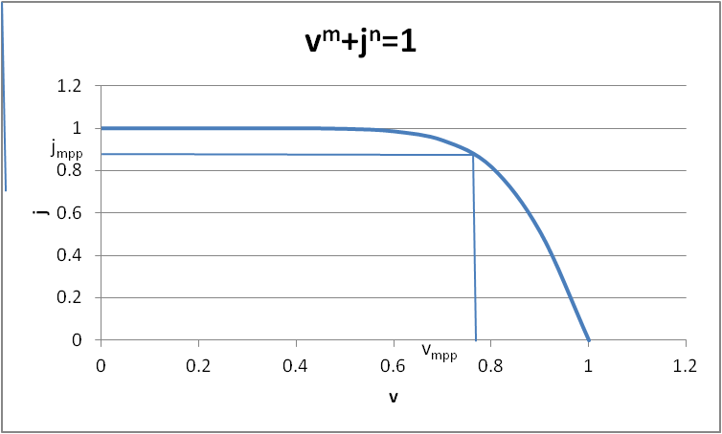

Figure 1. Reduced current j as a function of reduced voltage v.

Also, in order to find maximum normalized voltage, we need a plot of jv vs v.

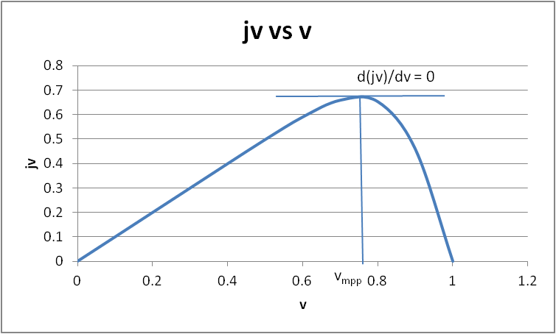

Figure 2. Reduced power jv as a function of reduced voltage v.

By inspection of figure 2, we can see an optimum power at vmpp = 0.76. Then, referring to figure 1, when v = vmpp we have j = jmpp = 0.88. Thus, FF = vmpp jmpp = 0.67. Ideally the fill factor for a solar material is as close to unity as possible. This would occur with a much sharper bend in the graph of figure 1.

**Example Problem Solution:**

Given (v) m + (j)n = 1and solving for *j*, we have:



Therefore, the normalized power (*jv*) is given as:



Using the chain rule we can show that,





which was obtained upon rearrangement. Therefore, = 0 when,

 = 0

This occurs when the sum in brackets is zero. That is,

  = 1

Cross multiplying,

 

Rearranging,  

Thus, 

Finally, 

Alternatively, 

Finally, we obtain: 

Now if we substitute this value in  we get,

jmpp = 

Which can be written as:

jmpp = 

Expanding, we obtain:

jmpp = 

which can also be written as:

jmpp = 

For the Fill Factor, FF = (vmpp)(jmpp)

FF = 

Which can be written as:

FF= 

**Home Problem Statement:**

1. Show that  and  given that

nlog(j) = log(1–vm) and at v = a, j = ja and at v = b, j = jb. In your derivations, assume that the value vm <<1 such that log(1–vm) ~ –vm .. (since vm <<1).

2. For a silicon solar cell with m=12.7 and n=1.14, find the fill factor.

3. Find m and n when current density at 0.441V is 63.0 mAcm-2 and at 0.405V is 54.9 mAcm-2. Assume the open circuit voltage and short circuit current density to be constant at 0.9 V and 1.5 mAcm-2.