CACHE Modules on Energy in the Curriculum
The Power of Solar Energy

Module Title: Using System Advisor Software Tool
Module Author: Niraj Palsule and Jason Keith
Author Affiliation: Mississippi State University
Problem Statement:
Tennesse Valley Authority buys electricity generated from Solar PV intalllations by paying an additional premium amount of $0.9/kWh to the retail rate for first 10 years and only the retail rate after that. Use System Advisor Model Software (SAM) to estimate the output of a 30.4 KWdc PV installation at Meridian,MS which would sell its electricity to TVA. Compare between fixed tilt, 1-axis and 2-axis array. For simplification. assume that TVA buys the electricity at the said additional premium amount for the entire period of 25-years.
Solution:
1) Download System Advisor 2013 beta version from https://sam.nrel.gov/content/downloads. Registering for an account at the SAM website is required. The software can be downloaded after logging in.
2) After you open the software, type the desired name of the project. We will name this one as “Swalm building”.
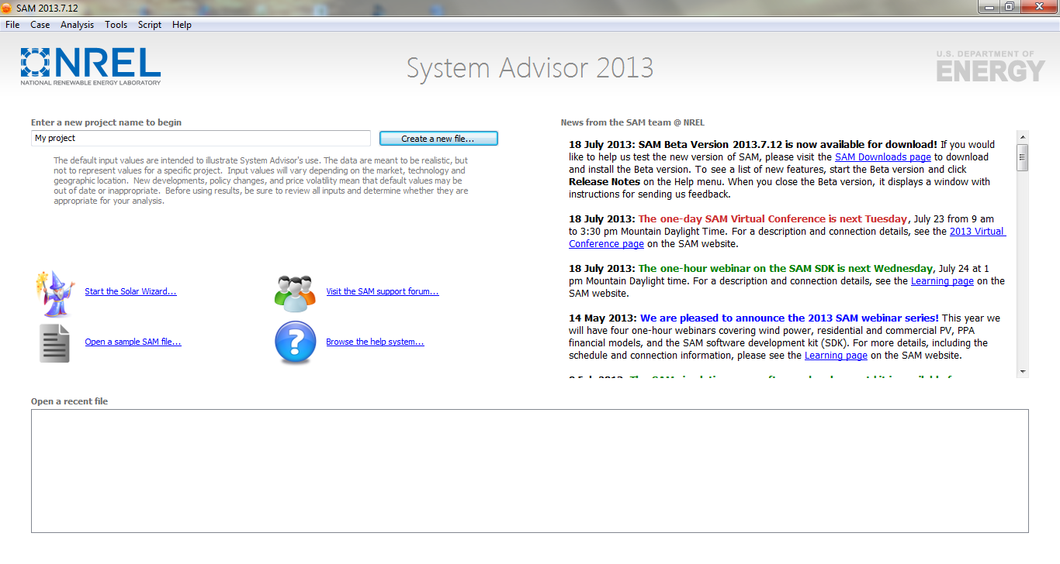
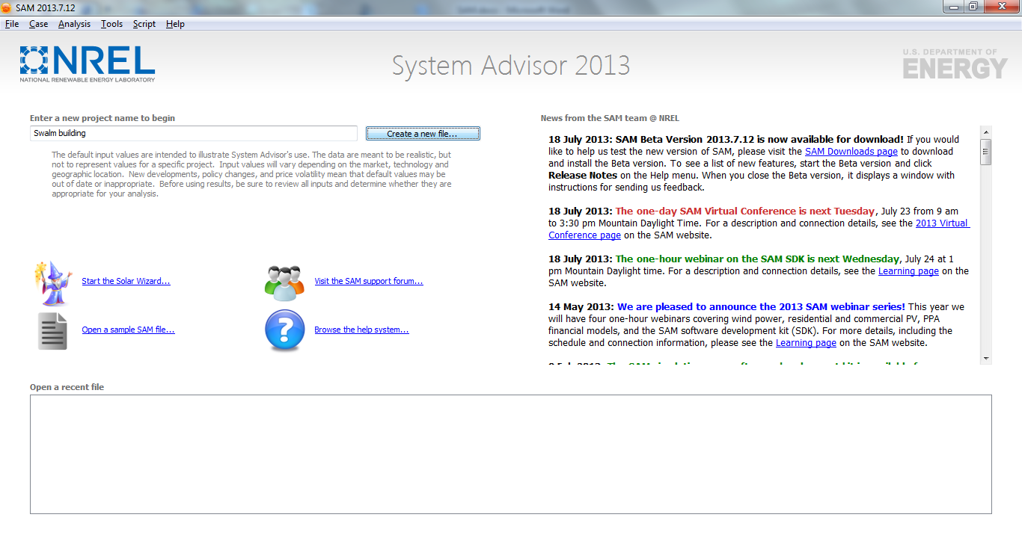
3) Clicking on “create a file” would lead you to a page allowing you to choose between different renewable energy systems. Choose “Photovoltaics” and proceed by clicking “Ok”.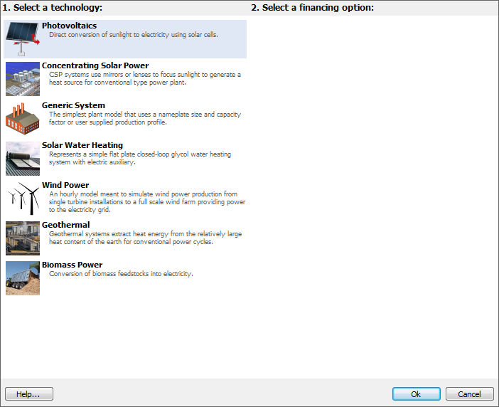
Choose “Flat Plate PV”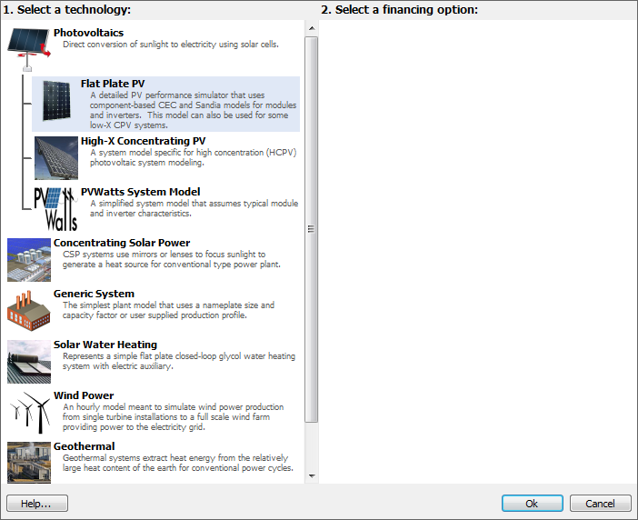
Since we are going to sell the electricity, choose “Commercial”.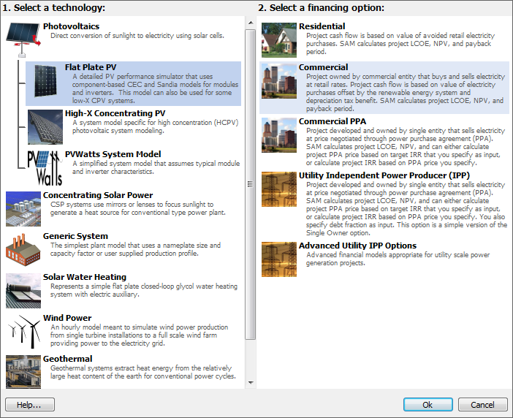
4) The program will open a window with many inputs for calculation: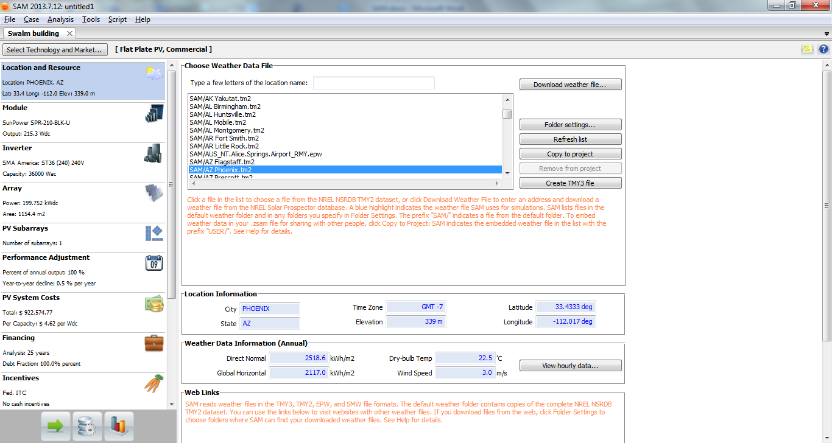
5) “Location and Resource” : Choose “Meridian” by typing MS in the search box.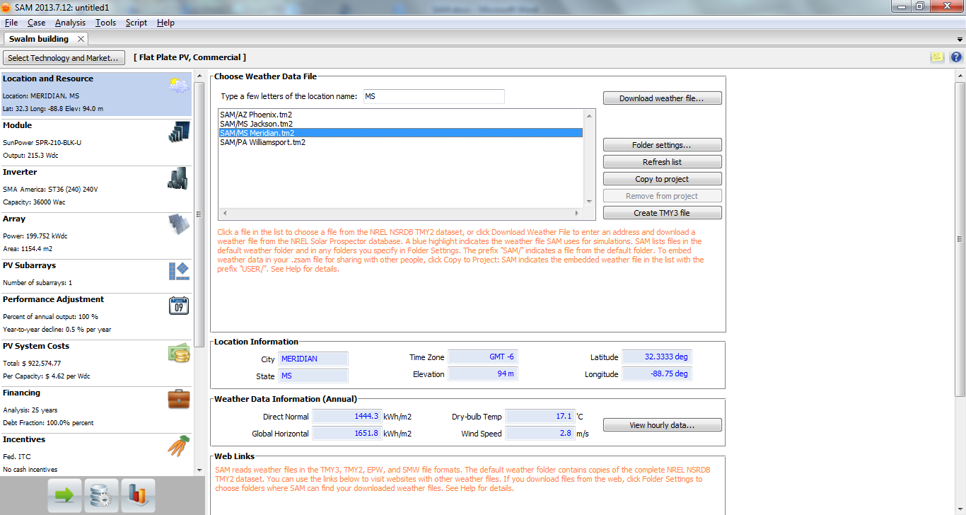

6) Module : Amongst a list of various models of solar cells, “SunPower SPR-210-BLK-U” would be set as default. Let us use this itself. No need to change anything in this entire section.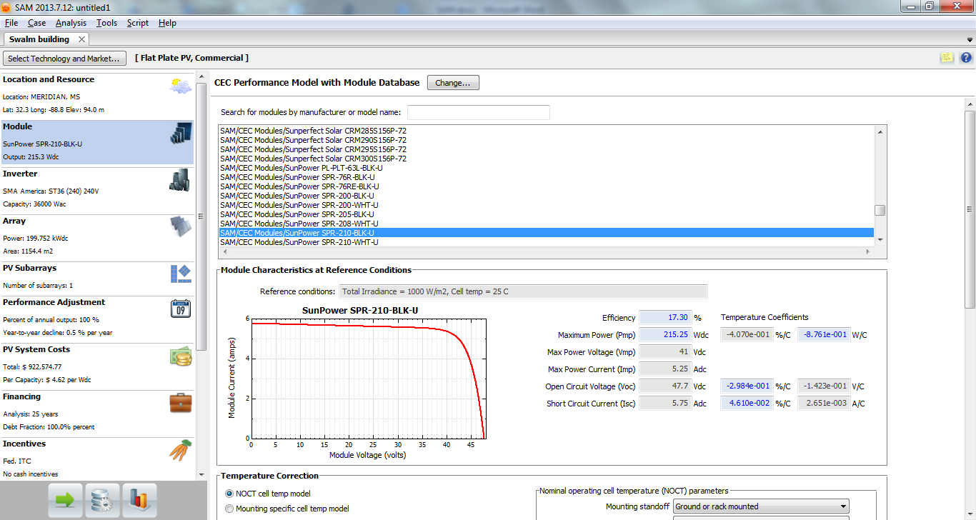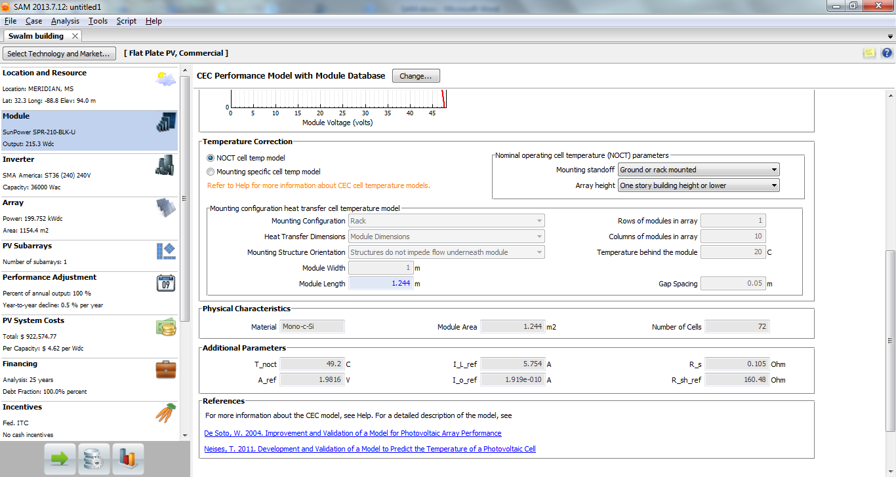

7) Inverter: The default inverter in our case is “SMA America ST36 240V”. It has a capacity of 36000 Wac. Since we plan to install a 30.4 kWdc system,we would use this one itself. The inverter capacity should not be lower or too higher than the size of the installation.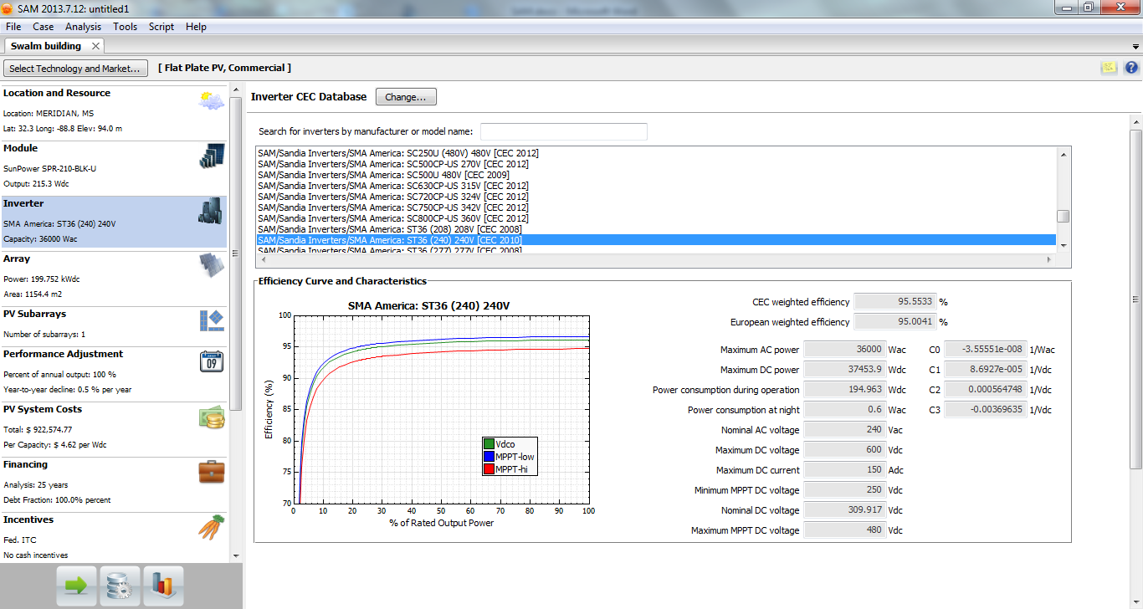
8) Array: The default value for a commercial array size would be 200 kWdc and DC/AC ratio would be the 1.1.
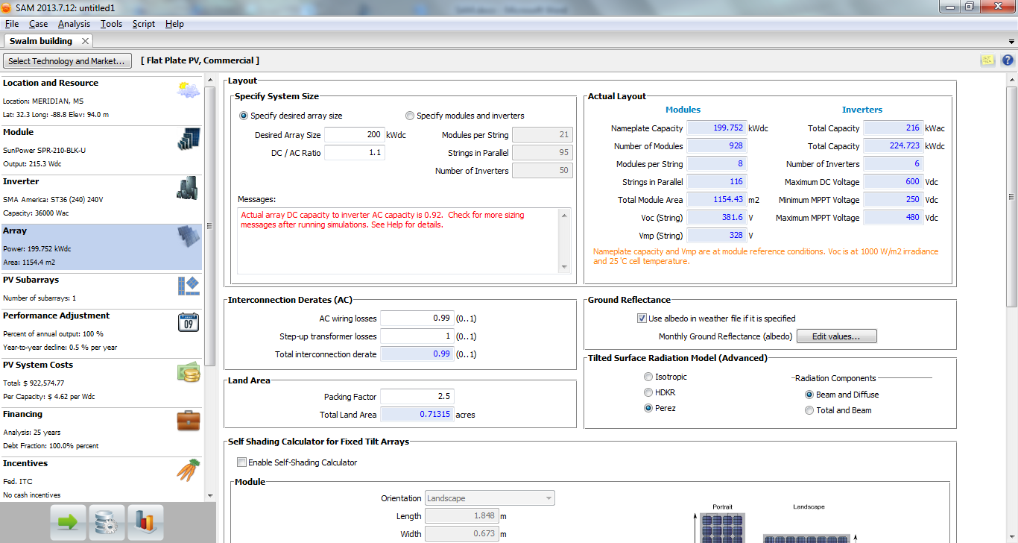

Change the “desired array size” to 30.4 kWdc and keep the default values for rest of the section.
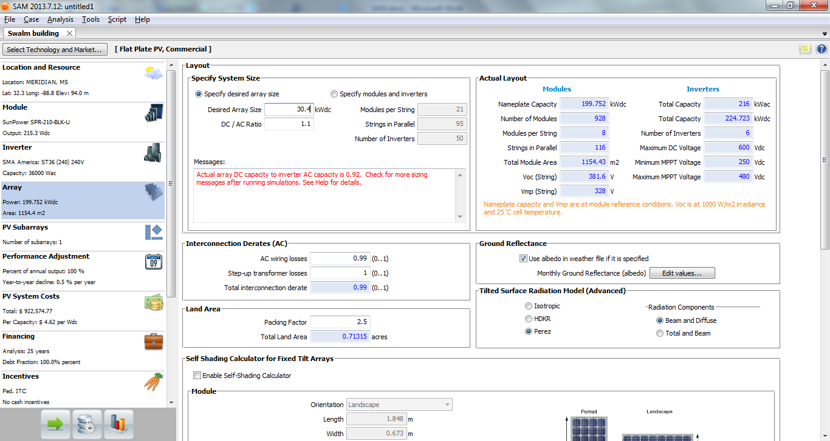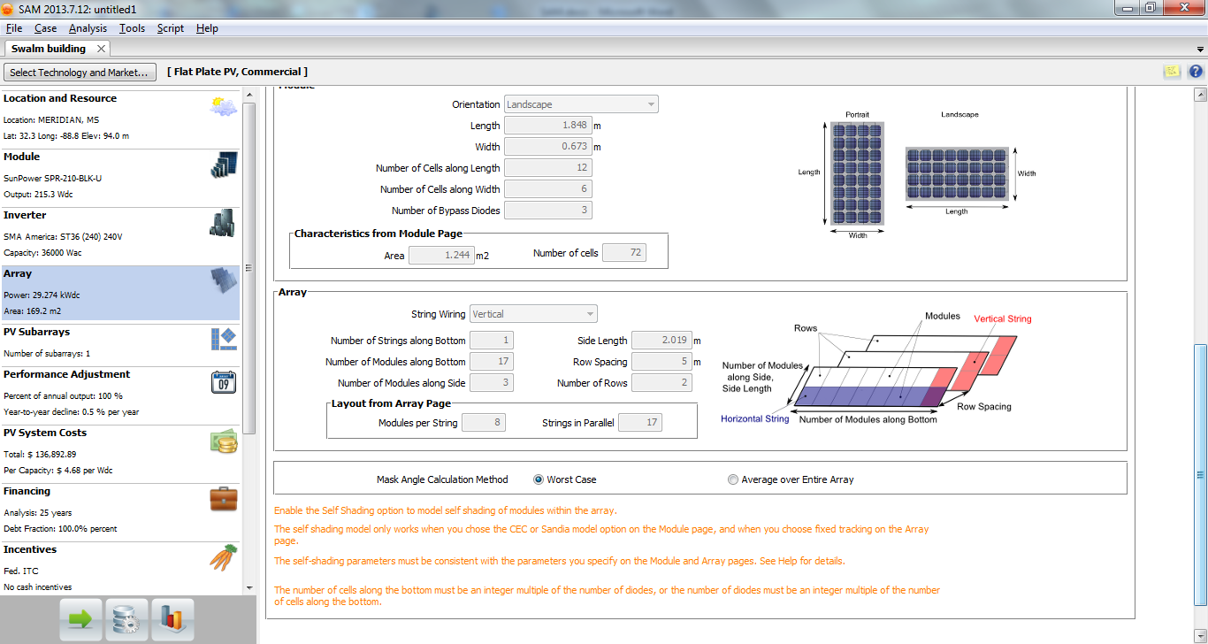

9) PV Subarrays: Many times the array is split into parallel arrays for optimum usage according to the location. We won’t be considering any such subarrays. The “Tilt” and “Azimuth” of panels is set to default (for a better output in general) according to our location at 33 and 180 degrees respectively. Hence no need to change that. We would change the tracking of array later on. For now, the default “Fixed” is fine. We can proceed to the next section without changing anything else.
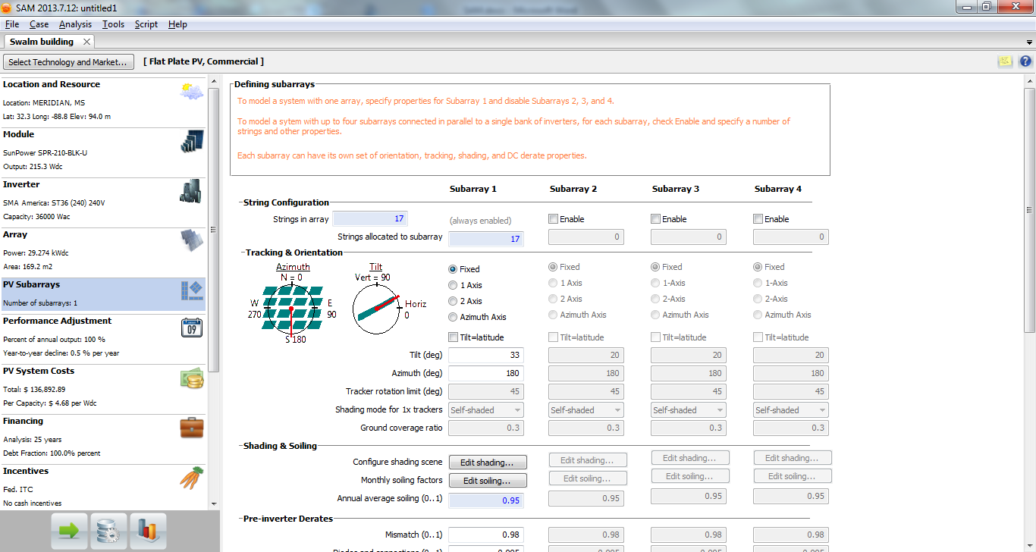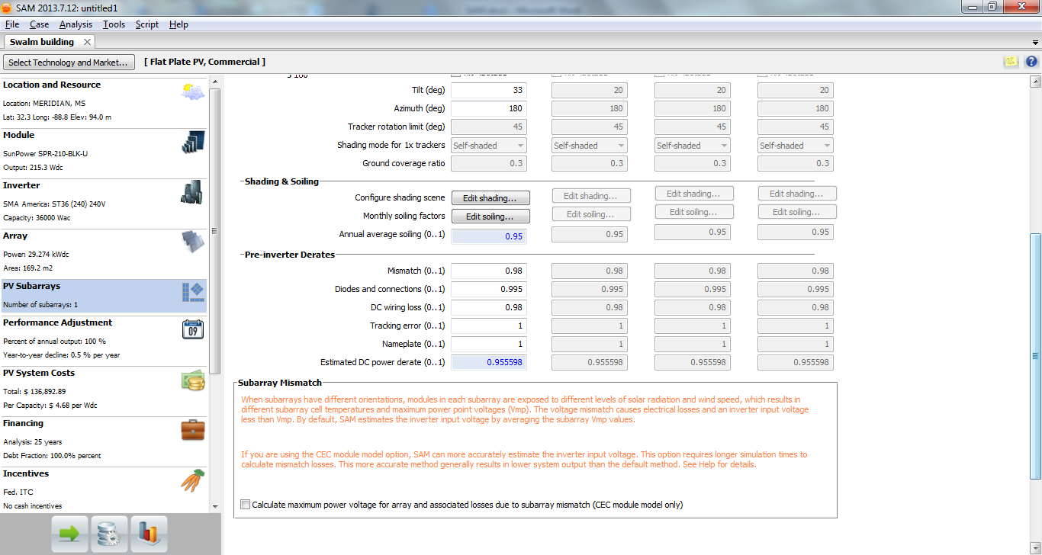
10) Performance adjustment: We need not worry about this section and leave it as it is. This is generally useful for utility service providers who have to match the demand-supply load. 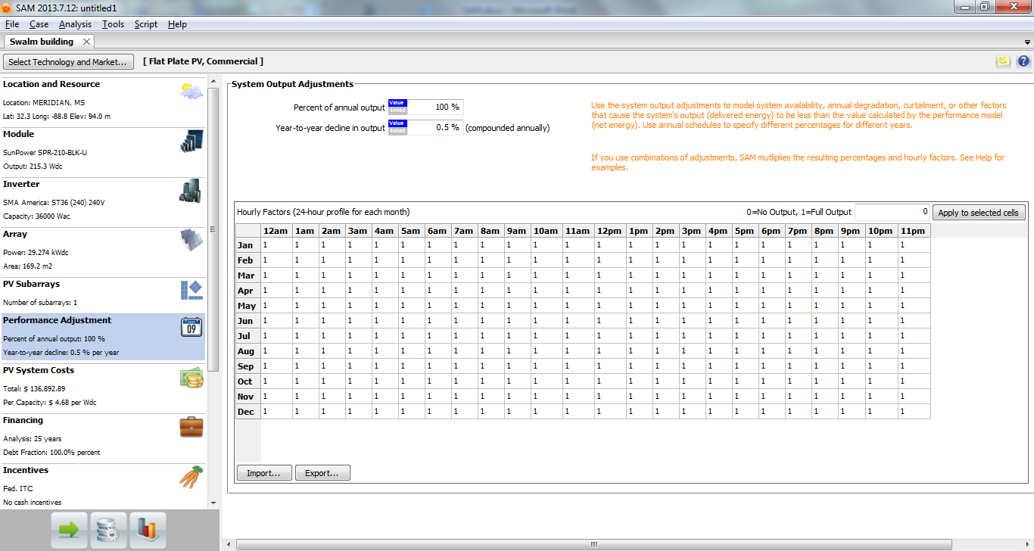

11) PV System Costs: This section enables us to input the detailed costs of installing the system. A total cost and cost in terms of $ per Wdc is calculated based on our inputs. 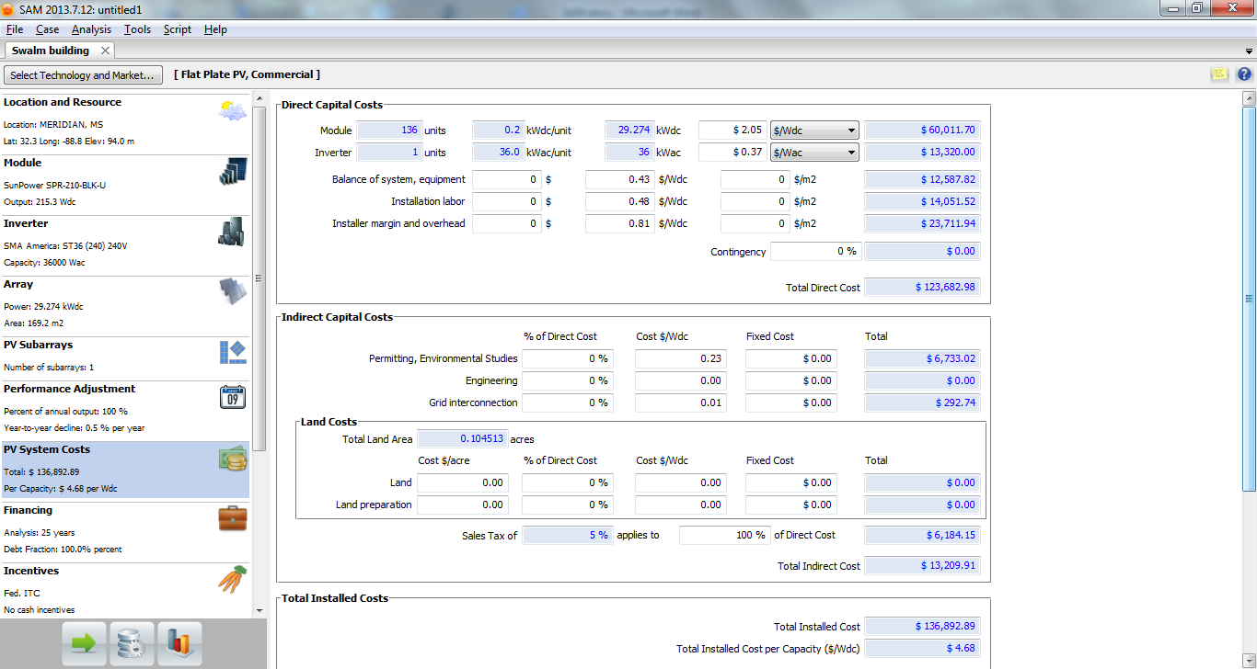

The Module cost is set to $2.05/Wdc by default.A raw search over the internet would make you familiar with the current module prices. Modules in the range of 15-17% efficiency are now widely available at a price of $1-$1.5/Wdc and few at even lesser prices. Let us use $1.5/Wdc as the module price.
30.4 kWdc is a medium-sized system for rooftop installation . Such installation can be done without the help of any external installer. So let us remove the “Installer margin and overhead” costs by changing its default value of $0.81/Wdc to 0. Even “Installation labour” cost can be removed if we have volunteers. However let us keep it to its default value of $0.48/Wdc for general practical purposes. The rest of the inputs can remain unchanged.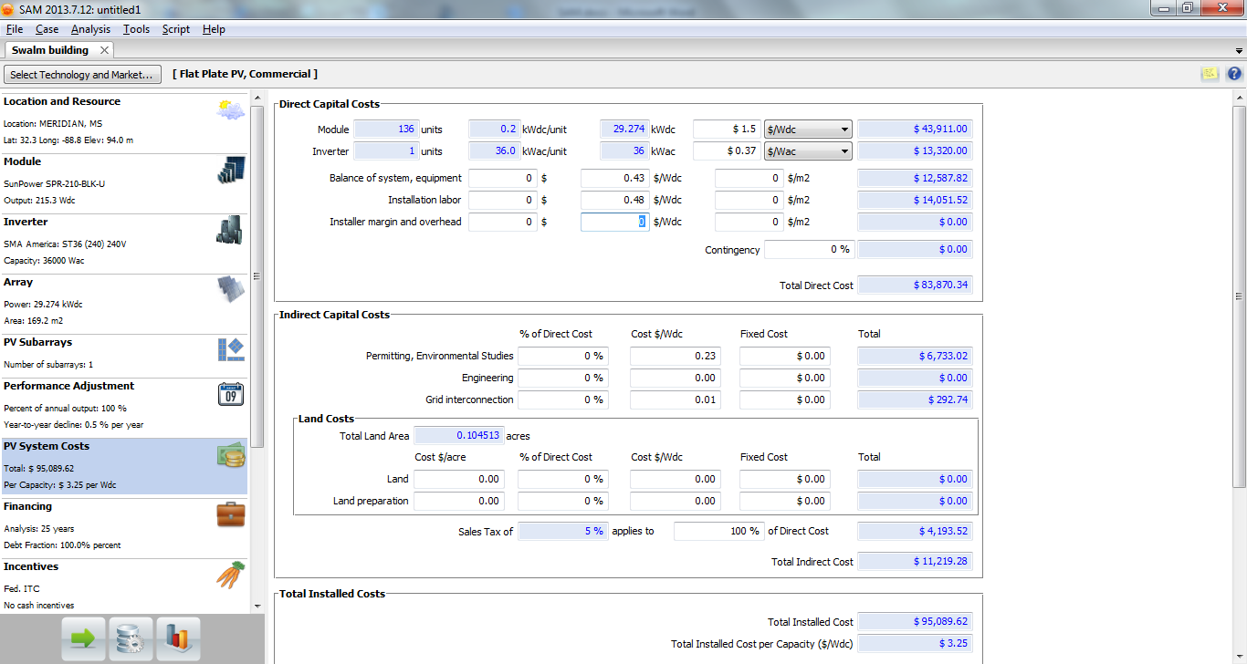
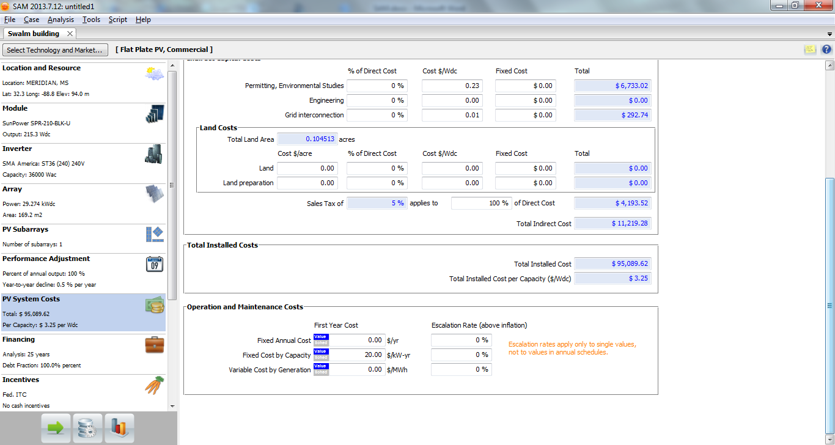

11) Financing: This section is for customizing loan terms and tax/insurance rates. We would be financing this installation on our own and hence let us change the Debt Fraction to 0% form its default value of 100%. Rest of the input values can remain unaltered.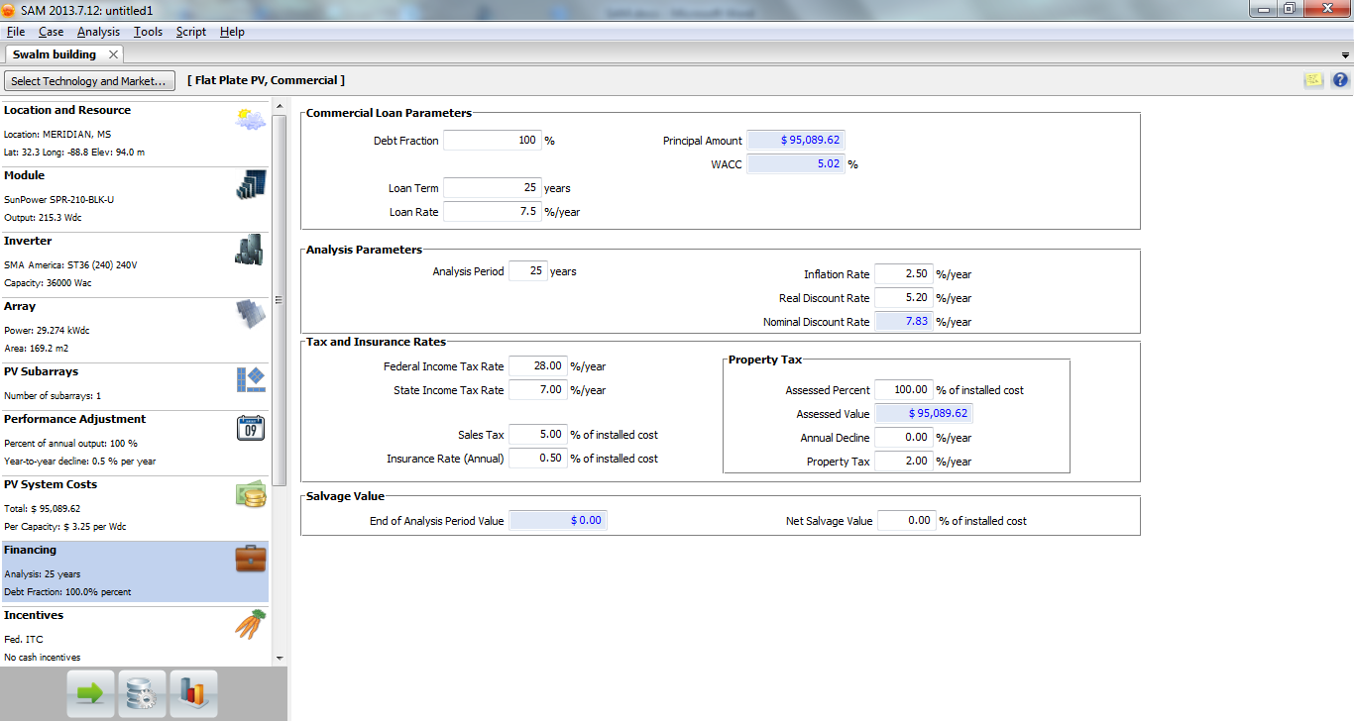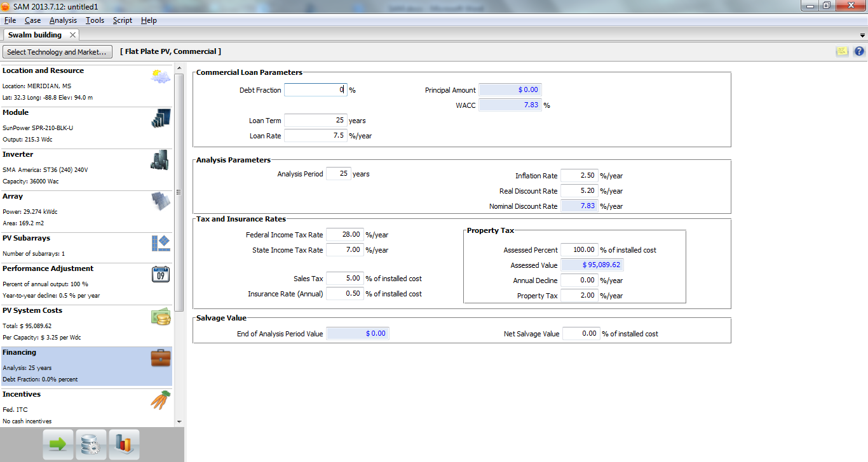

12) Incentives: A 30% Incentive Tax Credit is provided by the Federal government to all the installations in United States. This value is set as default. Since we do not have any other incentives, we would not change any input values of this section.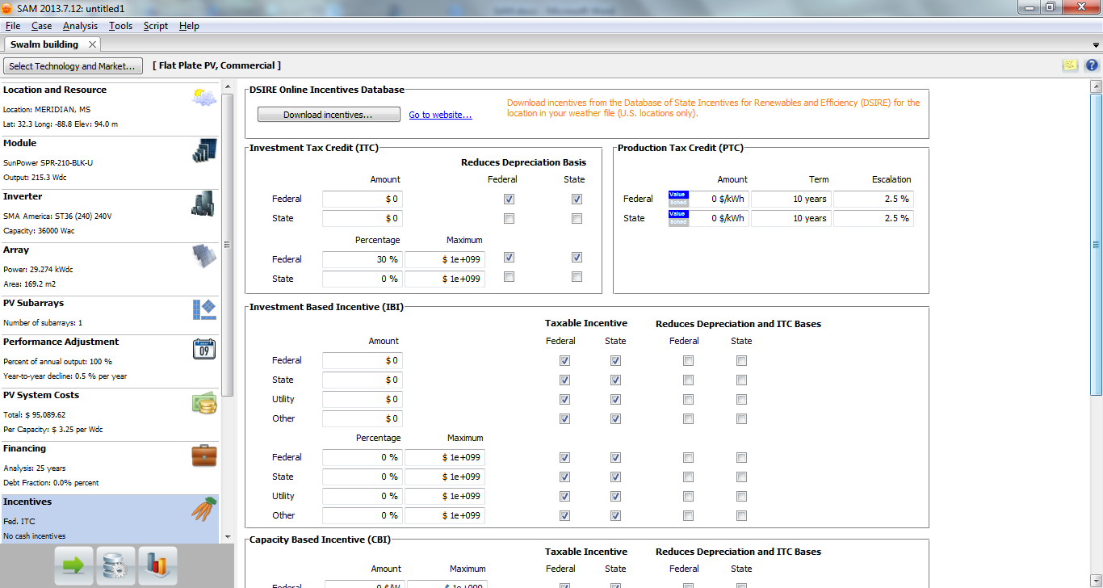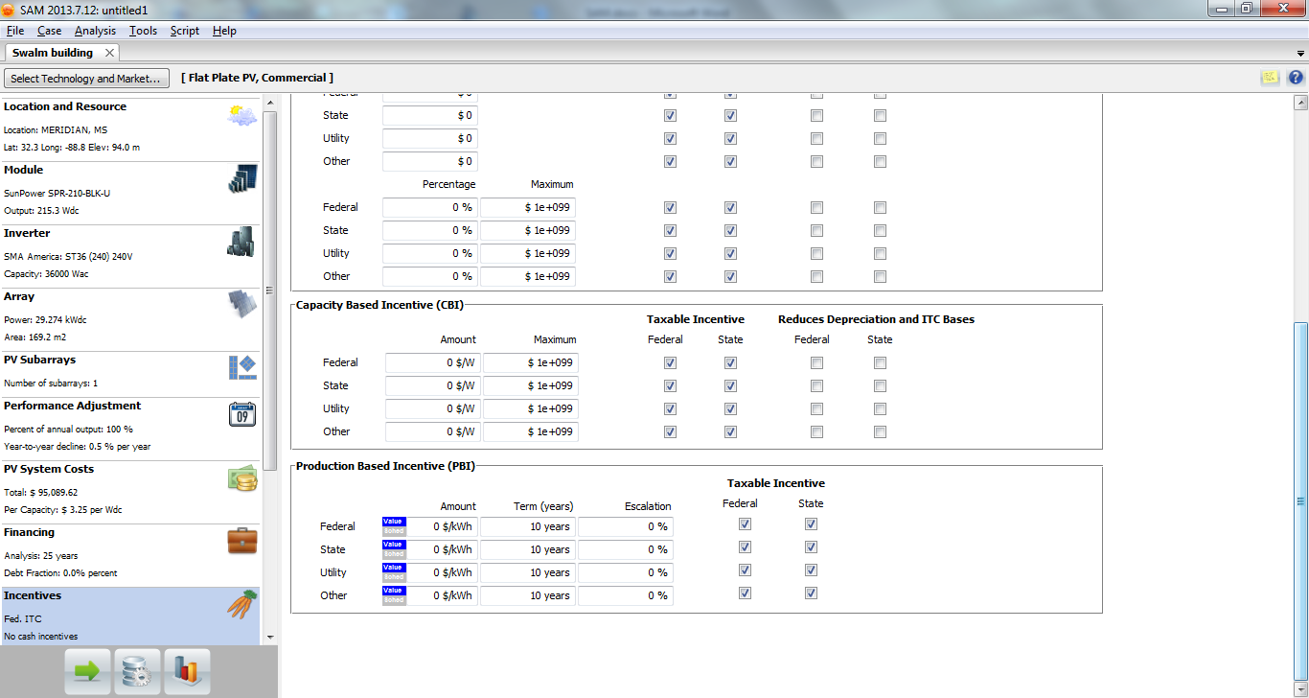

13) Depriciation: MACRS (Modified Accelerated Recovery System) is the current tax depreciaiton system in United States. Solar energy properties generally fall under the category of 5-year property class for MACRS depreciation. This is the default option for Depreciation which we would not change.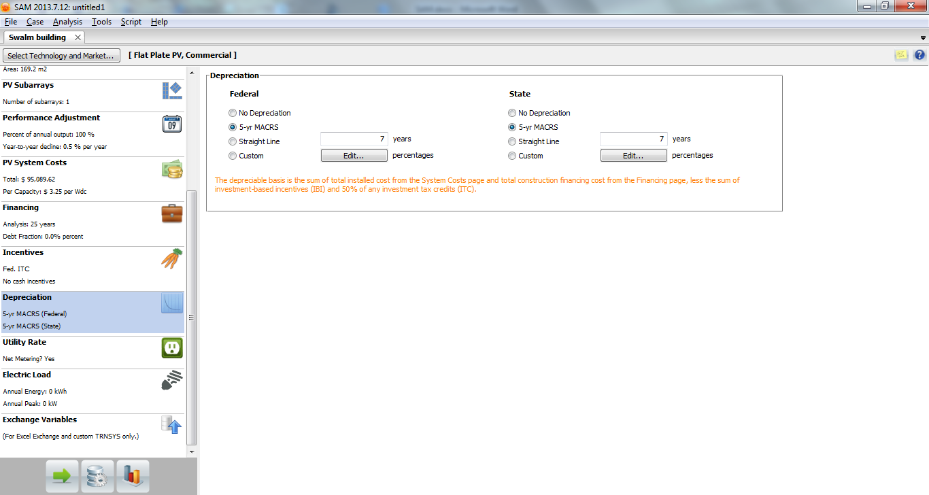

14) Utility Rate: Considering the policy of Tenesse Valley Authority, we would be selling the generated power at a rate of $0.11 + $0.09 = $0.20/kWh (retail rate + $0.09). Hence we would uncheck the option of Net metering and put the value of buy rate to be 0. Instead the “flat sell rate” would be $0.20/kWh. All other values need not be changed.
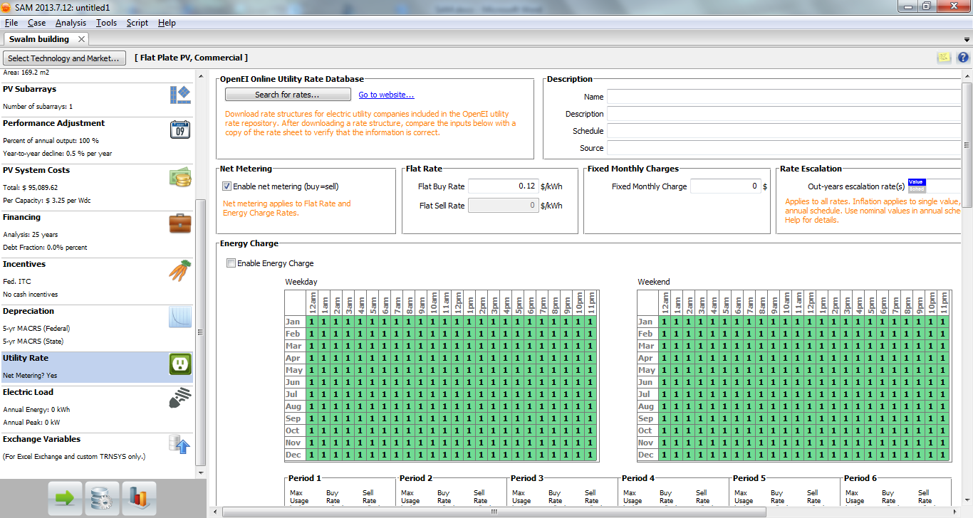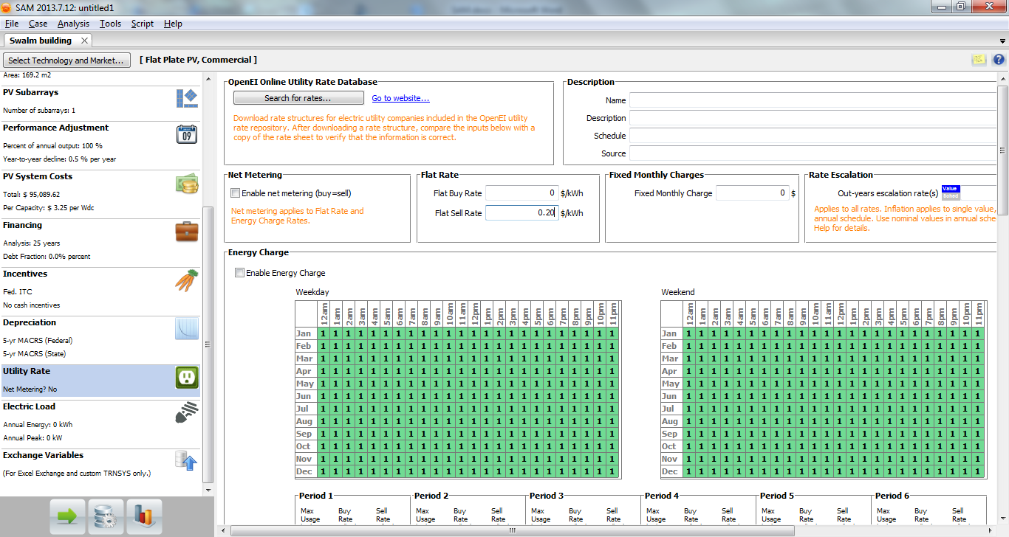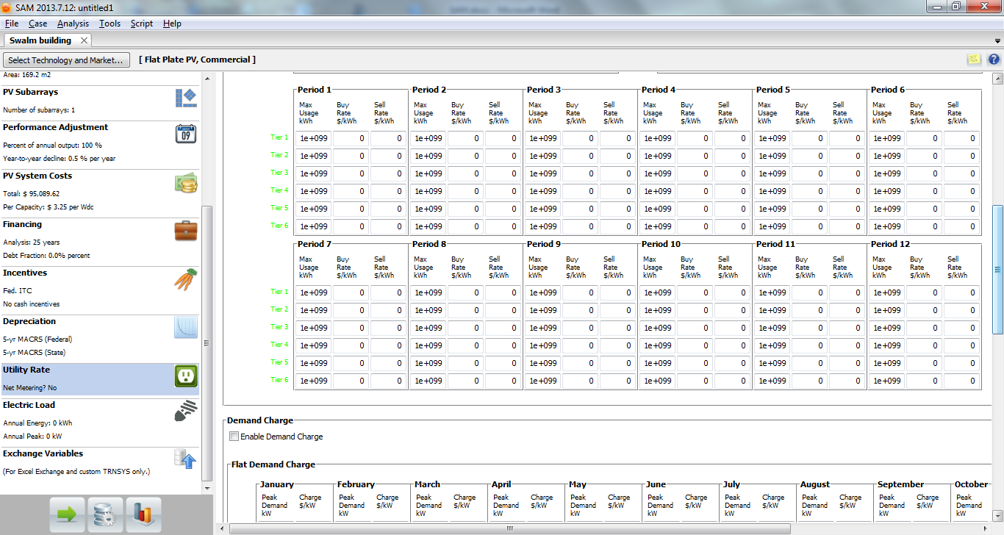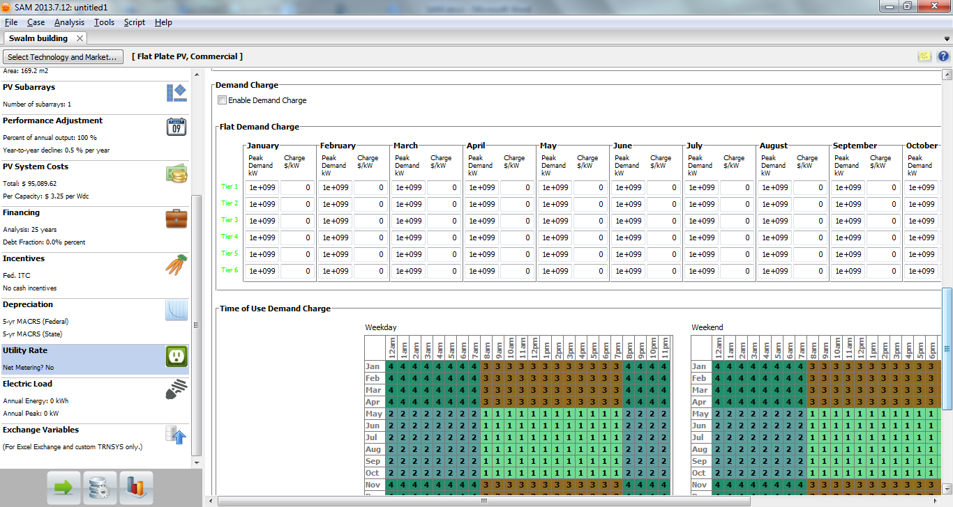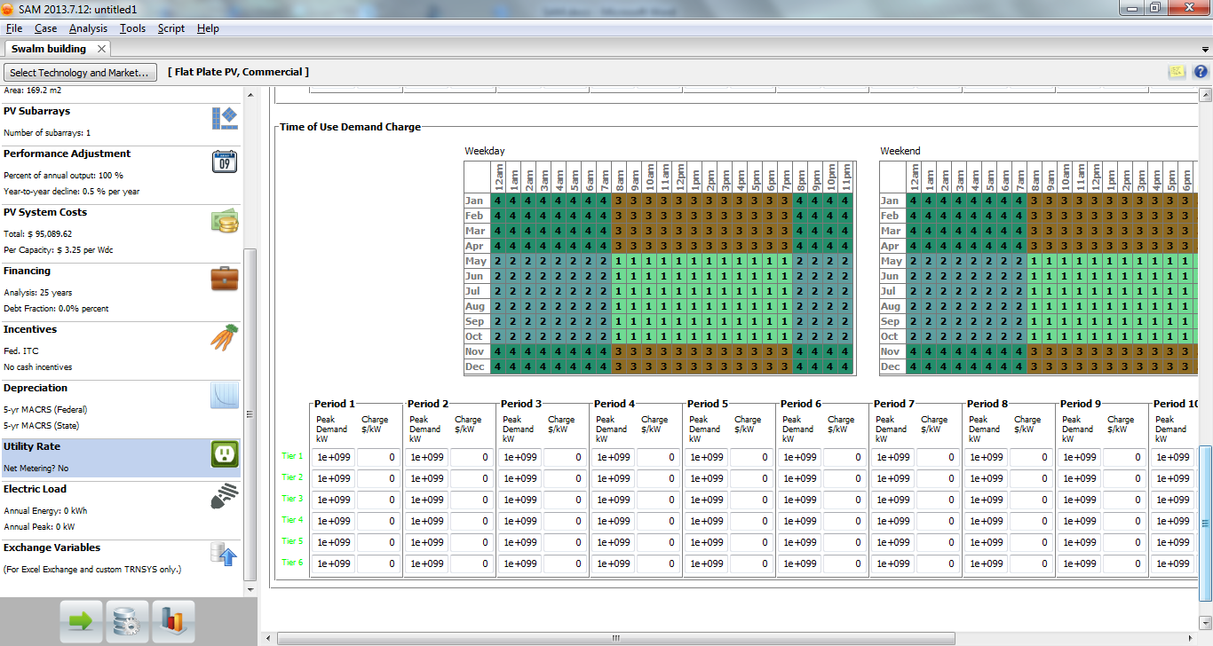

15) Electric Load: This section is for providng the consumption values of a load like a building which would be powered by the installation. Since we are not connecting any such load to our installation, we need not worry about this section. Our installation is grid connected and the power is for selling purposes only.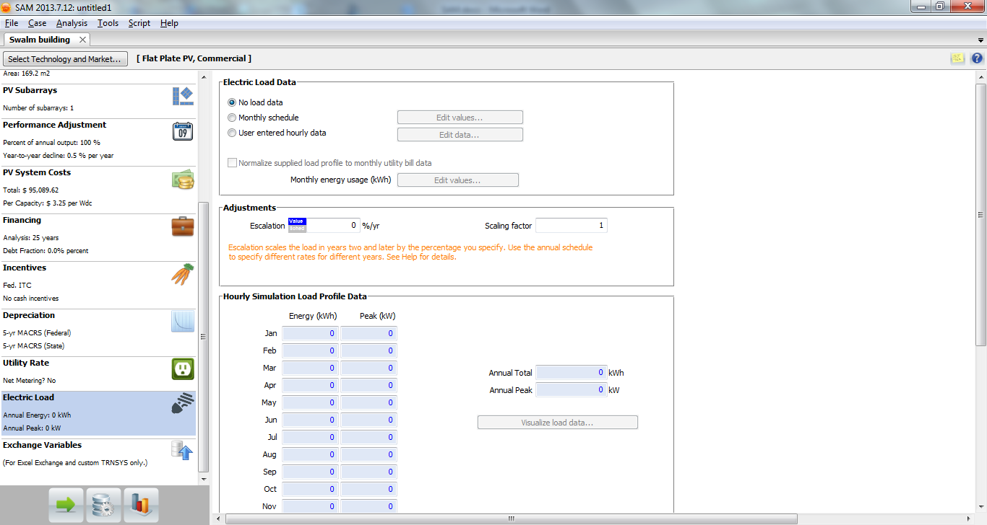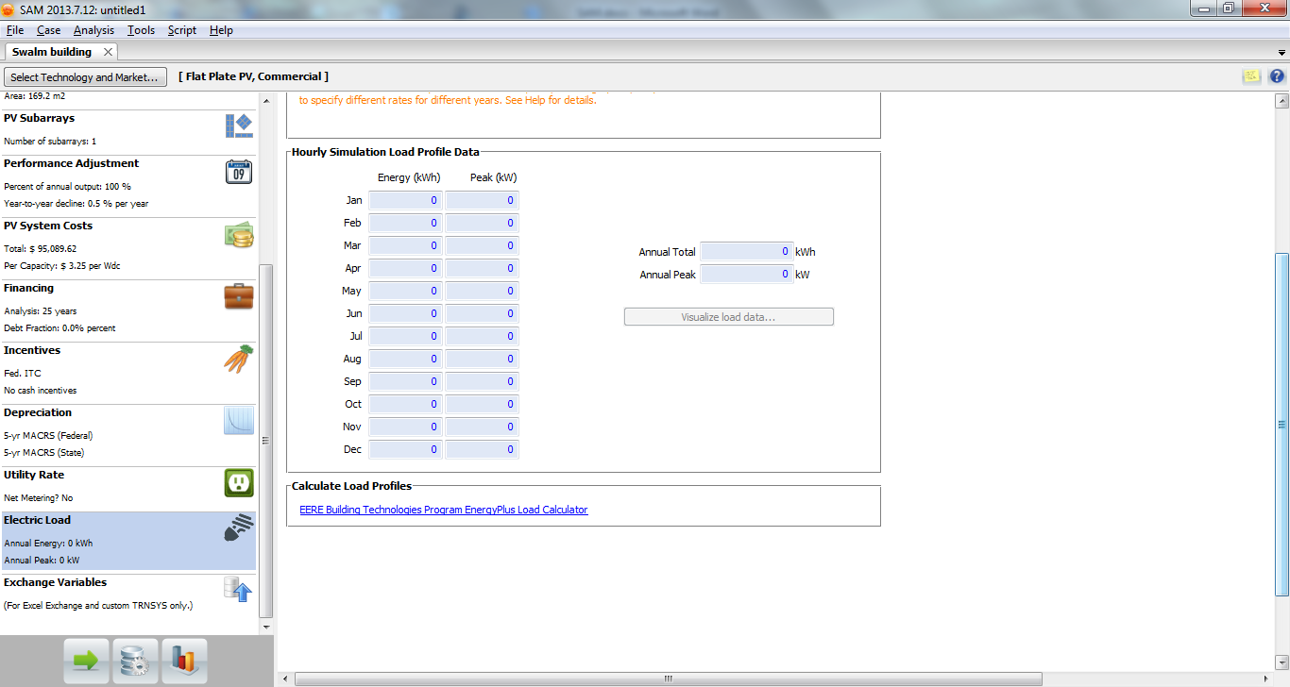

16) Exchange Variables: This section is useful for more complicated simulations wherein any other variable parameter are needed to be defined. Neglect it for our scenario.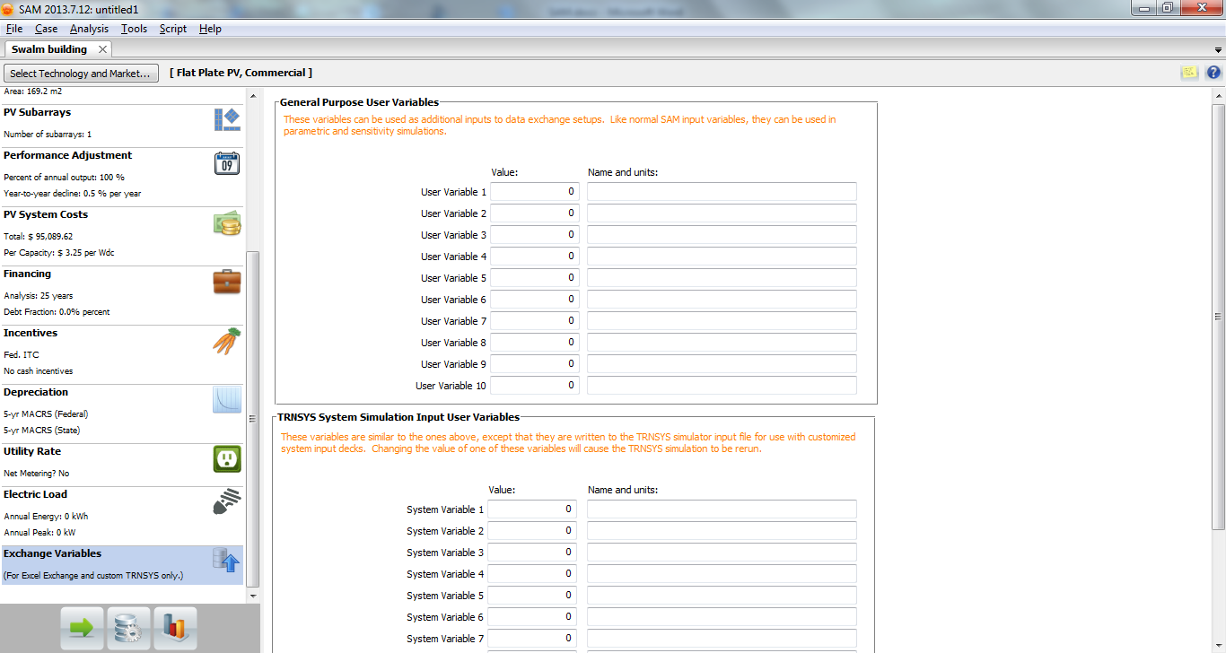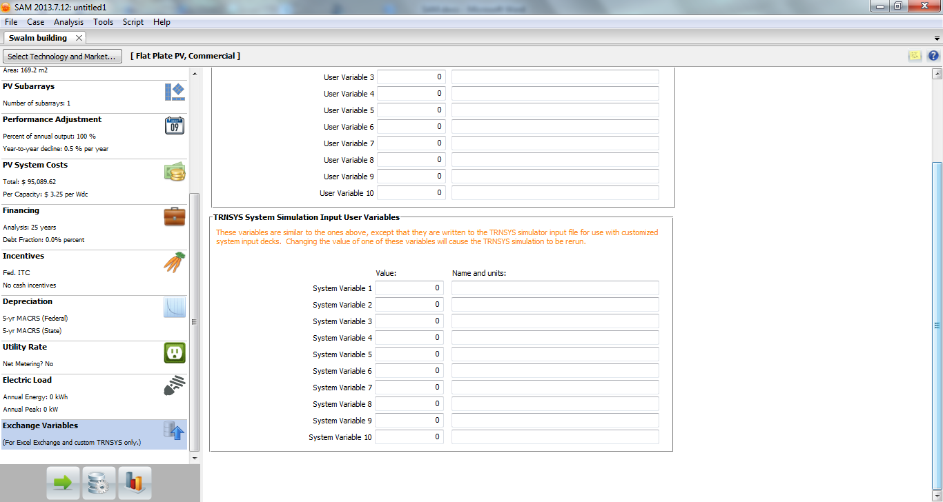

17) Click on “Run” (Green arrow) to simulate and see the results. You would get a wide variety of data.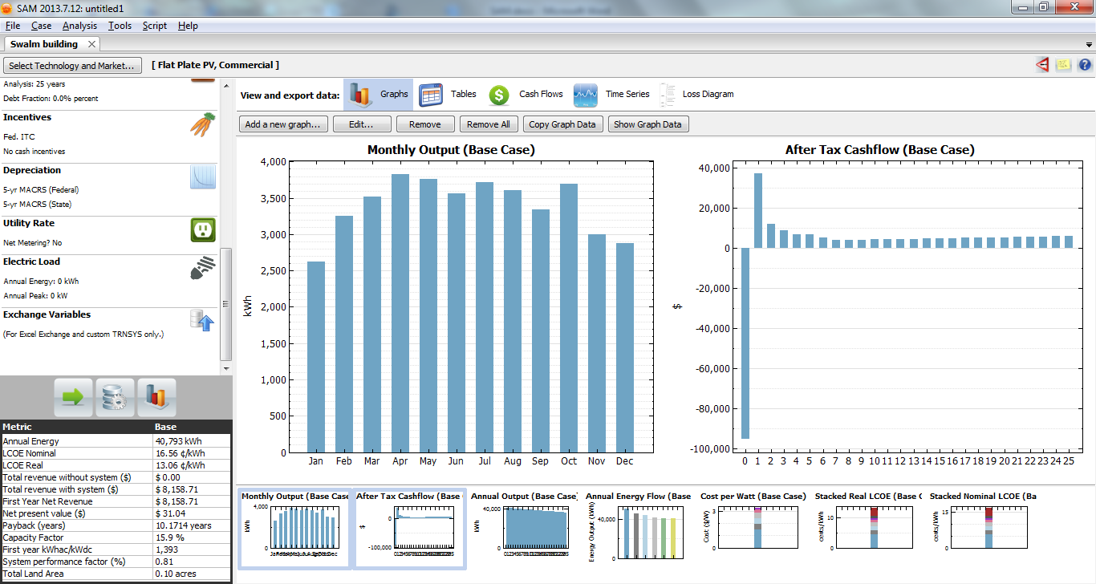
18) For changing the tracking of the array, go to PV Subarrays and choose 1-axis or 2-axis as desired. Be sure to go to PV System Cost to count for the added expenses of tracking. The change of cost should be done in the “Balance of System” input value. Increase the cost by $0.05/kWh for 1-axis and by a $1.00/kWh for 2-axis as compared to the cost of fixed tilt. Click “Run” to see the results once the changes are made. 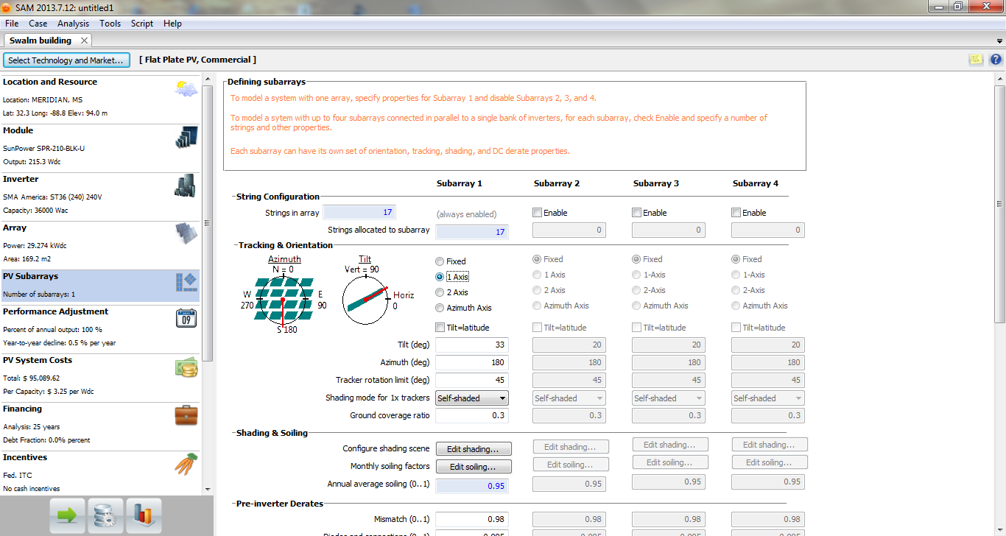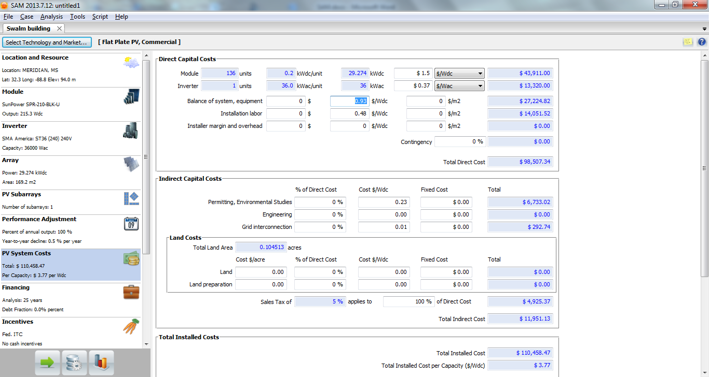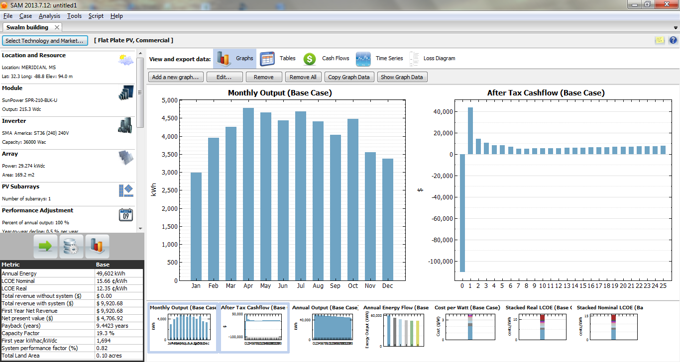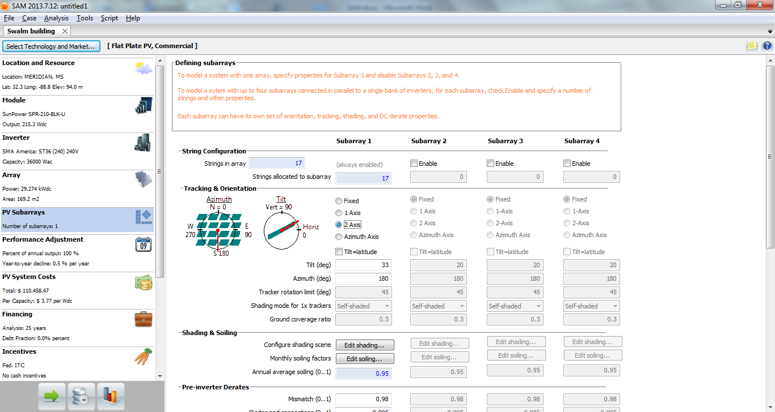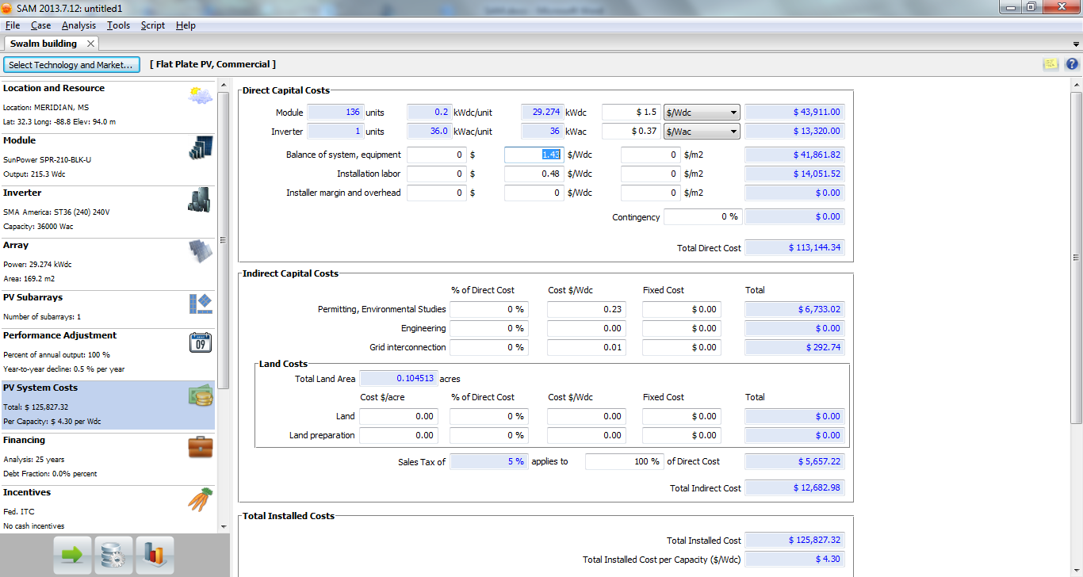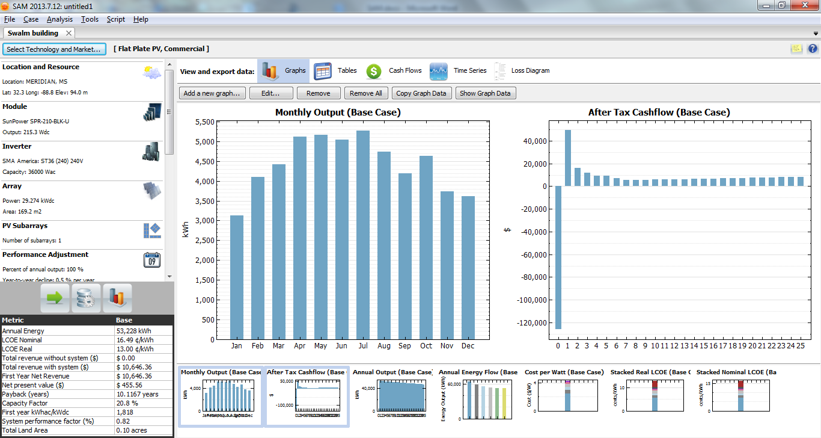

19) The file can be saved by going to File Save or a pdf report can be generated by clicking on ToolsGenerate Report.
The output of the installation can be summarized and compared as shown below:
1. Fixed tilt 2. 1-axis 3. 2-axis
The important factors which have changed are the annual energy, payback years and capacity factor. The annual energy and capacity factor increase drastically when we use 1-axis tracker instead of fixed tilt. This is because the tracking mechanism helps to increase the efficiency of the array. More amount of incident light can be utilized. The payback period is reduced by an year since the output-cost ratio is higher for 1-axis tracker. The increase in annual energy is relatively low between 2-axis tracker and 1-axis tracker. This itself is the trend which is generally seen. Even though the annual energy increases, the payback period increases as well. This is due to a lower output-cost ratio that for 1-axis tracker. Thus using 1-axis tracker turns out to be the best option in terms of payback period.

Homework Problem:
Use the Parametric Simulation method to solve Example Problem 1.

