CACHE Modules on Energy in the Curriculum
The Power of Solar Energy

Module Title: Using the PV Watts Online Tool
Module Author: Niraj Palsule and Jason Keith
Author Affiliation: Mississippi State University

PVWatts is an online tool developed by National Renewable Energy Laboratory (NREL) which determines energy production and related costs for photovoltaic solar energy installations. It is useful for manufacturers, installers and homeowners for estimation. Users can customize parameters like size, array type, tilt angle, azimuth angle, electricity cost and utility pricing. PVWatts uses the meteorological data for selected locations and calculates the incident solar radiation. Based on this it generates an hour-to-hour output for the array. Note that the module is based on a beta version which combines the functioning of three NREL softwares viz. PVWatts version 1, PVWatts version 2 and IMBY (In my backyard). Students might see slight changes in the tool as it gets updated.
Example Problem
Problem Statement:
(a) Use PVWatts to estimate the output of a silicon solar PV installation on the roof-top of Dave C. Swalm School of Chemical Engineering building, at Mississippi State University. Compare it for a fixed tilt, single axis tracking and double axis tracking array.
(b) Verify the result by rough hand calculations.
Solution:
Part (a)
1) Go to http://pvwattsbeta.nrel.gov/ to open PVWatts tool.
2) Enter Mississippi State University as the location as shown in Figure 1 and click on Go.
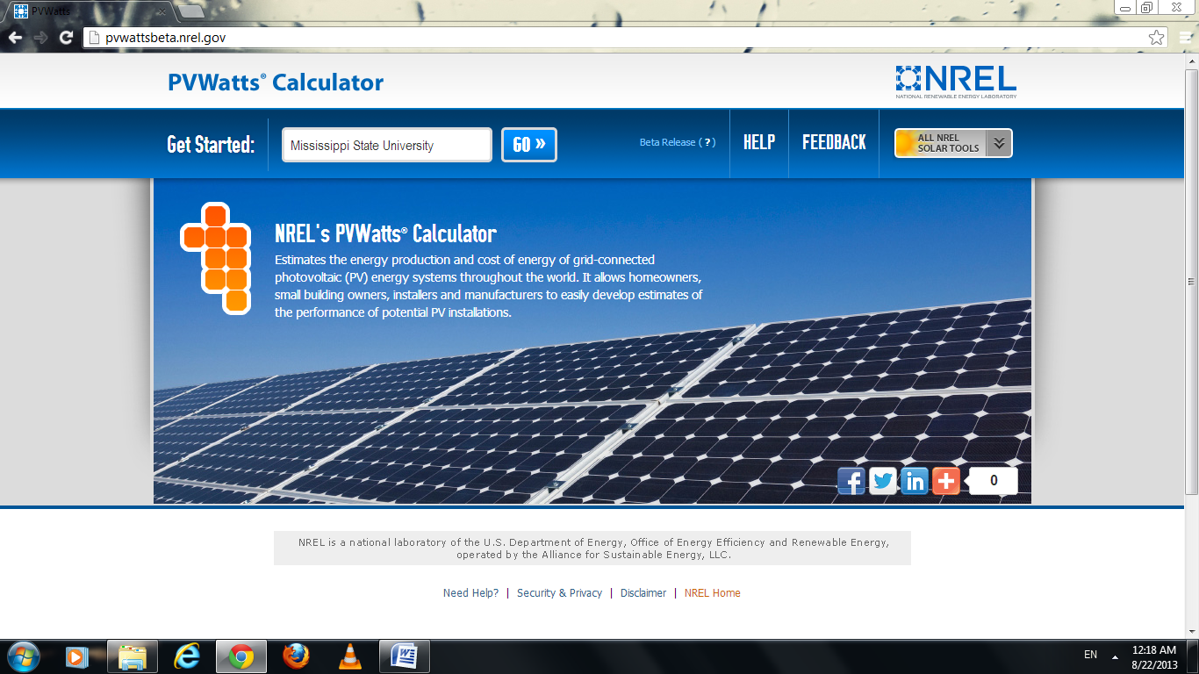
Figure 1

3) The following page would appear: 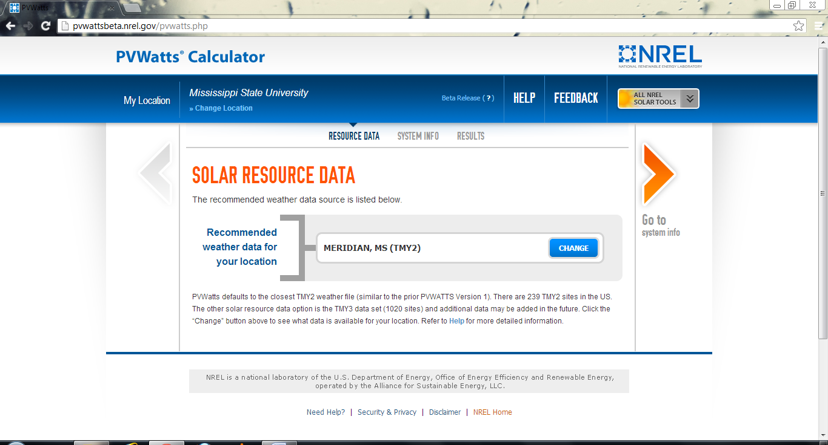
Figure 2

Click on “Change” and choose “Golden Tri (AWOS)” since it is the nearest location as shown in Figure 3 and 4.
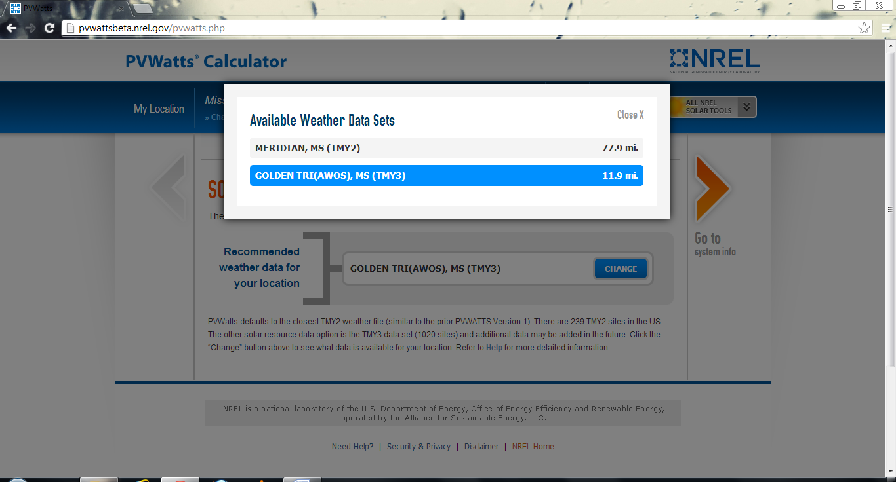
Figure 3
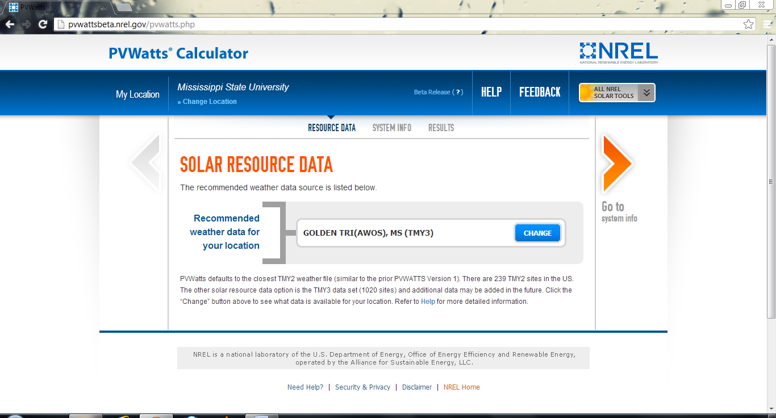
Figure 4
4) When you click on “Go to system info”, you would see a page displaying different parameters with input boxes (Figure 5). Some of them are set to a default value according to the location in order to maximize the output in general.
Let us first define the size of our system. Click on “Draw Your System”. 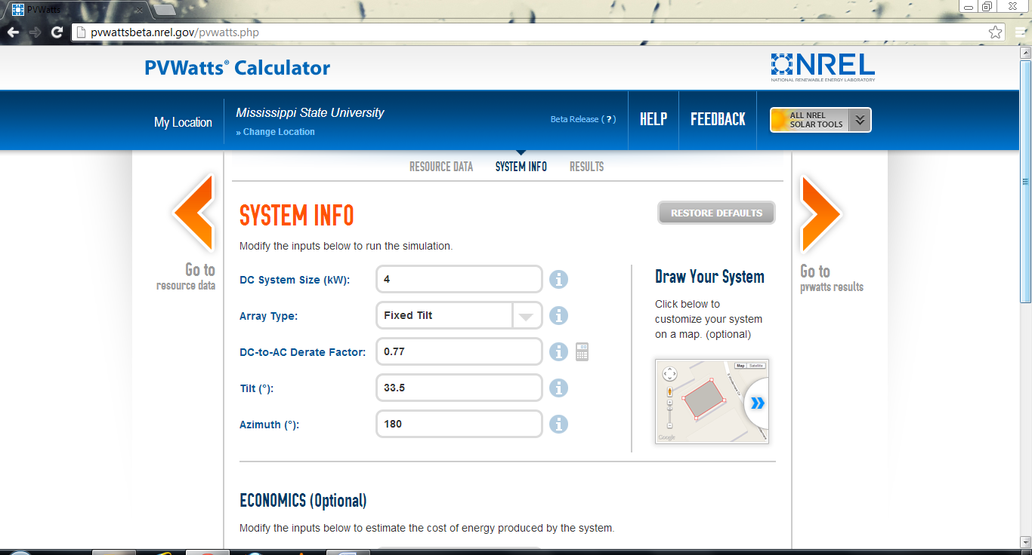
Figure 5
Since we are planning to install a system atop Dave C. Swalm School of Chemical Engineering building, let us navigate to our location. Refer Figure 6, Figure 7 and Figure 8. 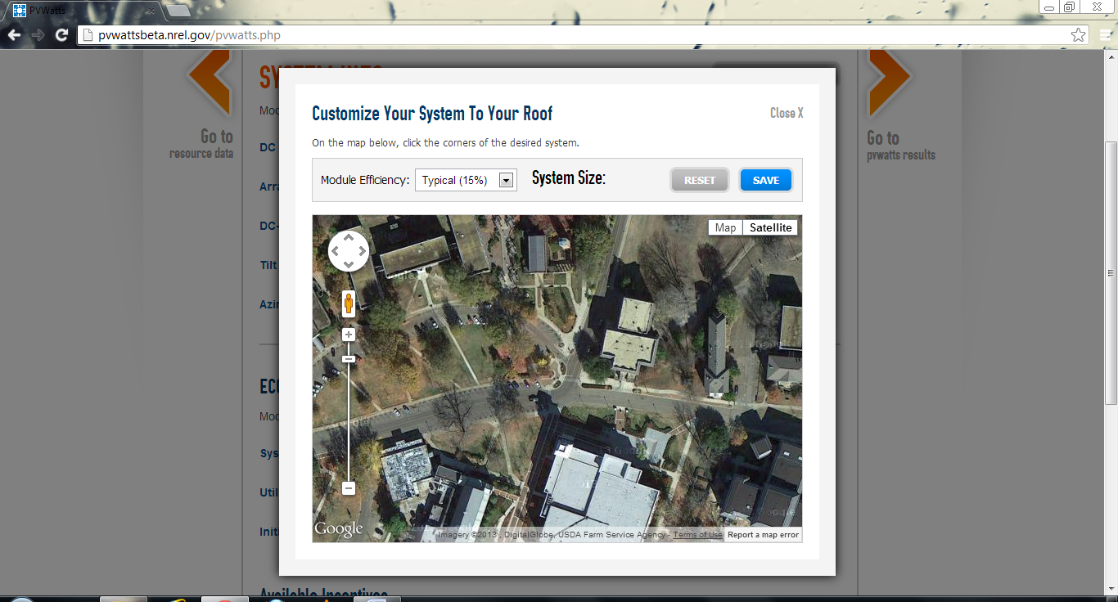
Figure 6
Turning on “Labels” helps us to identify the map quicker. Click on “Map” and check the box besides “Labels”.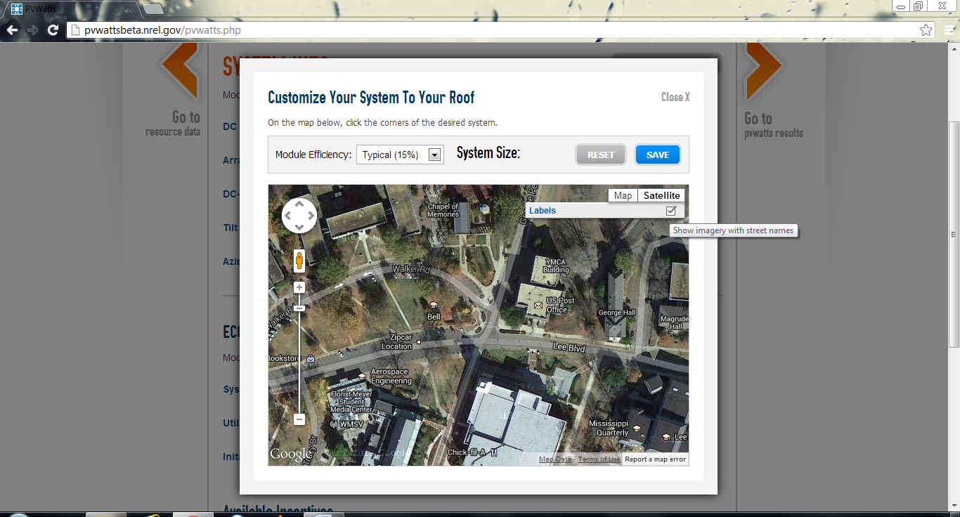
Figure 7
We will keep the module efficiency to be 15% as shown by default. 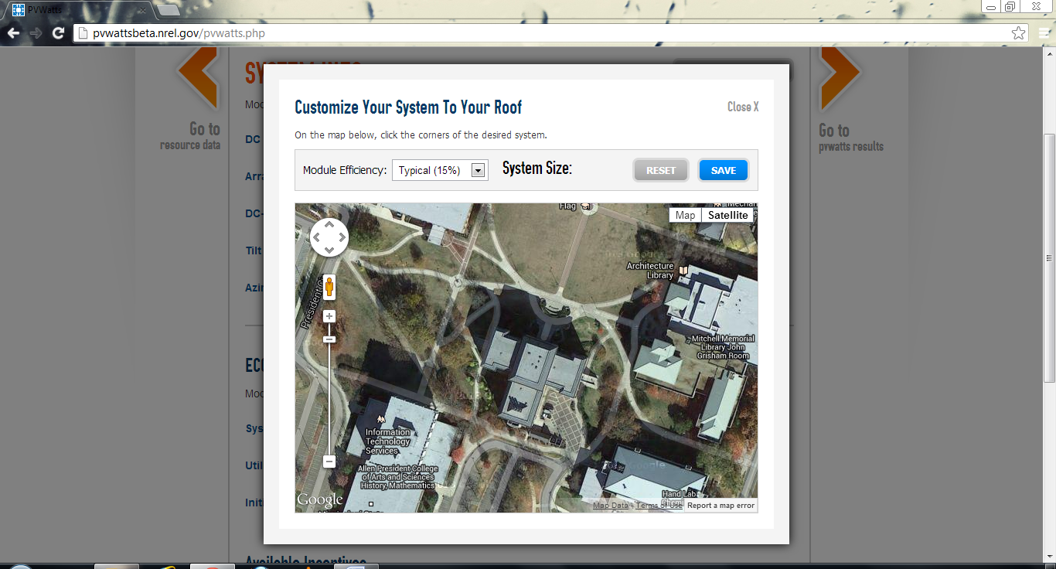
Figure 8
Create a rectangular field by clicking at the four corners of the roof. In this case, the size of the array comes out to be 30.4 KW as shown in Figure 9. Note that some space has been purposely left from the actual corners of the roof. This is done in order to roughly take into consideration the additional space required when solar trackers are used.
Click on “Save” once done.
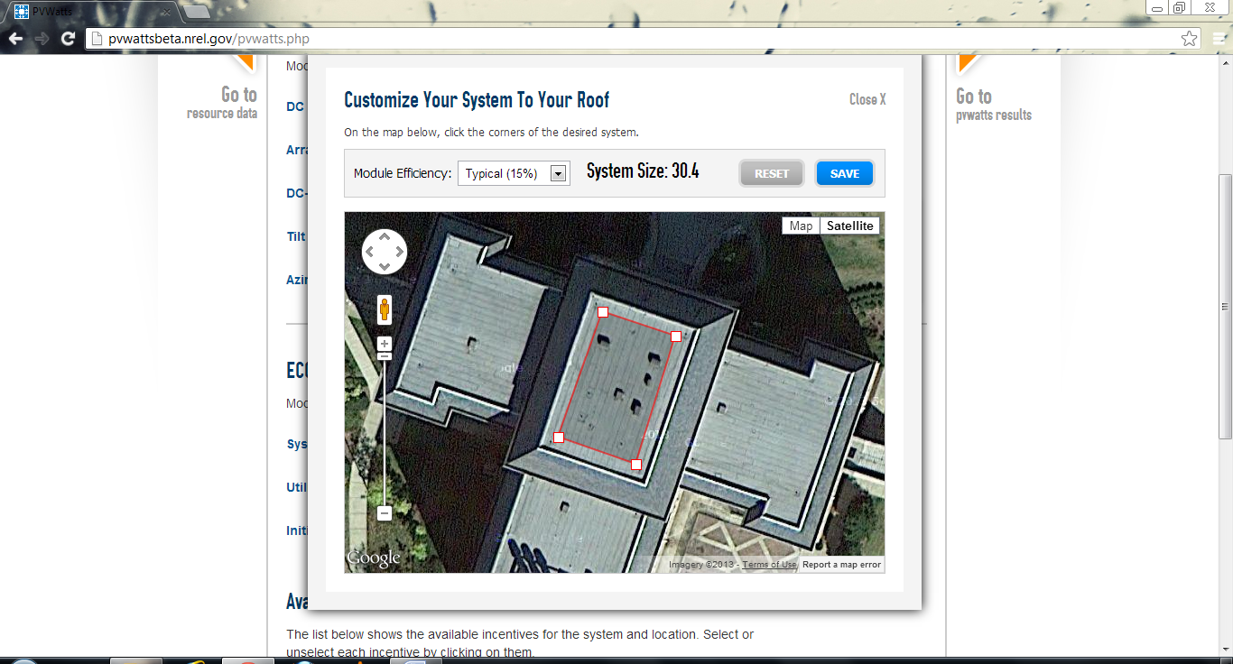
Figure 9
5) The size will get update in the system info page. Let us consider the Array type to be of Fixed Tilt first. This is the default option as well. See Figure 10.
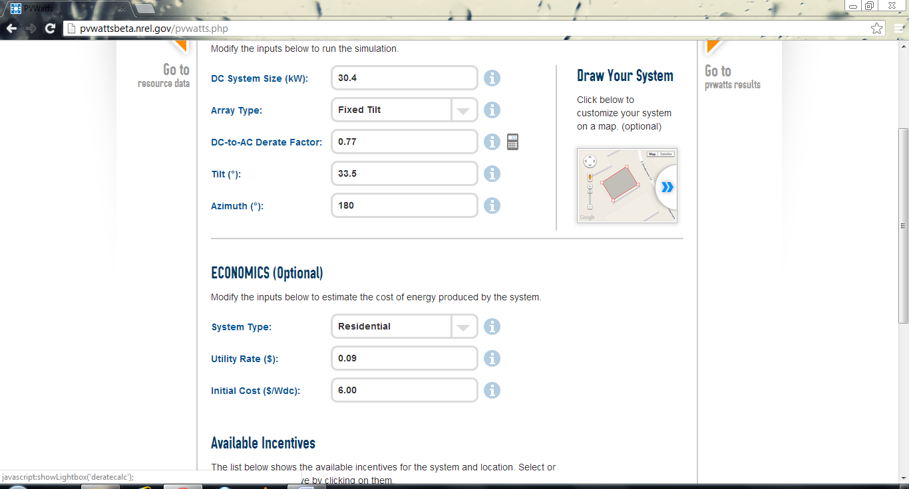
Figure 10
6) We can see Economics and Available Incentives parameters when we scroll down. The utility rate of 0.09 is the value provided by PVWatts for our location. Initial cost of $6/Wdc is the default value and our input is not allowed to exceed that. See Figure 11.
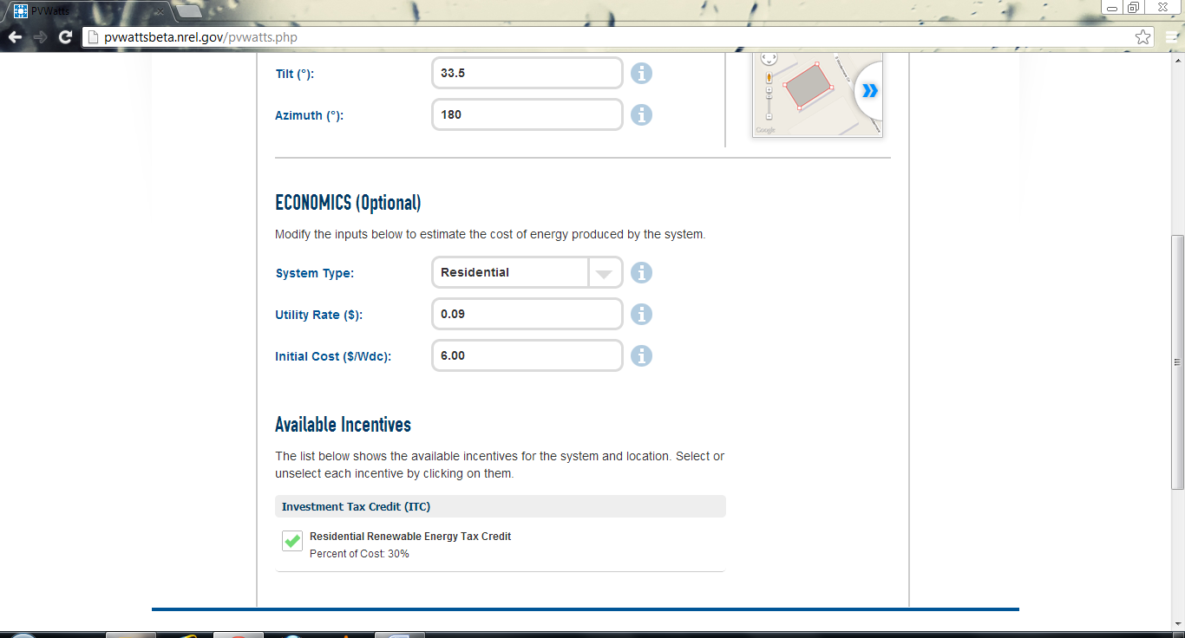
Figure 11
Let us take a value of $3/Wdc as shown in Figure 12.

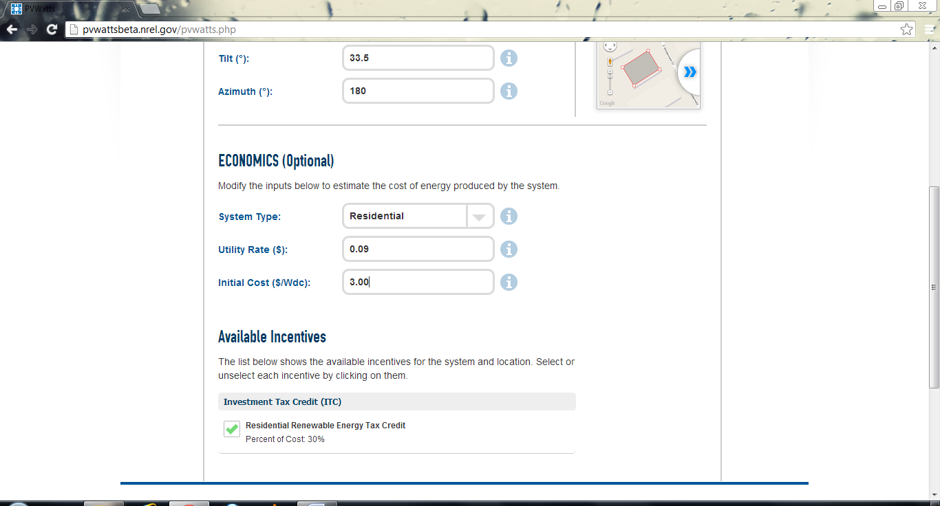
Figure 12
7) Scroll up and click on “Go to PVWatts results” to find the following output (Figure 13 and Figure 14).
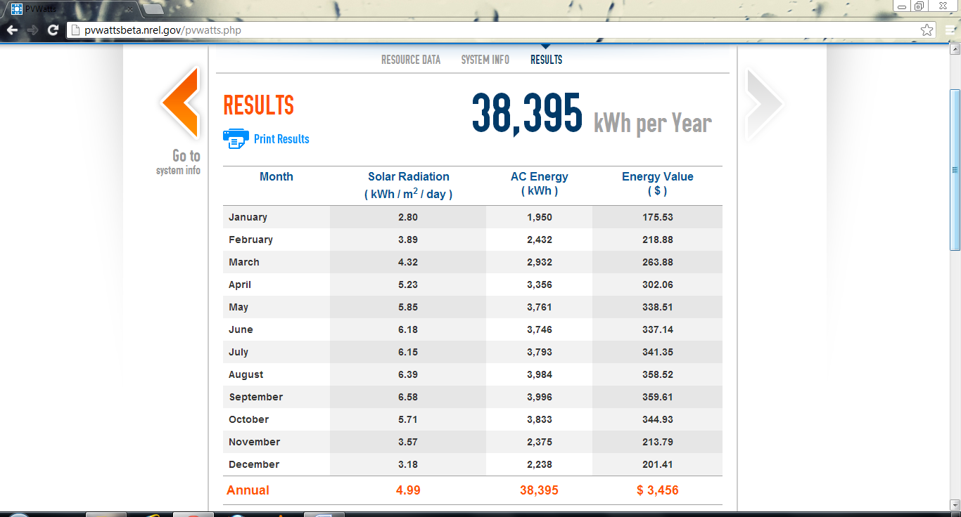
Figure 13
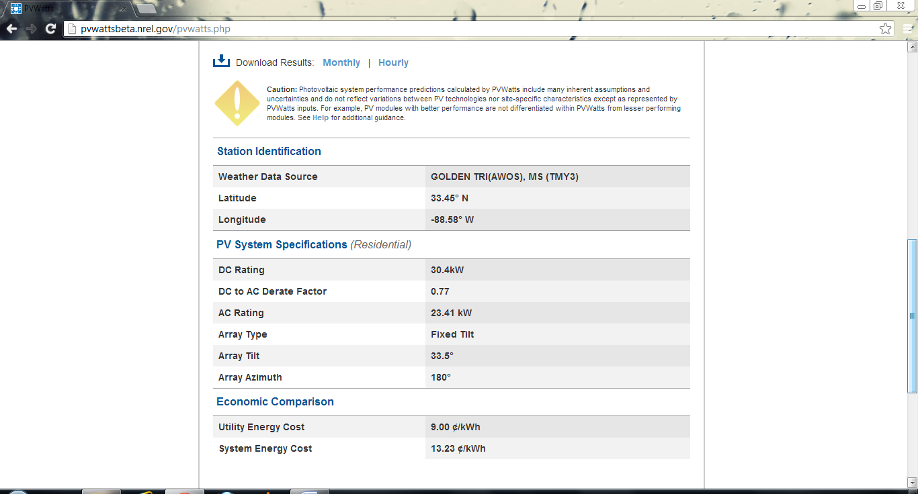
Figure 14
As you can see, a month-by-month output for a year is generated based on all the parameters which we have chosen. It also provides options for displaying the hourly output. Information on the source of the weather data and system energy cost is given as well.

8) For finding out the output for a single axis tracker, go to system info (Figure 10) and click on the input box of the parameter “Array type”. From the dropdown list choose the option “1-Axis tracker” (Figure 15 and Figure 16).
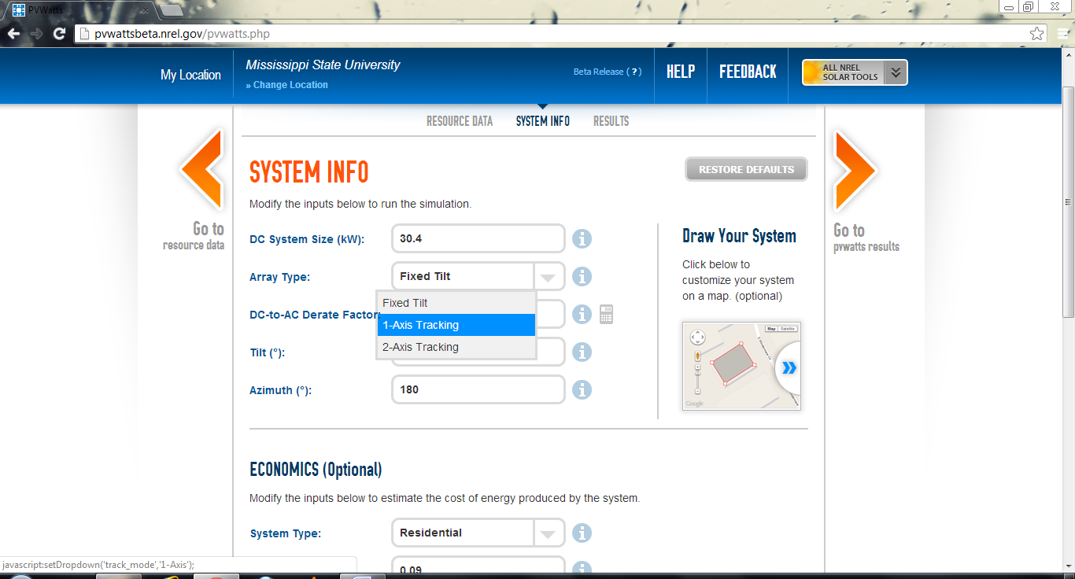
Figure 15
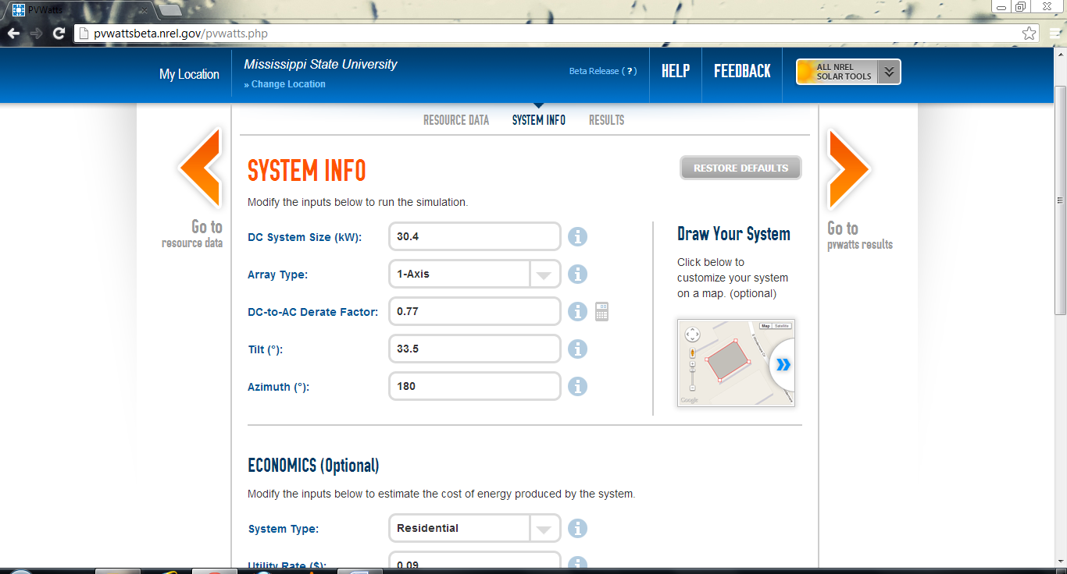
Figure 16
9) Be sure to change the “DC to AC derate factor” since we would need to consider the efficiency of the tracker as well. Click on the “calculator” sign next to the derate factor input box. A list of parameters that are used to calculate the derate factor will appear as shown in Figure 17. Let the values of other parameters be the same as default except for “Sun Tracking”.

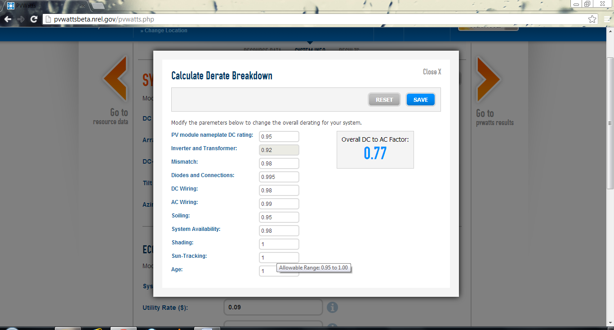
Figure 17
The allowable range is 0.95 to 1 i.e. 95% to 100%. Let us assume it to be 0.97. The overall derate factor automatically changes. In this case it got reduced to 0.75. (Figure 18)
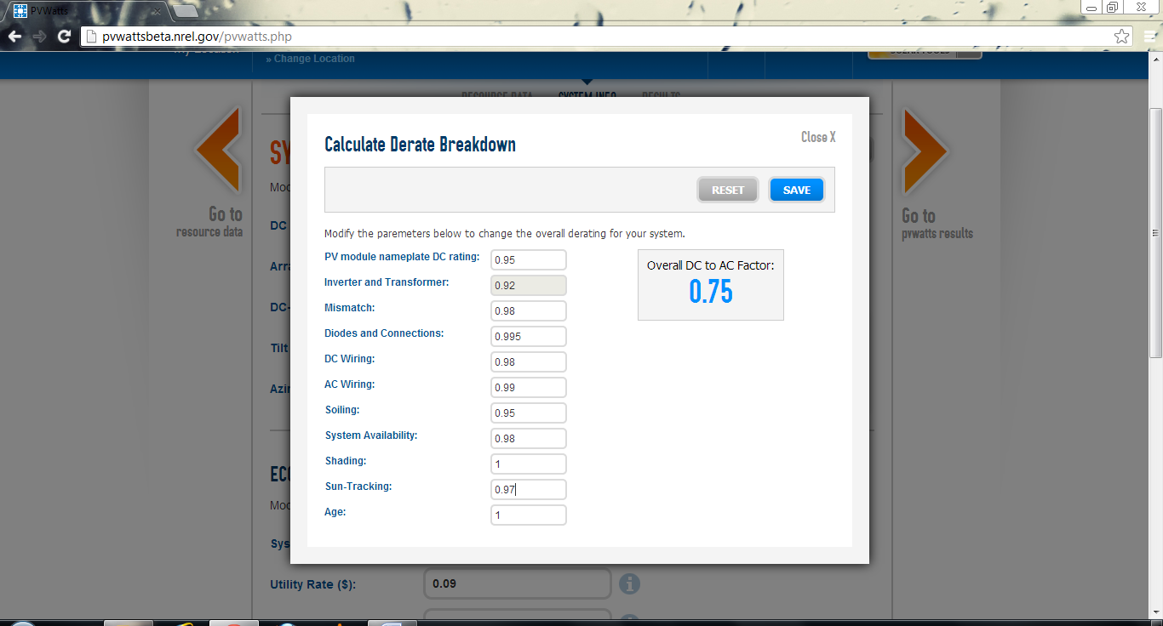
Figure 18
When you click on “Save”, the derate factor will get updated on the system info page (Figure 19)
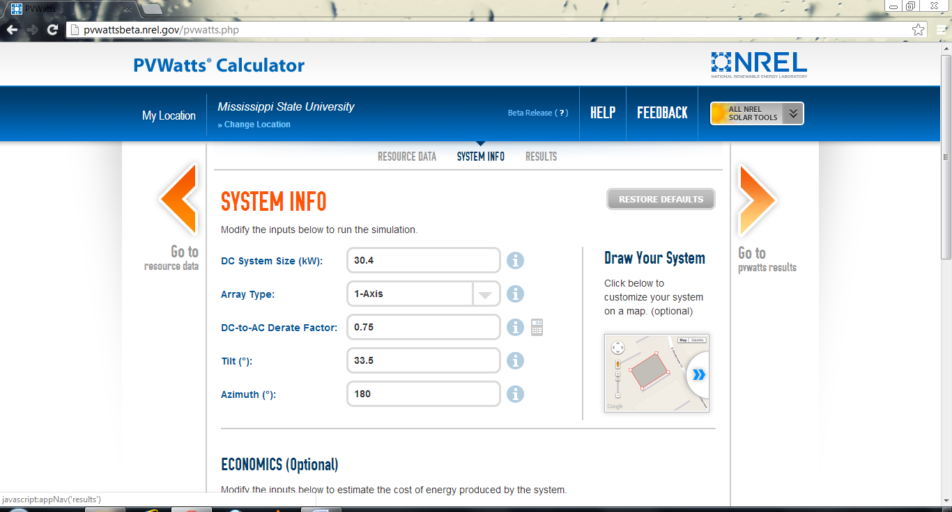
Figure 19
10) Scroll down to update the “Economics” parameters (Figure 11). The $/Wdc cost of the installation would increase since we have added the single axis tracker. Let us increase it by $0.5/Wdc resulting in $3.5/Wdc as the total cost as shown in Figure 20.

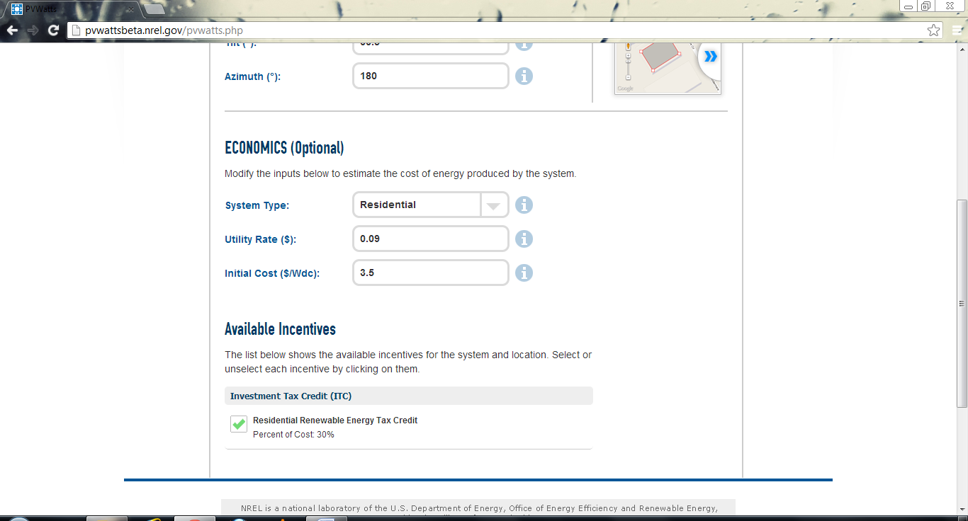
Figure 20
11) The output page would be as shown in Figure 21and Figure 22:
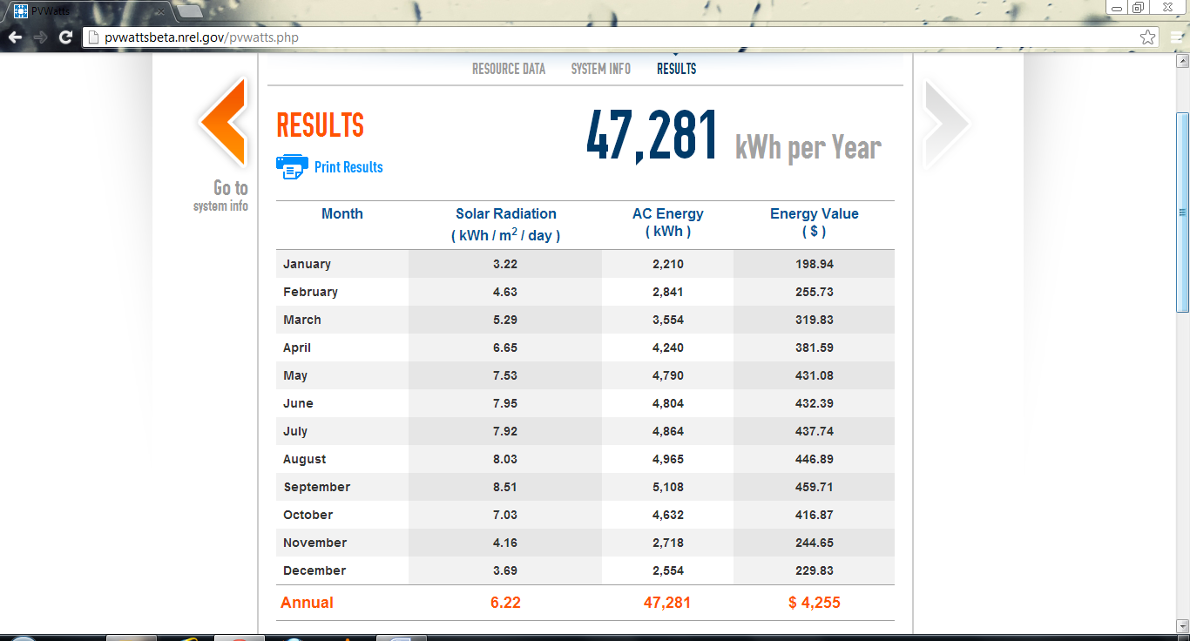
Figure 21
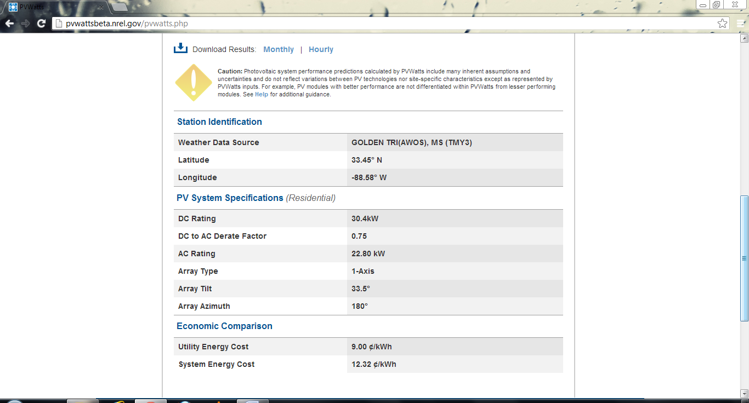
Figure 22
Observe that the output increased to 47,281 KWh from 38,395 KWh and the system energy cost declined to 12.32 cents/KWh from13.23 cents/KWh after changing the tracking type to 1-axis. Although the output differs from location to location, this trend is very common. Not that we have not accounted for the building’s ability to sustain the increased weight load of the tracking system. Such trackers are generally used in open space ground installations.

12) Follow a similar procedure for finding the output when a 2-axis (double axis) tracker is used. We would reduce the “Sun Tracking” further to 0.95 and increase the cost to $4/Wdc since an additional tracker is being used. Refer Figure 23-31.
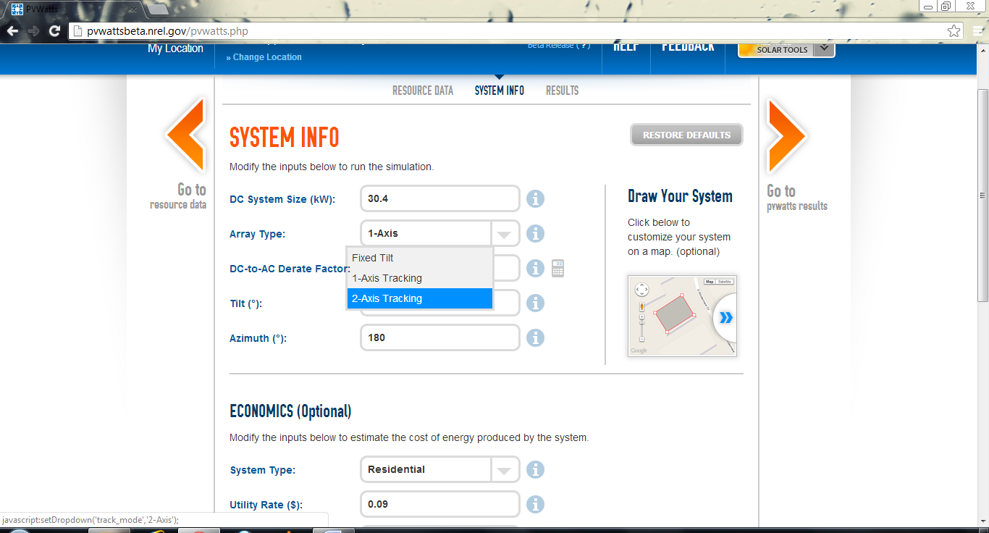
Figure 23
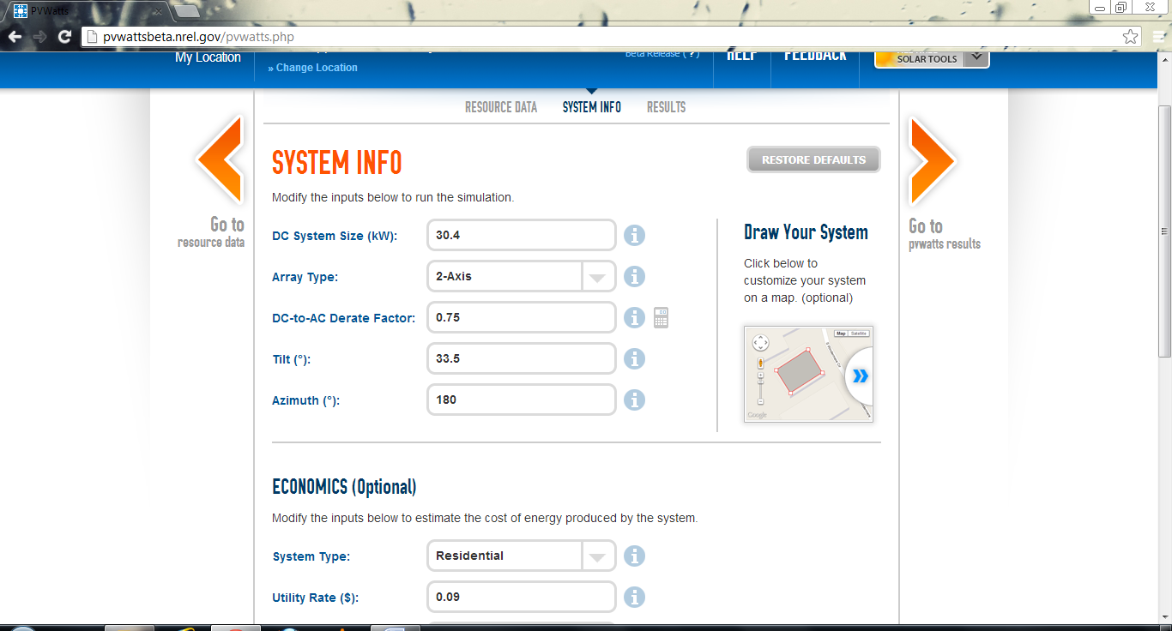
Figure 24
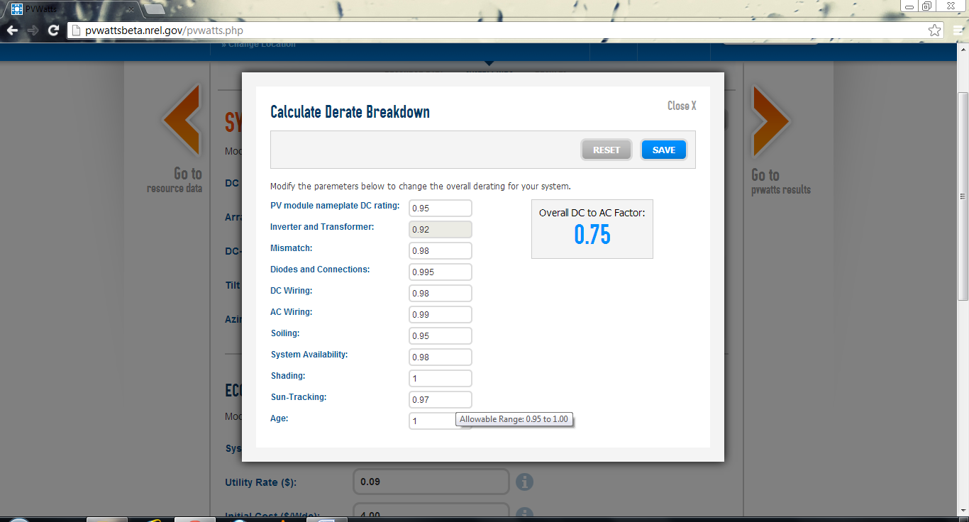
Figure 25
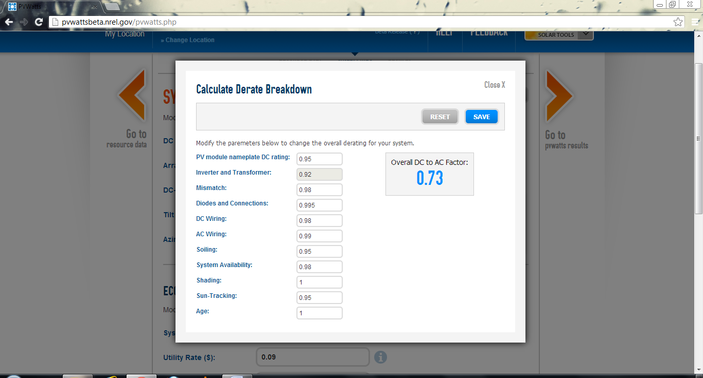
Figure 26
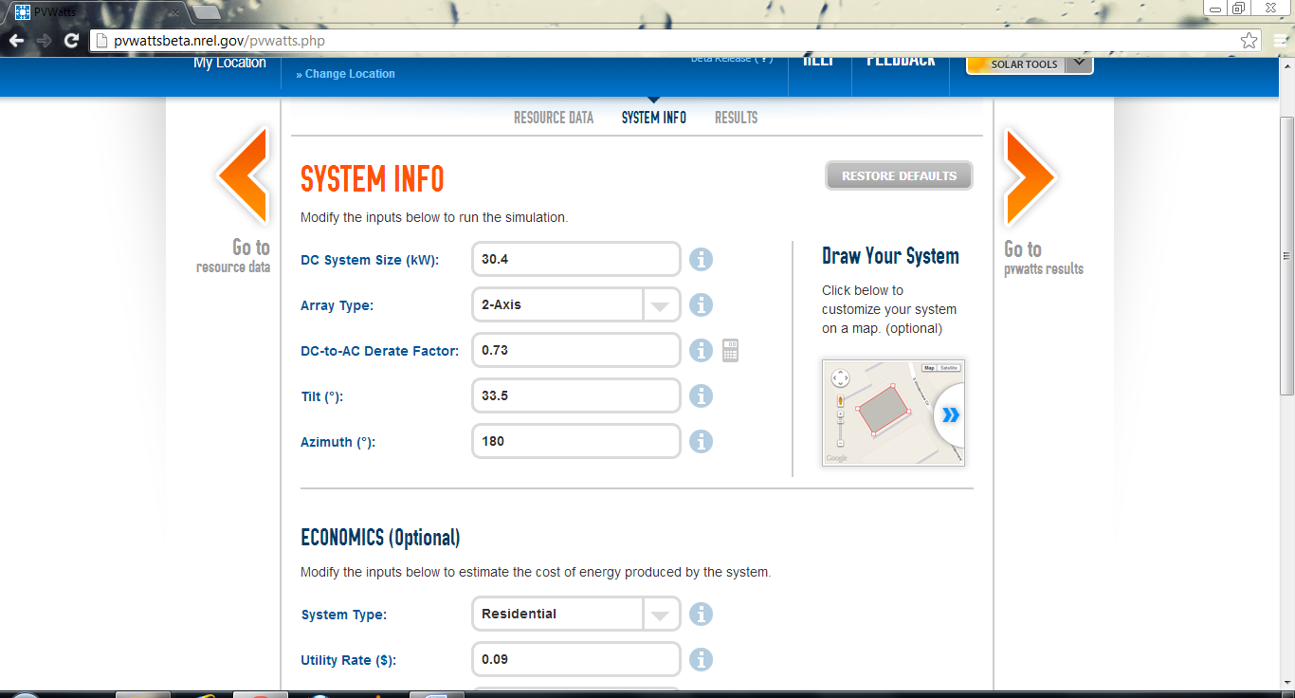
Figure 27
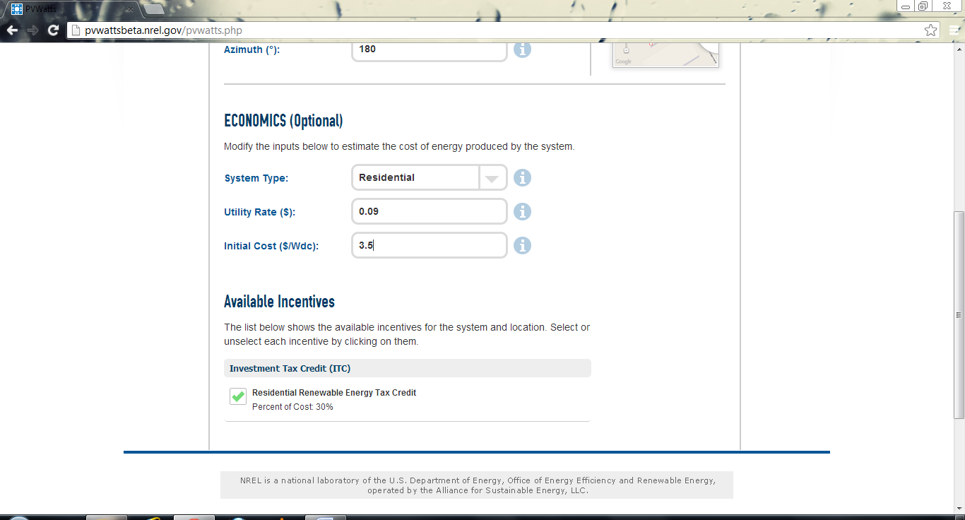
Figure 28
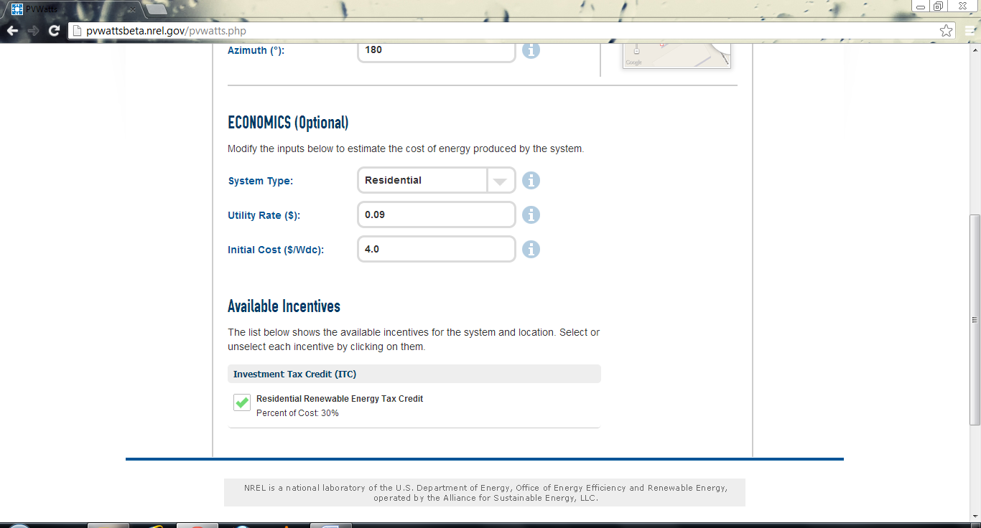
Figure 29
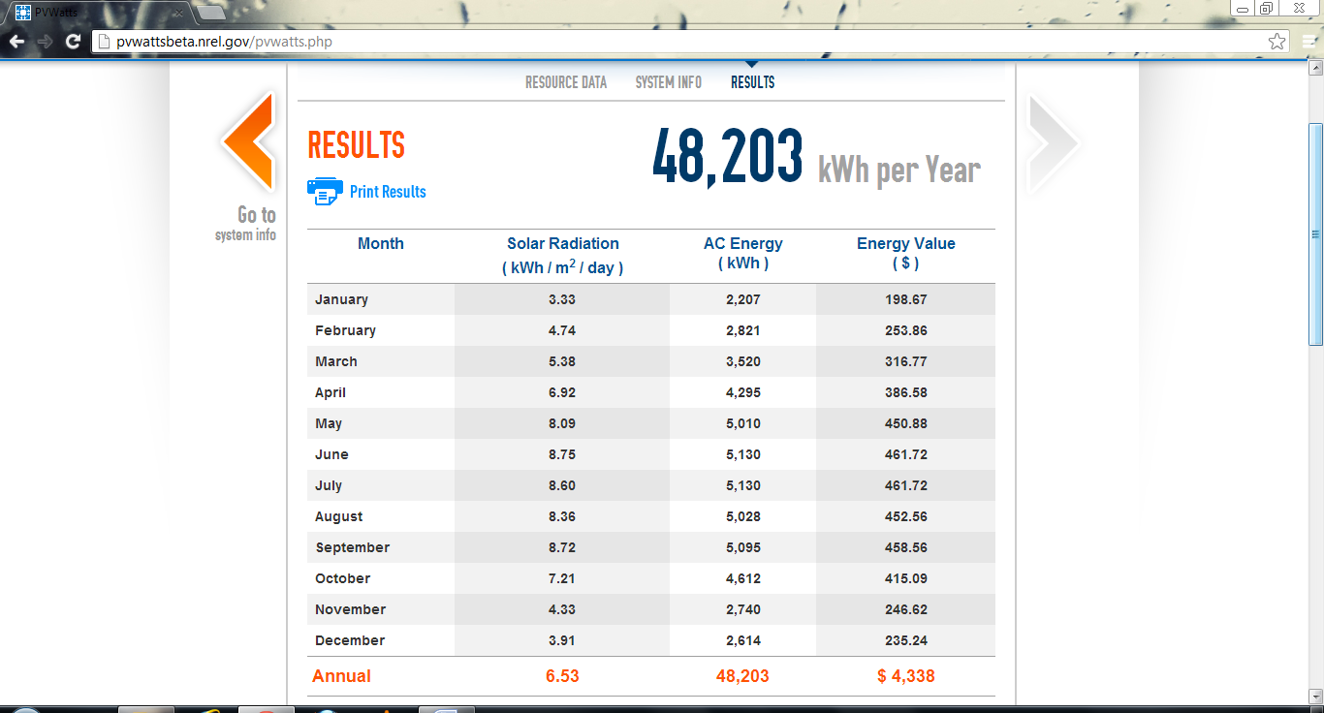
Figure 30
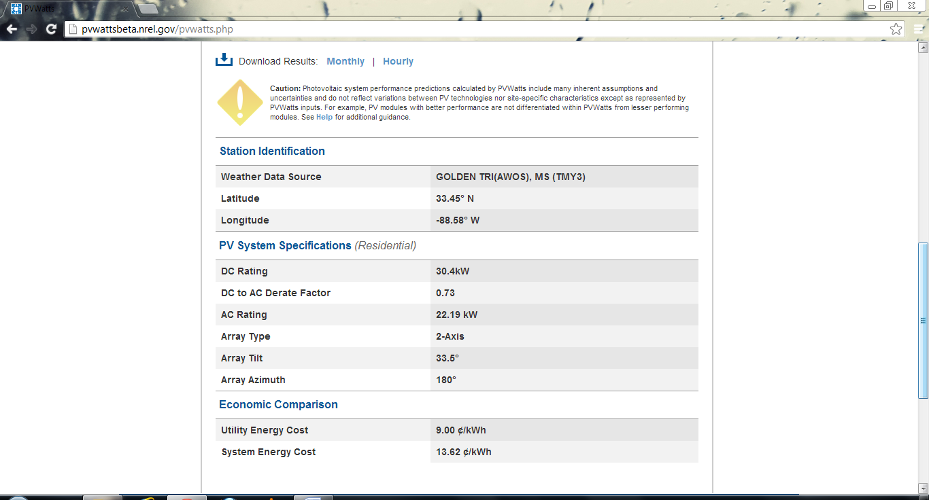
Figure 31
In this case, the output increased to 48,203 KWh but the system energy cost increased to 13.62 cents/KWh as well. This output is a very small increase from the output generated by 1-axis tracker. On the other hand, the cost of the system is more than the cost observed for fixed-tilt system. This also is a common trend throughout and hence 1-axis trackers are preferred over 2-axis trackers.

Homework Problem
Estimate the output of a Silicon solar PV installation for different types of array if it was to be installed on the roof-top of the MSU Energy Institute building.
Select the map and locate the MSU Energy Institute building. On top of the building’s roof, draw a rectangular field by clicking on four corners of the roof. Keep the efficiency as 15%. The size will get updated as 85.4 KWdc. Be sure to leave some space from the exact corners so as to account for the extra space needed for trackers. Refer Figure 1.

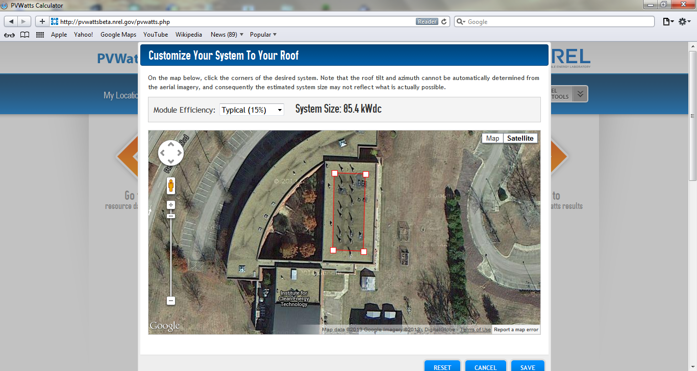
Figure 1

